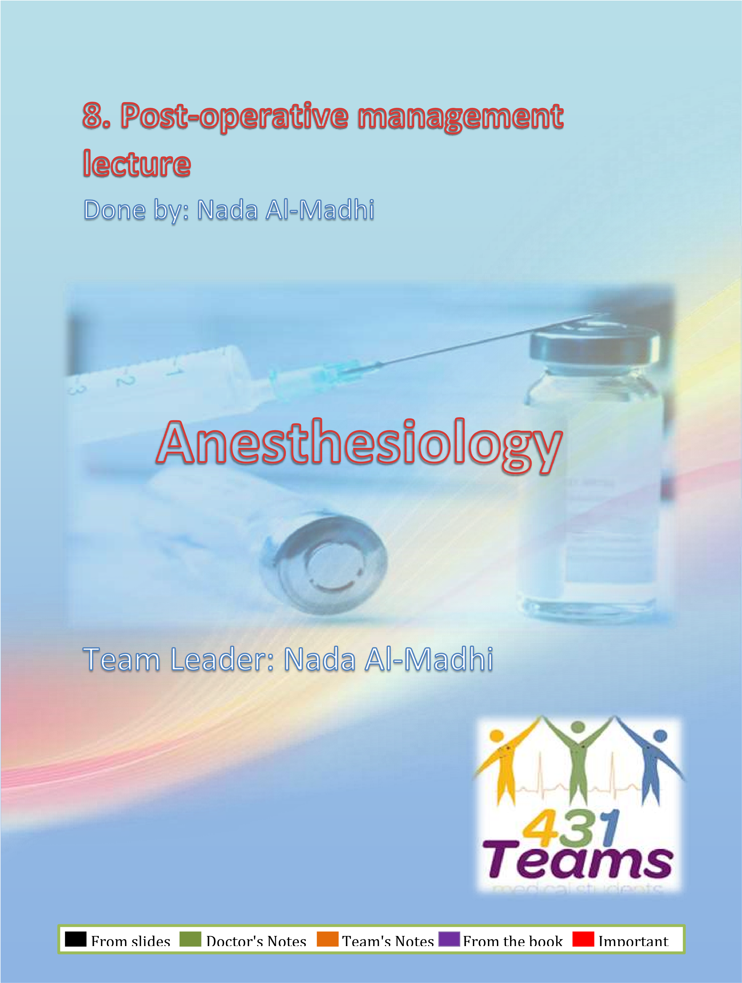
PACU
- Design should match function
- Location:
  - Close to the OR.
  - Access to x-ray, blood bank & clinical labs.
- Monitoring equipments inside the PACU
- Emergency equipment available incase of emergency.
- Personnel #Nurse 1:1 (managed by a nurse unless a
Cardiovascular/Respiratory emergency has occurred→ should contact the anesthesia for this patient)

Admission to PACU:
Steps:
- Coordinate prior to arrival (nurse in OR contact the nurse in recovery room about the arrival of the patient and mention his current status and what he needs at the moment: blood transfusion/ special monitors)
- Assess airway,
- Administer oxygen,
- Apply monitors,
- Obtain vital signs, (first thing to do in PACU is to put him in oxygen and obtain full vital signs)
- Receive report from anesthesia personnel.

PACU - ASA Standards
- Standard I
All patients should receive appropriate care
- Standard II
All patients will be accompanied by one of anesthesia team (to bring the patient to the PACU)
- Standard III
The patient will be reevaluated & report given to the nurse
- Standard IV
The patient shall be continually monitored in the PACU
- Standard V
A physician will sign for the patient out of the PACU (all patients going out from PACU must be signed by the anesthesia department

Patient Care in the PACU  • Admission | 1st thing to put is Oxygen  then apply monitor
- Apply oxygen and then monitor
- Receive report
- Monitor & Observe & Manage
➔ To Achieve
- Cardiovascular stability
- Respiratory stability
- Pain control (so before the doctor leave the patient to start another case the patient should be CVS/Resp. stable and pain must be controlled)
- Discharge from PACU (after 30min -1 hour) Monitoring in the PACU:
- Baseline vital signs (RR, BP, O₂ Sat, ECG, HR..
- Respiration
- RR/min, Rhythm*
- Pulse oximetry
- Circulation
  - PR/min & Blood pressure
  - ECG
- Level of consciousness
- Pain scores
Initial Assessment: (all patient in PACU should be monitored regularly by the nurse with the following)
1. Skin Color → detection of hypoxia → monitor saturation

2. Respiration

3. Circulation

4. Consciousness
5. Activity

All collectively we will call it the Alderete score (Patient in the first 15 min will be monitored every 5 min the color, respiration, circulation, conciseness and activity)→ if he’s stable after 15 min → he can be monitored every 15 min.
Alderete score #MCQ -> score applied for GA and regional anesthesia
Score | Activity | Respiration | Circulation | Consciousness | Oxygen saturation
2 | Moves all extremities | Breaths deeply and coughs freely. | BP + 20 mm  of  preanesth.  Level | Fully awake | Spo2 > 92% on room air
1 | Moves 2 extremities | Dyspneic, or shallow breathing | BP + 20-50 mm of  preanesth.  Level | Arousal on calling | Spo2 >90%  With suppl. O2
0 | Unable to move | Apneic | BP + 50 mm of  preanesth.  level | Not responding | Spo2 <92%  With suppl. O2

Common PACU Problems:
Respiratory and cardiovascular problems (but the Main problems which can occur are respiratory)
- Airway obstruction • Bleeding
- Hypoxemia • Agitation
- Hypoventilation • Delayed recovery
- Hypotension • “PONV”
- Hypertension • Pain
- Cardiac dysrhythmias • Oliguria
- Hypothermia All these above can happen but
mainly the respiratory problems
are more common.

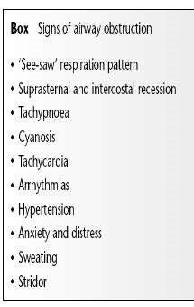

1. Airway Obstruction
- Most common cause: tongue fall back (deeply anesthetized received opioids post anesthesia) → not fully awake to protect his airways. ➔ Posterior pharynx
- May be foreign body gauze, secretions, blood…
- Inadequate relaxant reversal
- Residual anesthesia with opioids or any drug causing obstruction.
Management: (give oxygen and apply jaw thrust with oral or nasal airway)
- Patient stimulation sometimes with opioids → stimulation → he will wake up and will protect
- Suction,
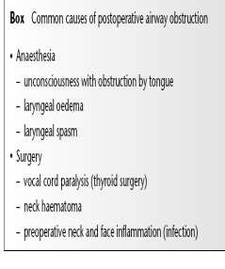
- Oral Airway if he’s semi-con →can’t tolerate it! → Gag reflex
- Nasal Airway tolerated better by pt→ avoid spasm.
- Others: Advance or tumor and if all above failed → sat is still going down and not fully awake→ more invasive actions:
  - Tracheal intubation o Cricothyroidotomy
  - Tracheotomy

Because of full monitor all equipments should be available in RECOVERY room (like intubation, laryngeoscope, ambo bag, airways ..) all should be available at PACU + emergency drugs like succinylcholine, atropine …
Hypoventilation: High CO₂
Hypoxemia: low O₂
2. Hypoventilation (another respiratory complication)
- Residual anesthesia→ main cause
  - Narcotics (opioids)
  - Inhalation agent
  - Muscle Relaxant
- Post op - Analgesia
  - Intravenous e.g. opioids
  - Epidural (high spinal or epidural)

Treatment:
- Close observation→ give it sometime→ effect the drug will be reduced especially healthy patients → taking deep breath will maintain saturation-> not applied in pediatrics or neonates→ easily desaturated.
- Assess the problem (is it because of drugs we give? like narcotics, muscle relaxants?)
- Treatment of the cause: Oxygen – Reverse (or Antidote):
- Muscle relaxant ⇦ Neostigmine to reverse the action of muscle relaxant + atropine cause it will increase the mascarinic effect
- Opioids overdose ⇦ Naloxone (antidote of opioids)
- Midazolam ⇦ Anexate

Cardiovascular problems in PACU (hyper/hypotension and dysrhythmias)

3. Hypertension
- Common causes: e.g.
  - Pain
  - Full bladder: always have to solve these 2 problems before jumping for other causes and giving meds especially when the patient is healthy (patient has to be pain free and ask him if he wants to go to the toilet before the operation/ or insert Foley cath)
- Hypertensive patients→ if patient free of pain and bladder is empty → risk for HTN crisis→ manage with labetalol or esmolol → but don't give meds unless you already excluded the first causes.
- Fluid overload
- Excessive use of vasopressors (ephedrine, phenylephrine) →before shifting the patient.
Treatment:
- Effective pain control and empty the full bladder
- Sedation (midazolam) → hypertensive patient → anxiety → be cautious it may cause hypoxia (especially geriatric patients) so its not always a good choice
- Anti-hypertensive: IV not oral, and short acting
- Beta blockers (1st of choice) (labetalol)
- Alpha blockers
- Hydralazine (Apresoline)
- Calcium channel blockers
4. Hypotension common problem post GA and regional
- Decreased venous return
– Hypovolemia
  - ⬇ Fluid intake (not giving adequate fluid replacement)
  - ⬆ Losses (continuous bleeding form surgical site)
- Bleeding
- Sympathectomy(spinal epidural)
- 3rd space loss abdominal surgery → high fluid shift → need around 1015ml/kg/hr to replace 3rd space loss.
- Left ventricular dysfunction cardiac disease → hypotension and infarction do ECG to rule out MI → specially if he is not bleeding and surgery is not major.

Treatment
- Initially treat with fluid bolus→ but before know the cause especially in geriatric patients (cardiac problems)→ cant tolerate giving 1L bolus of NS→ pulmonary edema
- + Vasopressors
- + Correction of the cause

5. Dysrhythmias
Secondary to
- Hypoxemia main cause in PACU → 2-3 min →dysrhythmia → bradycardia common in peds
- Hypercarpia → hypoventilation
- Hypothermia
- Acidosis
- Catecholamines
- Electrolyte abnormalities. Hyper/hypokalemia, hypomagnesaemia

Treatment: apply o₂ and treat the cause monitor urine output via cath Identify and treat the cause,
- Assure oxygenation,
- Pharmacological

6. Urine Output
• Oliguria → oliguria If <0.5ml/kg/hr.
- Hypovolemia
- Surgical trauma (abdominal surgery post hysterectomy, post Csection) body release some factor that cause
- Impaired renal function,
- Mechanical blocking of catheter. Main cause in recovery room
- Treatment:
    - Assess catheter patency
    - Fluid bolus
    - Diuretics e.g. Lasix
  - Post op Bleeding → causes of hypovolemia – Causes:
- Usually Surgical Problem.
- Coagulopathy, (aspirin, heparin, in prolonged use of cardiac bypass machine the Plt will be destructed)
- Drug induced.

Treatment of Post op Bleeding:
- Start i.v fluid lines ➢ push fluids→ replace the blood loss 3:1 with crystalloids, colloid and blood 1:1
- Blood sample do ABG and Hb
    - CBC
    - Cross matching
    - Coagulopathy
- Notify the surgeon,
- Correction of the cause → main treatment of post op bleeding

  - Hypothermia:

- Most of patients will arrive cold → due to redistribution of temperature post GA and regional. It will happen at the beginning but should be managed
- Treatment: placing a bair hugger, warming the room, give warm IVF to overcome the problem
    - Get baseline temperature during anesthesia
    - Actively rewarm
    - Administer oxygen if shivering→ one sign of hypothermia is shivering and the complication of shivering is increase O2 consumption and hypoxemia → so if shivering immediately put facemask to overcome the hypoxia → rewarm → 10-20mg of pethedine with Unknown mechanism.
    - Take care for: hypothermia is common in these categories • Pediatric→ serious in neonates
- Geriatric.

- Altered Mental Status: never give sedation if patient is agitated in recovery → search for the cause first
  - Reaction to drugs
    - Drugs e.g. sedatives, anticholinergics
    - Intoxication / Drug abusers
  - Pain
  - Full bladder
  - Hypoventilation
  - Low COP
  - CVA
Treatment:
  - Reassurances,
  - Always protect the patient
  - Evaluate the cause • Treatment of symptoms.
  - Sedatives / Opioids if necessary do not give to geriatric and peds→ never jump to sedation before identifying the cause if no cause you can then give it→ small incremental dose

- Delayed Recovery start in operating room OR → if he didn't wake up after 30mins → delayed recovery → main cause of drug → drug effect during surgery
- Systematic evaluation
  - Pre-op status
  - Intraoperative events → see if anything happened→ opioids → resp. depression → give small dose of naloxone to reverse the effect of opioids depression → if awake → transfer to recovery → if he has the respiratory depression again→ opioids work for 30-1 hour and naloxone only work for 20 mins
  - Ventilation
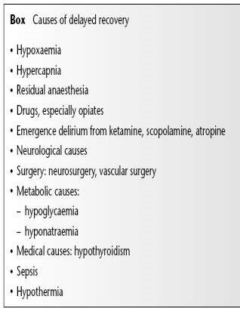
  - Response to Stimulation
  - Cardiovascular status

- The most common cause:
  - Residual anesthesia ➢ consider reversal (muscle relaxant-> neostigmine opioids→ antidote naloxone)
- Hypothermia. Ped and geriatric play major role in delayed recovery→ prolong the effect of all anesthesia agents especially muscle relaxants →the residual is potent enough to make the patient hypoventilated.
- Metabolic e.g. diabetic coma,
- Underlying psychiatric problem
- CVA

11. Postoperative Nausea & Vomiting “PONV
- Risk factors patient cause, surgical cause and anesthesia cause – Type & duration of surgery abdomen, bowel, ophtha, ears..
  - Type of anesthesia GA so when you discuss regional anesthesia with patient you must inform him that he wont have sore throat and PONV
  - Drugs→ inhalational agents , opioids, NO
  - Hormone levels→ female
  - Medical problems→ GERD
  - Autonomic involvement--> spinal epidural, hypotension can cause PONV

Prevention of “PONV”

- NPO status→ > 8 hours
- Dexamothasone
- Droperidol,
- Metoclopramide
- H₂ blockers,
- Ondansetron
- Acupuncture

12. Postoperative Pain most imp thing we do in PACU is manage Post Op patin→ give analgesia intraop and post op

- Causes:
- Incisional Skin and subcutaneous tissue
- Laparoscopy Insuflation of Co₂ ➢ Others:
- Deep cutting, coagulation, trauma
- Positional nerve compression, traction & bed sore.
- IV site needle trauma, extravasation, venous irritation
- Tubes drains, nasogastric tube, ETT
- Surgical complication of surgery
- Others cast, dressing too tight, urinary retention

search for the cause:
Severe pain → orthopedic surgery → give good amount of analgesia→ if still we have pain→ I have to search for other cause like urinary retention, cast that is too tight → treat the cause first
Subjective → from patient→ he’ll tell you that he has pain
In peds patients→ he will cry only → objective: behavior, cardiovascular→
hypertensive, tachycardic … indication of pain
Visual score→ by looking at the patient facial expressions
Numerical score → 1-4 mild 4-7 moderate 7-10 severe
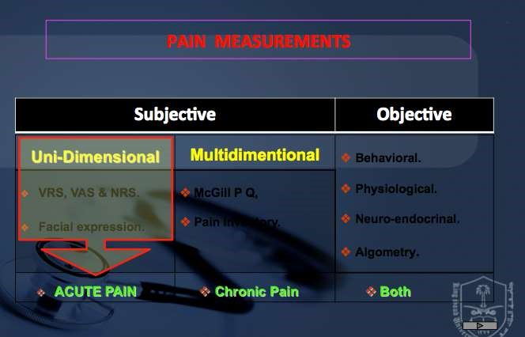
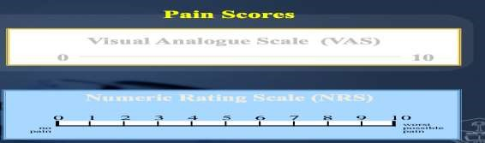

ACUTE POSTOPERATIVE MANAGEMENT TOOLS
Pharmacotherapy |  | Regional techniques
- Non Opioid Analgesics  - NSAADs  - Analgesic /Antipyretic  - Analgesic/Antiinflam/Antipyretic  - NSAIDs  - Non-selective COX inhibitors  - Selective COX-2 inhibitors  - Opioids  - Weak Opioids.  - Strong Opioids.  - Mixed agonist-antagonists  - Adjuvants  - α-2 Agonists  - LA  - SP inhibitors  - NMDA inhibitors  - Anticonvulsant / Antidepressants  - Calcitonin  - Relaxants  - Cannabinoids  - Others |  | - Local infiltration  - Wound perfusion  - Intra-abdominal inj. of LA/Analg.  - Intercostal & Interpleural  - Paravertebral 6. USG-RA: e.g. TAP  7. Neuraxial:  - Epidural:  - Thoracic  - Lumbar  - Spinal  - Single shot  - CSA  - CSE

If surgery os minor and mild-moderate pain → combination of NSAIDS and paracetamol → avoid giving opioids → cause NV and respiratory depression.
Severe pain and big incision→ give opioid → monitor and incremental dose

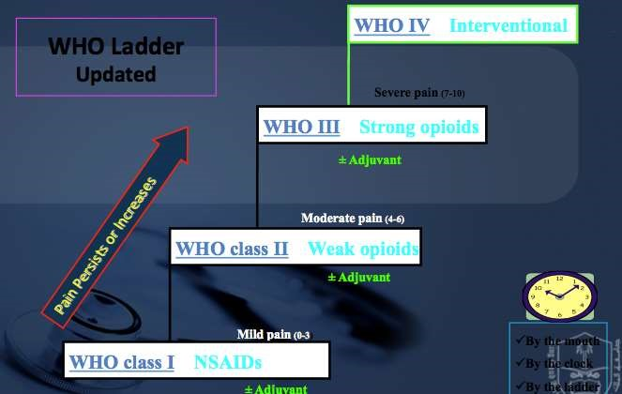

WHO (I) Non Opioid Analgesics:
1. Non Opioid Analgesics
- NSAADs
- Analgesic / Anti-inflam / Antipyretic / Anticoagulant
- ASA
- Analgesic /Antipyretic
- Paracetamol
- NSAIDs
- Non-selective COX inhibitors:
- Diclofenac & Ketoprofen
- Selective COX-2 inhibitors
- Celecoxib & Rofecoxib

Mild pain → class I→ NSAIDS effective
WHO class I

NSAIDs

WHO class II

Weak opioids

WHO III

Strong opioids

Mild pain

(0
-
Moderate pain

(4
-
6)

±

Adjuvant

±

ad
Adjuvant

±

Adjuvant

Moderate pain→Class II→ weak opioids→ tramadol

Severe pain→strong opioids→ class III→ fentanyl, morphine, hydromorphine
Class VI newly added → for intervention → putting catheter for chronic pain
If you want to give NSAIDS make sure his kidney function is normal and no coagulopathy (if we want to use aspirin) Mild and acute pain → paracetamol
Adding NSAIDS/ paracetamol to opioids
PCA→decrease PCA opioid consumption
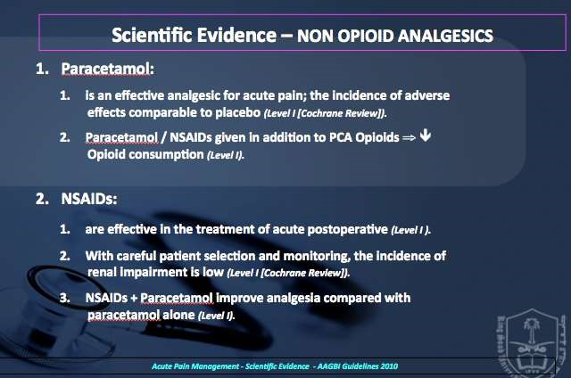

WHO Ladder II - Weak Opioids:→ means weak side effects (weak risk of side effects (not like fentanyl and morphine) Resp. depression/itching…)
- Tramadol:
  - Tramadol: Morphine:
    - Parenteral = 1: 10 & Oral = 1: 5
    - Dose: 200 – 400 mg/d
- Codeine:
  - Metabolized to morphine.
WHO class I

NSAIDs

WHO class II

Weak opioids

WHO III

Strong opioids

Mild
pain
Moderate pain

(4
-
6)

±

Adjuvant

±

Adjuvant

±

Adjuvant

  - Codeine: Morphine = 1: 10
- Dextro-propoxyphene:
  - Methadone Derivative
  - Prolongation of Q-T interval.

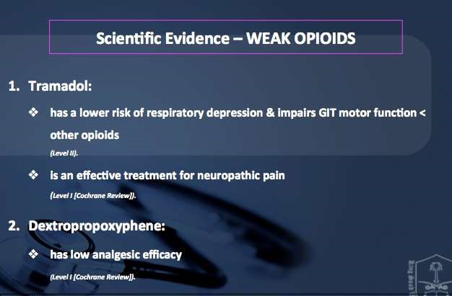

WHO Ladder III - Strong Opioids

Morphine:
- Sedation
- PONV
- Respiratory Depression main ad effect
- Fentanyl
  - Rapid action, Short duration.
  - Fentanyl : Mophine = (1:10)

- Pethidene: not used so much → active metabolite can lead to seizures 1. Active metabolite: ⬆ t½ .
  - Prolongs Q-T interval.
  - Pethidine : Mophine = (1:10)
- Hydromorphone:→ more potent than morphine→ only given as PCA not bolus.
  - Powerful, rapidly acting.
  - Release is in distal gut.
  - Hydromorphone : Morphine = 1 : 5

Patient Controlled Analgesia:
PCA is a unique way of administering pain medications. The medication is administered with the help of a pump. Patient has the freedom to control the amount and dose of the pain medication

WHO Ladder IV – Regional Anesthetic Techniques
- Local infiltration
- Wound perfusion
- Intra-abdominal LA
- Intercostal
- Interpleural
- Paravertebral 7. USG - RA: e.g. TAP
8. Neuraxial:
- Epidural:
- Thoracic
- Lumbar
- Spinal
- Single shot
- CSA
- CSE

Neuraxial (spinal/Epidural) (LA/Opioids/ other)
- Advantages:
  - Provide prolonged & effective analgesia and avoid the complication of GA (airway manipulation/ post op NV/ airway complications)
- Side effects
  - Respiratory depression. →High block
  - N/V → because of hypotension → in spinal once the patient feels nauseated → look for hypotension → treat it and then if NV continues → treat it
  - Pruritus→ cause sometimes we add fentanyl
  - Urinary retention.
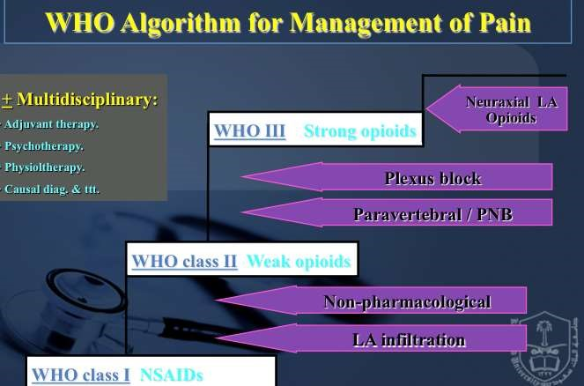
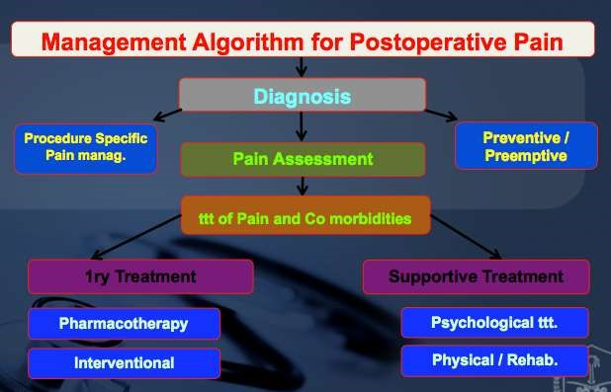

PACU (30mins-1 hour) Discharge Criteria

- Fully Awake,
- Patent airway,
- Good respiratory function,
- Stable vital signs,
- Patency of tubes, catheters, IV’s • Reassurance of surgical site
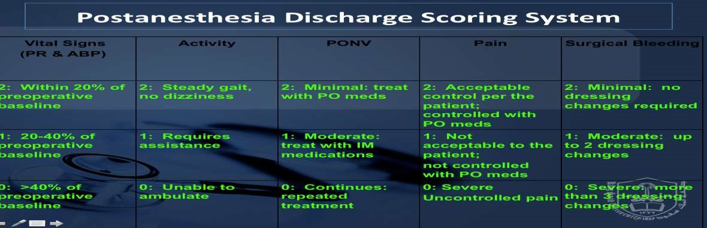
Score should be 10-9.
If less we will not shift him to ward until we consult the surgical team

Summary: from Toronto notes

- Pain management should be continuous from OR to post-anesthetic care unit (PACU) to hospital ward and home
- Pain service may assist with management of post-operative inpatients
Post-Operative Nausea and Vomiting (PONV)
  - Hypotension and bradycardia must be ruled out
  - pain and surgical manipulation also cause nausea
  - often treated with dimenhydrinate (Gravol®), metoclopramide (Maxeran®) (not with bowelobstruction), prochlorperazine (Stemetil®), ondansetron (Zofran®), granisetron (Kytril®)
Post-Operative Confusion and Agitation
  - ABCs first – confusion or agitation can be caused by airway obstruction, hypercapnea, hypoxemia
- Neurologic status (Glasgow Coma Scale, pupils), residual paralysis from anesthetic
- Pain, distended bowel/bladder
- Fear/anxiety/separation from caregivers, language barriers
- Metabolic disturbance (hypoglycemia, hypercalcemia, hyponatremia – especially post-TURP)
- Intracranial cause (stroke, raised intracranial pressure)
- Drug effect (ketamine, anticholinergics)
- Elderly patients are more susceptible to post-operative delirium

