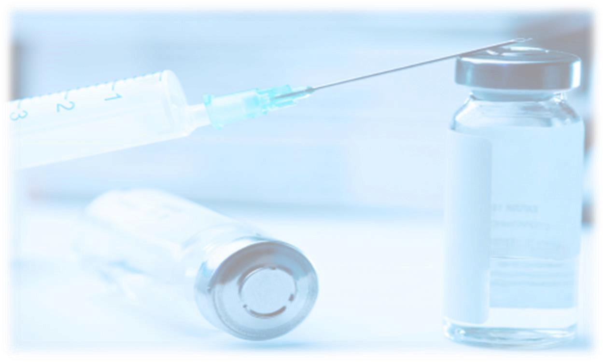
D
one by:
Reem Alsalman

Team Leader: Nada Al
-
Madhi

From
slides
Doctor's Notes

Team's Notes From the book Important

REGIONAL/NEURAXIAL ANESTHESIA:
Reversible loss of sensation in a specific area of the body.
- Bier block It is not use now... For more information http://www.nysora.com/techniques/3071-bier-block.html
- Ultrasound guide peripheral nerve block , Ankle block
- Neuroaxial block :Spinal, Epidural, Caudal DEFINITIONS:
- SPINAL ANESTHESIA (INTRATHECAL):
Administration of medication into subarachnoid space ( intrathecal space )
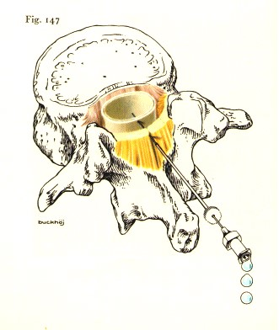

Ligament of flava or
ligamentum Flavum

- EPIDURAL ANESTHESIA:
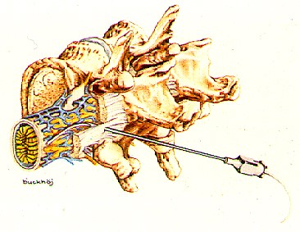
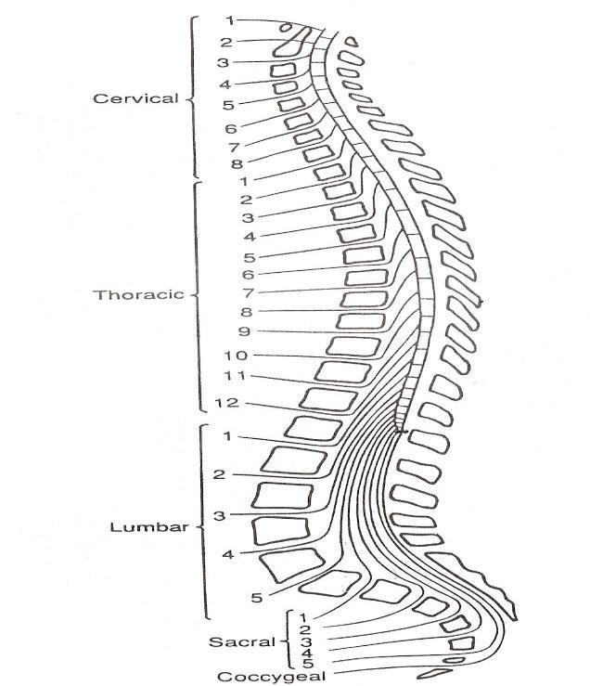
Cervical 7
A
dministration of medication in epidural space

OVERVIEW OF THE SPINAL ANATOMY

The vertebrae are 33 number, divided by structural into five region:

Use for thoracic and higher abdomen
surgery

Spine end in L1
-
2
. To locate use iliac
crest, at it
s

level the L4
located

At S5 the
sacral hiatus
site of

caudal,
which is use most commonly in pediatr
ic

Thoracic 12
Lumber5
Sacral 5
Coccygeal3-4.

SPINAL CORD
Located and protected within vertebral column extends from the foramen magnum to lower border 1st L1 (adult). Spinal Ccord tapers to a fibrous band - conus medullaris. Nerve root continue beyond the conus- "cauda equine", Surrounded by the meninges, (dura, arachnoid &pia mater) .The spinal cord becomes the cauda equina at the level of L2 in an adult and the cerebrospinal fluid stops at the level of S2.
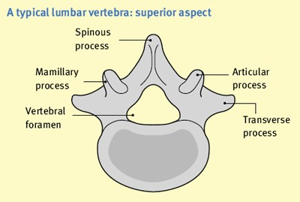
The epidural space

is 3
–
mm wide
6

The contents of the epidural space are:

•
Nerve

roots

•
Venous

plexus

•
Fat

•
Lymphatic

The spinal aesthesia

w
ork in
1

–

2

min because it act on naked
nerve root unlike the epidural
takes longer
"20
–

"
30
because
it act on covered nerves.

The veins contain no valves and communicate directly with the intracranial, thoracic and abdominal venous systems.
EPIDURAL ANESTHESIA:
ANATOMY:
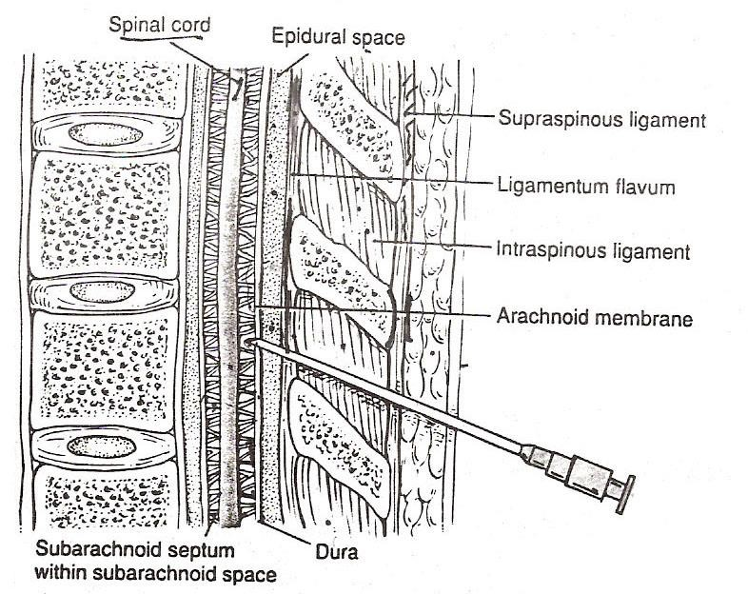

INDICATIONS
▪ The objective of epidural analgesia is to relieve pain in :
- intraoperative &postoperative Major surgery
- Trauma (# ribs)
- Palliative care (intractable cancer pain)
- Labor pain analgesia

CONTRAINDICATIONS
Absolute:
- Patient refusal – Abnormal co-agulation profile – Infection at insertion side, septicemia – Allergy to local anesthetic drug Relative:
- Raised intracranial pressure – Hypovolemia
- Chronic spinal disorders – Central nervous system disease
- LMWH can be given before and after 8 h surgery and the dose is 40mg.
- Warfarin stopped 3 days before surgery and monitored PT, INR.
- Heparin monitored by PTT.
- Aspirin is relative.
- Used anticoagulant drugs
Requirements before starting regional anesthesia:
  - Informed consent
  - Vascular access
  - Resuscitation drugs and equipment
We preload the pt with 1L of fluid because of sympathetic block.
One of the side effect of epidural is hypotension and vasodilatation for that we use Fedrin or Phenylephrine
  - Sterility of anesthetists
  - Sterility of operative site
  - No contraindications toprocedure
  - Correct dosage of local anesthetic drug
The equipment used for the insertion of an epidural catheter is:
  - Tuohy needle is either 16 or 18 gauge.
It is 10 cm long: 8 cm of needle and 2 cm of hub. It is marked in centimeters and has a curved ‘Huber’ tip.
  - The epidural catheter has three holes , 2 cm from the end of the catheter. The catheter is marked in centimeter gradations up to 20 cm.
  - The filter has a 0.2 μm mesh that stops the injection of particulate matter, such as glass, and bacteria into the epidural space.
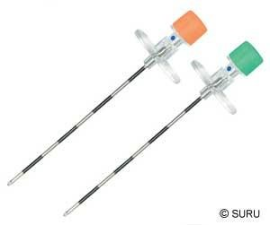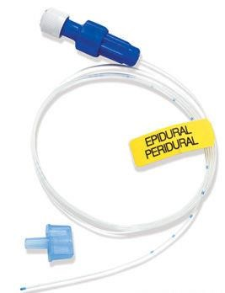

Technique of insertion of an epidural catheter:
  - An intravenous infusion of 500 ml of crystalloid
  - Atropine and a vasopressor should be drawn up before starting the block.
  - Can be done in either the lateral or sitting position spine should be flexed.
  - local infiltration
  - Slow controlled advance of the Tuohy needle using a syringe whith loss of resistance technique by air or saline.
  - The needle passes through skin, subcutaneous tissue, supraspinous ligament, interspinous ligament, ligamentum flavum,and finally enters the epidural space.
  - The ligaments resist the injection of air or saline, but when the needle enters the epidural space the resistance is lost.

Patient assume a sitting or side-lying position with the back arched toward the 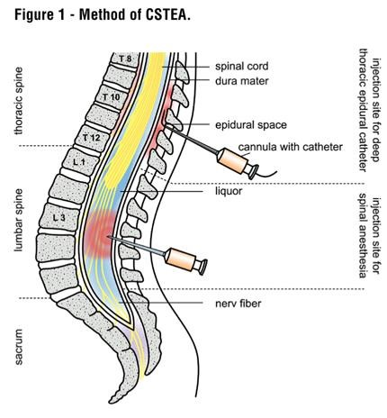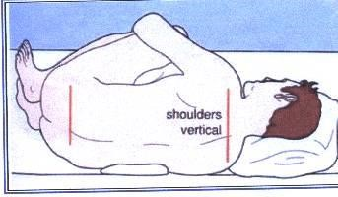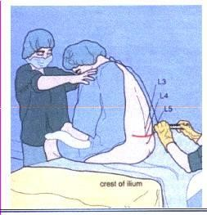physician.Help to spread the vertebrae apart

INSER
TION OF EPIDURAL CATHETER

Positioning of patient

The site is dependent upon the area of pain

Fixing the catheter

The epidural satiable for long surgery
because of catheter that allows us to
maintain

anesthesia unlike the spinal
last for an hour to hour and half

Incision Level
Thoracic T4-T6
Upper abdo T6-T8
Lower abdo T8-T10
Pelvic T8-T10
Lower extremity L1-L4
• Ideal Placement 3-5 cm catheter
CATHETER MIGRATION:
A change in depth of the catheter indicates migration either into or out of the epidural space.
- Catheter migration into a blood vessel in the epidural space or subarachnoid space
- rapid onset of neuroaxial block
- Decrease loss of sensory or motor loss (marcain)
- Profound hypotension
- Toxicity
- Out of the epidural space
- ineffective analgesia
- no analgesia
- drugs deposited into soft tissue.
COMPLICATIONS OF EPIDURAL ANALGESIA:
Severe hypotension Accidental intravenous injection
Dural puncture: – massive spinal anesthetic – headache
Leg weakness Shivering
Atonic bladder Contraction of the small bowel
Backache Epidural haematoma
Isolated, reversible nerve damage from catheter/needle trauma
Epidural abscess Meningitis

How
to manage
P
ost
Dural

p
uncture
H
eadache
?

First conservative if last more than 24h then b
y
injection of
25
ml
of
b
lo
od 1 space above previous one.

Atonic bladder => put
catheter

if long surgery

MEDICATION COMMONLY USED
OPIOIDS-Fentanyl +Morphine (affect the pain transmission at the opioid receptors)
L.A.-Bupivacaine(marcaine)
(inhibits the pain impulse transmission in the nerves with which it comes in contact)
In epidural, we have to do Test dose, which is 2% lidocaine with 5 microgram/ml epinephrine. If pt.
have tachycardia after injection that is means, I am in vessel.

METHODS OF ADMINISTRATION
- BOLUS (FENTANYL, DURAMORPH)
- CONTINUOUS INFUSION( bupvacaine + fentanyl )
- All drugs administered epidural should be preservative free.
- All epidural opioids should be diluted with normal saline prior to intermittent bolus administration.
SPINAL ANESTHESIA:

How you can know the level of anesthesi
a?

T
he
nipple is
T4,

The
umbilicus

is T10,
and shoulder

blade

is T7

and so on.

T
he
n with Ice Bag check the level of
sensation

of
temperature
.

Note that the motor block level is
2
segments
below

sensory block!

NEEDLES:
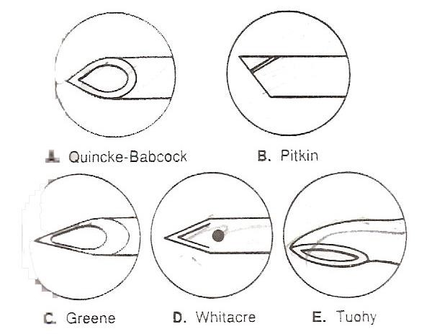

Note:

T
he
needle
tip and
gage play the
major role in post
dural puncture
headache

SPINAL ANESTHESIA
Injection of local anaesthetic into the cerebrospinal fluid (CSF) by means of a lumbar puncture. It is normally given as a single injection, but can be used in conjunction with epidural anesthesia (combined spinal epidural anesthesia) for longer procedures.
Local anesthetic solutions for spinal anesthesia are isobaric or hyperbaric with respect to the CSF. Isobaric solutions are claimed to have a more predictable spread in the CSF, independent of the position of the patient. Hyperbaric solutions are produced by the addition of glucose and their spread is partially influenced by gravity.
• If we use hypobaric it will go up to the brain causing convulsions then coma.
Many factors determine the distribution of local anesthetic solutions in the CSF; this makes prediction of the level of blockade difficult ( Local anaesthetic drug , Baricity ,Dose of drug , Volume of drug ,Increased abdominal pressure ,Spinal curvatures , Position of patient, Speed of injection)

How you can know
if the fluid is CSF or not
?

By Glucose
!

CSF had glucose

COMPLICATIONS:
Pain on Injection. Backache. Headache.
Urinary Retention. Meningitis. Vascular Injury.
Nerve Injury. High Spinal Anaesthesia.
CAUDAL ANESTHESIA:
The caudal space is a continuation of the epidural space in the sacral region.
The signet-shaped, formed by the failure of fusion of the laminae of the fifth sacral vertebra. The hiatus is bounded laterally by the sacral cornua and is covered by the posterior sacrococcygeal ligament, subcutaneous tissue and skin.
The epidural space is located by passing a needle through the sacral hiatus. The caudal canal contains veins, fat and the sacral nerves.
The cerebrospinal fluid finishes at the level of S2.
Caudal anaesthesia is used for operations in areas supplied by the sacral nerves, such as anal surgery and circumcision.
The precautions are the same as those described for epidural anesthesia .
The needle must be aspirated after insertion to exclude blood and cerebrospinal fluid.
The complications are the same as for epidural anesthesia .
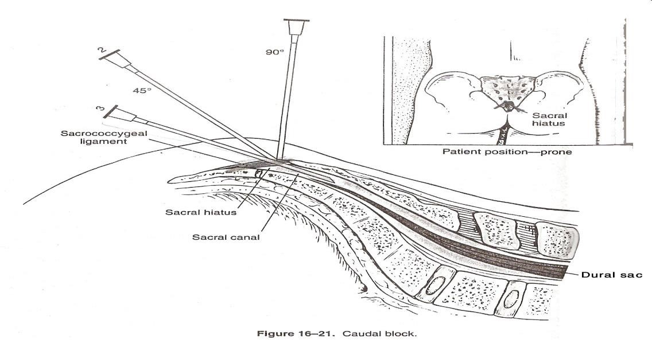

INTRAVENOUS REGIONAL ANALGESIA
A limb can be anaesthetized by the administration of local anesthetic intravenously distal to a tourniquet placed high on the limb.
This technique is used on the arm only, because the leg needs toxic doses of local anesthetics.
It is used commonly for manipulation of fractures and brief operations on the hand .
An intravenous cannula is inserted into a vein on the dorsum of the hand.
A single or double cuff is placed around the humerus. If a double cuff is used, the higher cuff is compressed first
Local anesthesic injected usually lidocaine 0.5 % 40 ml
wait until the arms anaesthetized, then the lower cuff is inflated over the numb skin to make it more comfortable for the patient. patient will often only tolerate the cuff for 45–60 min because of pain.
The cuff must remain inflated for at least 20 minutes, otherwise systemic toxicity may occur from rapid uptake of the drug when the tourniquet is released.
The main problem with this block is the tourniquet. It must not deflate accidentally.
ULTRA-SOUND GUIDED PERIPHERAL NERVE BLOCK OR NERVE STIMULATION
ANATOMY OF LUMBAR AND SACRAL PLEXUS:
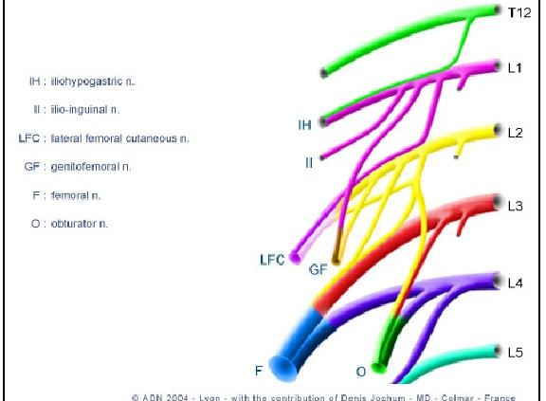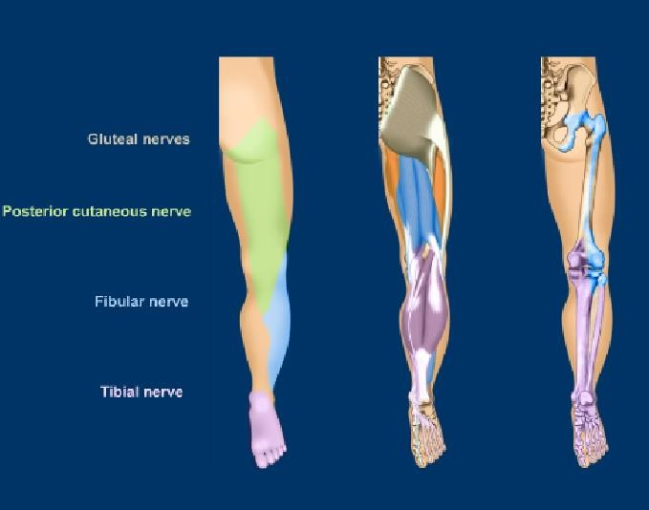

ADVANTAGES/DISADVANTAGES OF REGIONAL AND LOCAL ANESTHESIA: ADVANTAGES :
patient remains conscious maintain his own airway aspiration of gastric contents unlikely
smooth recovery requiring less skilled nursing care as compared to general anesthesia postoperative analgesia reduction in surgical stress earlier discharge for outpatients less expense
DISADVANTAGES:
patient may prefer to be a sleep
practice and skill is required for the best results
Some blocks require up to 30 minutes or more to be fully effective
analgesia may not always be totally effective-patient may require additional analgesics, IV sedation, or a light general anesthetic
toxicity may occur if the local anesthetic is given intravenously or if an overdose is injecte
some operations are unsuitable for local anesthetics, e.g., thoracotomies

PHARMACOLOGY OF LOCAL ANESTHETICS DEFINITION AND MODE OF ACTION
LA are drugs that block the generation and propagation of impulses in excitable tissues: nerves, skeletal muscle ,cardiac muscle, brain.
Local anesthetics is sodium channel blockers inhibiting Na+ flux and thus blocking impulse conduction

ABSORPTION, DISTRIBUTION, METABOLISM
LA readily crosses the blood-brain barrier (BBB) once absorbed into the blood stream
Ester-type LA (Procaine, Tetracaine) broken down by plasma and hepatic esterases; metabolites excreted via kidneys
Amide-type LA (Lidocaine, Bupivicaine) broken down by hepatic mixed function oxidases (P450 system); metabolites excreted via kidney

SELECTION OF LA
Choice of LA depends on:
Onset of action –influenced by pKa (lower the pKa, the higher the concentration of the base form of the LA and the faster the onset of action)
Duration of effects – influenced by protein binding (long duration of action when the protein binding of LA is strong)
Potency – influenced by lipid solubility (agents with high lipid solubility will penetrate the nerve membrane more easily)
LOCAL ANESTHETICS
AMIDES MAX / DOSE
NOTE:

A
ny
fat
-
soluble

drug

it will
be
slower

in onset and longer in
duration!

BUPIVACAINE 2 MG/KG
LIDOCAINE 7 MG/KG
ROPIVACAINE 4 MG/KG
MEPIVACAINE 7 MG/KG
PRILOCAINE 6MG/KG
LOCAL ANESTHETICS
ESTERS MAX /DOSE
CHLOROPROCAINE 20 MG/KG
COCAINE 3 MG/KG
NOVOCAINE 12 MG/KG
TETRACAINE 3 MG/KG

Mechanism of Action
▪ Bupivacaine (marcaine)
- local anaesthetic works as an analgesic (subanesthetic dose)
- inhibiting impulse transmission in the nerve fibers
- sensory nerves are blocked first before the motor fibers
- sensory fibers carrying the pain is blocked before those carrying heat cold touch and pressure.

PROGRESSION OF LOCAL ANESTHESIA
Loss of:
1. Pain 2. Cold 3. Warmth 4. Touch 5. Deep pressure 6. Motor function
OPIOIDS

Mechanism of action-distribution
- Vascular uptake by blood vessels in the epidural space
- Diffusion through dura into CSF to spinal cord to the site of action.
- Uptake by the fat in the epidural space.

Morphine (Duramorph/Astramorph)
Hydrophilic(water soluble)
Slow to diffuse across the dura on to the spinal cord
Can cause late respiratory depression
Monitor respiratory status for 12 hrs after the last dose of duramorph
Duration 6 hrs+, Broad spread

Fentanyl (preservativefree)
Lipophilic(fat soluble) Crossess the dura rapidly
Rapid onset of action(segmental) Decreased risk of late respiratory depression
Onset 5-20 mins ,Duration 2-4hrs Excellent for breakthrough pain Adverse Effects -Opioids
- Sedation and resp.depression- IV narcan
- N/V-Opioids stimulate the chemoreceptor trigger zone primperan
- Pruritus- diphenhydramine or narcan (low dose)
- Urinary retention- low dose narcan and /or catheterization
- Slowing of GI motility
- Hypotension

Adverse Effects L.A
• Hypotension:
- assess intravascular volume status Treatment
-no trendelenberg positioning fluids
- Temporary lower-extremity motor or sensory deficits. Tx: lower the rate or concentration.
- Urine retention Tx: catheter
- Local anesthetic toxicity (neurotoxicity) Tx: stop infusion.
- Resp. insufficiency
Tx:stop infusion ABC(100% o2, call for help)

LOCAL/REGIONAL ANESTHESIA TOXICITY
Systemic Toxicity
- Occurs by accidental intravascular injection, LA overdose, or unexpectedly rapid absorption
- Manifests mainly at CNS first and then CVS
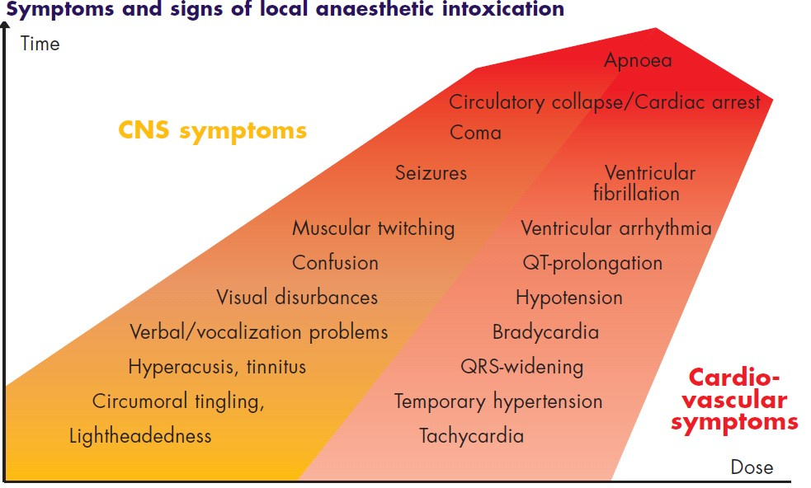

PREVENTION AND TREATMENT OF LOCAL/REGIONAL ANESTHESIA TOXICITY
Prevention
- Always use the recommended dose
- Aspirate through the needle or catheter before injecting the local anesthetic.
- If a large uantity of a drug is required, use a drug of low cardiac toxicity and divide the dose into small increments, increasing the total injection time • Slowl injection and communicate with the pt.
Treatment
- Early recognition of signs
- 100% O2, manage ABCs
- Diazepam may be used to increase seizure threshold
- If the seizures are not controlled by diazepam, consider using: Thiopental, Possibleendotracheal intubation .
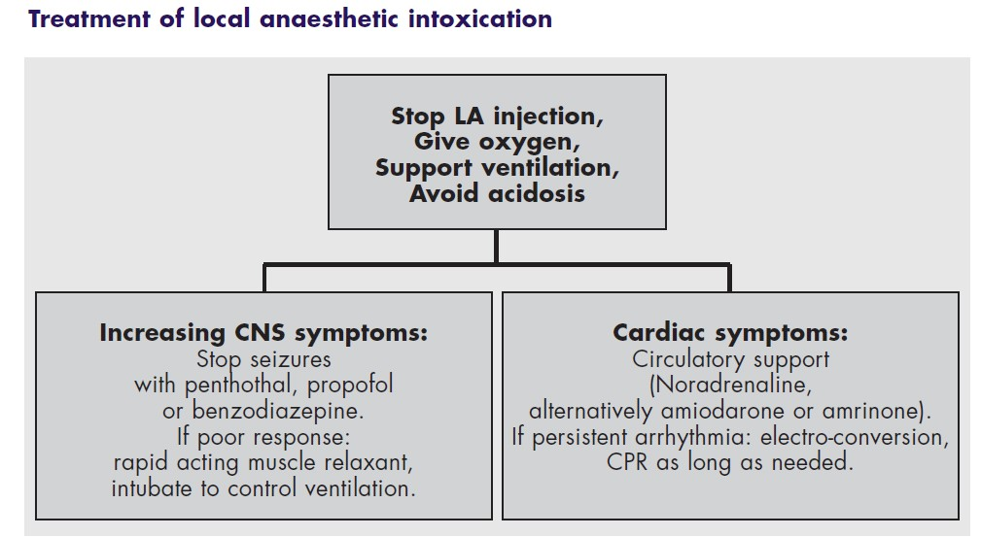
Used lipid emulsion with CPR with refractory cardiac arrest with vasopressor

NOTE:

T
he
Idea behind using lipid emulsion is
the
bupivacaine

is l
ipid soluble so that
help to bring it from the heart to lipid and decrease the toxicity.

