What is Sexually Transmitted infections?
Sexually transmitted infections (STIs) are infections that are spread primarily through person-to-person sexual contact. There are more than 30 different sexually transmissible bacteria, viruses and parasites.” World Health Organization.
COMMON SEXUAL TRANSMITED
DISEASEs
- HIV
- SYPHILIS
- Chlamydia
- Gonorrhea
- Trichomoniasis

How to approach a patient with STI
- history
Some patients may not be comfortable talking about their sexual history, sex partners, or sexual practices. Try to put patients at ease and let them know that taking a sexual history is an important part of a regular medical exam or physical history.
Taking a sexual history:
- Introduce yourself and establish your role as clinician.
- Interview patient alone or with an unrelated translator.
- Be non-judgmental and objective to enhance patient behavioral outcomes
- Use active listening, open-ended questions, and clarify/verify your own and patient understanding.
- Actively listen for informational content, emotional content, comprehension, omitted information, etc.
- Begin with least sensitive questions (e.g.; general health history), then progress to sexual behaviors
- ; do not use labels ("straight," "bisexual," "gay," "queer," “shooter,” etc.)

History must cover the 5Ps:
- The five “P”s stand for:
- Partners
- Practices
- Protection from STDs
- Past history of STDs
- Prevention of pregnancy

STDs can be transmitted many different ways, but most can be passed by:
- Vaginal sex
- Anal sex
- Oral sex
- Skin-to-skin contact
- Infected Mother to child
Examination:
- A. General examination must include the mouth, throat, skin and lymph nodes in all patients.
- B. The inguinal, genital and perianal areas should be examined with a good light source.
- C. The groins should be palpated for lymphadenopathy and hernias.
- D. The pubic hair must be examined for nits and lice.
- E. The external genitalia must be examined for signs of erythema, fissures, ulcers, chancres, pigmented or hypopigmented areas and warts.
- F. The urethral meatus is located and the presence of discharge noted
- G. The cervix should be inspected for ulceration, discharge, bleeding and ectopy and the walls of the vagina for warts.

(STDs)?!
Herpes simplex virus

Herpes simplex virus type 2:
First Infection > nerve ganglia > trigger > reactivate > sores and bluster

From mother to the neonate

HSV is spread through direct contact with herpes sores; HSV also can be present on the skin even if there are no sores. If a person comes into contact with the virus on an infected person’s skin, he or she can become infected.

Diagnosis:
Presentation
Multiple, bilateral, and painful genital vesicles or ulcer.
Fever, headache, malaise, and lymphadenopathy.

Investigation
PCR accurate
Serology tests and antibodies

Complications
Rectal inflammation Proctitis
Meningitis
Involvement of sacral plexus urine retention

Management
Antiviral medications: acyclovir, famciclovir and Valacyclovir.
Partner must be tested and treated.
C.S in infected pregnant.

Human papilloma virus

Human papillomaviruses (HPV) are common viruses that can cause warts in the skin. There are more than 100 types of HPV.
They can be low risk(6,11) or high risk(16,18).

Risk factors
Multiple partners
Immunocmpromised
Contact with infected person
Mother to newborn rare

Diagnosis:
Prevention
HPV vaccine Gardasil and Cervarix. 3 doses

Complications
Most serious is cancer.

Management
Medical therapy
Cryotherapy
Surgical excision
Electro cautery

HPV cancers include cancer of the cervix, vulva, vagina, penis, or anus. HPV infection can also cause cancer in the back of the throat, including the base of the tongue and tonsils, we do Biopsy

Investigation
HPV test, Check for the virus.
Pap test, check for any cell changes.
Under age 30: Pap test every 3 year
From 30 to 65: HPV test and Pap test (co-testing) every 5 years

Presentation Asymptomatic
Genital warts usually appear as a small bump or groups of bumps in the genital area. They can be small or large, raised or flat.
In women may cause vaginal discharge and bleeding.
Recurrence is common.

Case …
Anne Drew is a 34-year-old woman who comes in stating that she wants to get "checked out" because her partner, has small solid "bumps" on the skin at the base of his penis. He told her that he was diagnosed and treated for genital warts about a year ago, and his health care provider told him they could recur.

History
- No history of abnormal Pap tests and no history of STDs.
- Last Pap test was performed 4 months ago.
- Sexually active since age 16 with multiple partner.
- Currently sexually active with one partner for the last eight months.
- Uses oral contraceptives for birth control.
- No vaginal discharge

Physical Examination
- Vital signs: blood pressure 96/74, pulse 78, respiration 13, temperature 37.1° C
- Chest, heart, musculoskeletal, and abdominal exams within normal limits
- Pelvic exam is normal
- Visual inspection of the genitalia reveals multiple small (<0.5 cm), flesh-colored, papular painless lesions in the perineal area

Diagnosis:
HPV infection.

Trichomoniasis:
A sexually transmitted disease (STD) caused by a microscopic parasite, usually found in the vagina and urethral tissues.
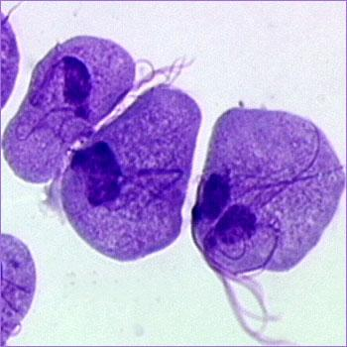
Etiology: Trichomonas Vaginalis
Mode of transmission:
- Sexual contact.
- perinatal, from mother to child.
Complication During pregnancy:
- Preterm delivery.
- Low birth weight.

Signs and symptoms
Men | Women
- Usually asymptomatic in beginning .  - Irritation inside the penis.  - Slight burning after urination or ejaculation.  - urethral discharge. | - Greenish-yellow, frothy vaginal discharge with a strong odor.  - Painful urination.  - Vaginal itching and irritation.  - Discomfort during intercourse.  - The cervix may have multiple small hemorrhagic areas which lead to the description strawberry cervix.
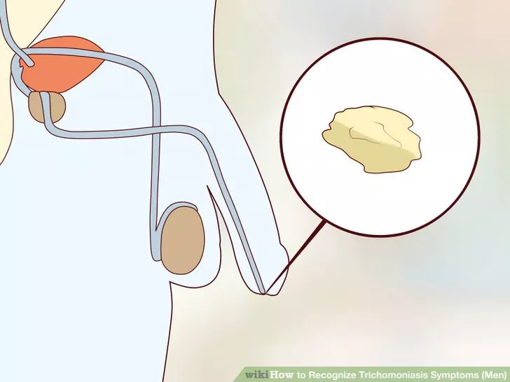 | 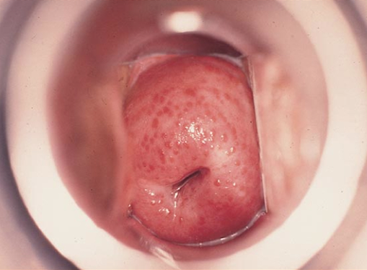

Diagnosis
- History
- Examination
- Laboratory: sample of vaginal or urethral fluid to look for the disease-causing parasite.

Dark field microscopy:  Positive in 40-80% of women  and 30% of men. | Culture techniques :  confirm the diagnosis.
 | 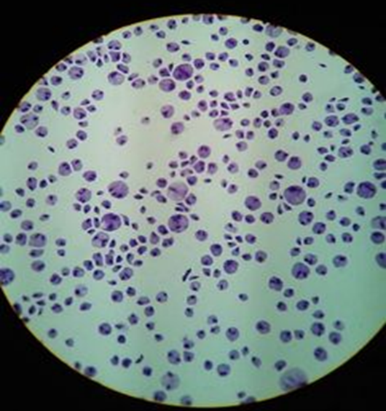

Treatment: Metronidazole or Tinidazole.
For: symptomatic, asymptomatic patients and their partners.

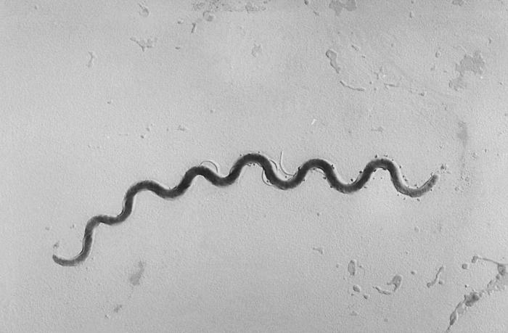
Syphilis: Sexual transmitted with the bacterial infection which spread through broken skin or mucous membranes.
Etiology: Treponema pallidum.
Mode of transmission:
- Sexual
- vertical

Signs and symptoms by stages:
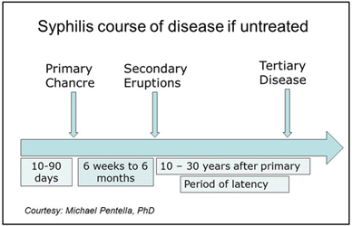

Diagnosis:
Laboratory | Examination | History
- detect T. pallidum from lesion exudate or tissue by dark field microscopy.  - Serologic tests  - Nontreponemal tests.  - Treponemal tests. | - Oral cavity .  - Lymph nodes .  - Skin upper body.  - Palms and soles .  - Genitalia and perianal area.  - Neurologic examination .  - Abdomen . | - History of syphilis.  - Known contact to an early case of syphilis.  - Typical signs or symptoms of syphilis in the past 12 months.  - Most recent serologic test for syphilis.

Dark field microscopy of smear:  primary or secondary stage. | Serologic tests:

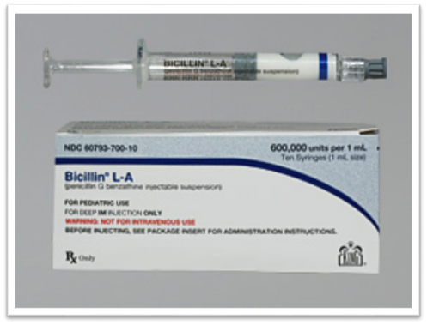
Treatment: Benzathine penicillin (Bicillin L-A®)
G 2.4 million units intramuscularly in a single dose.
If penicillin allergic :
- Doxycycline 100 mg orally twice daily for 14 days.
- or Tetracycline 500 mg orally 4 times daily for 14 days.

Gonorrhoea
Transmission :Direct inoculation of infected secretions from one mucous membrane to another.
Primary sites of infection :Mucous membranes of the urethra, endocervix, rectum, pharynx and conjunctiva.
Clinical features
 | Men  Urethritis | Women  Urogenital infection
Symptoms | - Urethral discharge (80%) and/or dysuria (50%) within 2-5 days  - Urethral infection can be asymptomatic (10%) | - Increased or altered vaginal discharge is the most common symptom (up to 50%)  - Lower abdominal pain may be present (up to 25%)  - Urethral infection may cause dysuria (12%) but not frequency  - Gonorrhoea is a rare cause of intermenstrual bleeding or menorrhagia
Signs: | - Mucopurulent or purulent urethral discharge  - Rarely, epididymal tenderness/swelling or balanitis may be present | - Mucopurulent endocervical discharge and easily induced endocervical bleeding (50%)  - Pelvic/lower abdominal tenderness (5%)  - Commonly, no abnormal findings are present on examination
Extra-genital infections:
- Rectal infection is usually asymptomatic but may cause anal discharge (12%) or perianal/anal pain or discomfort (7%)
- Pharyngeal infection is usually asymptomatic (90%)
- Eye involvement in adults : purulent conjunctivitis, may rapidly progress to panophthalmitis
Complications
Men: Transluminal spread my result in epididymo-orchitis or prostatitis
Women: pelvic inflammatory disease (PID).
Disseminated gonoccoccal infection: may occur following haematogenous dissemination causing skin lesions, arthralgia, arthritis and tenosynovitis.

Diagnosis
Microscopy | Nucleic Acid Amplification Tests (NAATs) | Culture
Sensitivity is 90 – 95% in men with urethral discharge | - High sensitivity (96%) in both asymptomatic and symptomatic infection  - urine and urethral swab specimens from men and in vaginal and endocervical swabs from women. | - It allows confirmatory identification and antimicrobial susceptibility testing.  - Culture continues to offer a specific, sensitive and cheap diagnostic test at genital sites.

Management
- A culture should be taken in all cases of gonorrhoea diagnosed by NAATs
- Screening for coincident STIs
Indications for therapy
- Identification of intracellular Gram-negative diplococci on microscopy of a smear from the genital tract
- Positive culture or NAAT for N. gonorrhoeae from any site
- Recent sexual partner(s) of confirmed cases of gonococcal infection
- Consider offering on epidemiological grounds following sexual assault
Treatment for uncomplicated anogenital infection: Ceftriaxone 500 mg i.m. as a single dose with azithromycin 1 g oral as a single dose
Treatment of Gonococcal PID Ceftriaxone 500mg i.m. immediately followed by oral doxycycline 100mg twice daily plus metronidazole 400mg twice daily for 14 days
Treatment of Gonococcal epididymo-orchitis Ceftriaxone 500 mg i.m. plus doxycycline 100 mg twice daily for 10–14 days
Chlamydia

- Genital chlamydial infection is caused by the obligate intracellular bacterium C. trachomatis.
- Approximately 50% of infected males and 80% of infected females are asymptomatic

Clinical features
 | Men  Urethritis | Women  Urogenital infection
Symptoms | may be so mild as to be unnoticed  - Urethral discharge  - Dysuria | - In the majority, infection is asymptomatic  - Increased vaginal discharge  - Post-coital and intermenstrual bleeding  - Dysuria  - Lower abdominal pain  - Deep dyspareunia
Signs: | - Urethral discharge | - Mucopurulent cervicitis with or without contact bleeding  - Pelvic tenderness  - Cervical motion tenderness
Extra-genital infections:
- Rectal infection Rectal infection is usually asymptomatic, but anal discharge and anorectal discomfort may occur
- Pharyngeal infection: is usually asymptomatic
- Conjunctival infections: Usually sexually acquired - the usual presentation is of unilateral low-grade irritation; however, the condition may be bilateral

Complications
Men
- Sexually aquired reactive arthritis
- Epididymo-orchitis.

Women
- PID, endometritis, salpingitis
- Tubal infertility
- Ectopic pregnancy
- Sexually acquired reactive arthritis (SARA) (<1%)
- Perihepatitis
Complications: Potential to transmit to newborn during delivery – Conjunctivitis, pneumonia
Diagnosis
Nucleic Acid Amplification Tests (NAATs)
- Vulvo-vaginal swabs (VVS): A vulvo-vaginal sample is the specimen of choice in women.
- First-catch urine: In men is reported to be as sensitive or more sensitive than urethral sampling .
- Extra-genital sampling: Rectal swabs and pharyngeal swabs: NAATs

Management
- Screening for coincident STIs

Uncomplicated urogenital infection and pharyngeal infection:
Doxycycline 100mg bd for seven days (contraindicated in pregnancy)
or
Azithromycin 1g orally in a single dose
Alternative regimens:
if either of the above treatment is contraindicated:
Erythromycin 500mg bd for 10–14 days
or
Ofloxacin 200mg bd or 400mg od for seven days

Hepatitis B

- Hepatitis B is an infection of the liver caused by the hepatitis B virus.
- It can be:
Acute (<6 months of liver inflammation )
Chronic (>6 months of persistent liver inflammation)

Modes of Transmission
- The incubation period is 75 days on average, but can vary from 30 to 180 days.
- Parenteral
Blood transfusion
Sharing needles
Needles stick
Tattooing
- Sexual
- Perinatal

Signs and Symptoms
- Anorexia
- Nausea & Vomiting
- Low-grade fever
- Myalgia
- Fatigability
- Right upper quadrant pain
- Jaundice
- Dark Urine

Investigation
- Lab:
Serology:
HBsAg
HBeAg
HBcAg
Anti-HBc (IgM,IgG)
Liver Function test
PCR: to detect viral DNA
- The presence of serum antigens and immunoglobulins is the most important factor for diagnosing viral hepatitis. These are helpful for determining the acuity or chronicity of illness as well as adequate immunity
- Acute HBV infection is characterized by the presence of HBsAg and immunoglobulin M (IgM) antibody to the core antigen, HBcAg
- HBeAg is usually a marker of high levels of replication of the virus, The presence of HBeAg indicates that the blood and body fluids of the infected individual are highly contagious.
- Chronic infection is characterized by the persistence of HBsAg for at least 6 months (with or without concurrent HBeAg)

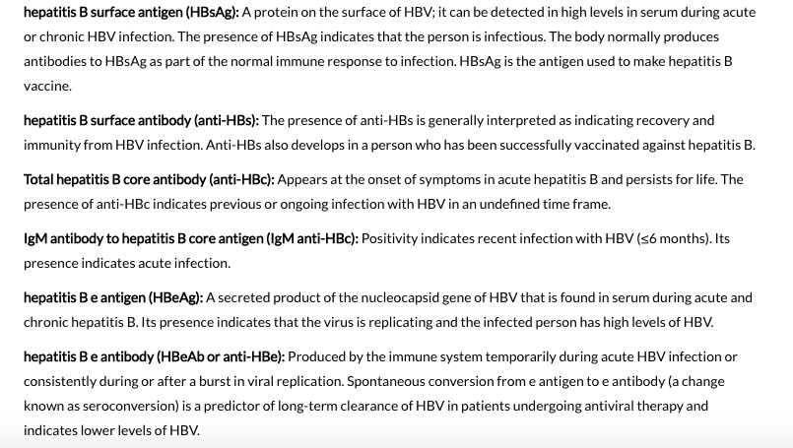

Management

- Acute Infection:
No medication, supportive treatment.
- Chronic Infection:
Antiviral agents such as lamivudine
“slow the progression of cirrhosis, reduce incidence of liver cancer and improve long term survival”
  - Interferon

Prevention
- Hepatitis B Vaccine:
Subunit vaccine composed of HBsAg.
3 doses “0,1,6 months “

Complications
- Cirrhosis
- Liver failure
- Hepatocellular carcinoma (HCC)
- Glomerulonephritis
- Polyarteritis nodosa

Hepatitis C

- The hepatitis C virus is a bloodborne virus
- The incubation period is 2 weeks to 6 months.
- Modes of Transmission:
Mainly Blood Transfusion + IV Drug Abuse
Less common Sexual Transmission and prinatal
- Symptoms and signs:
Fever, fatigue, decreased appetite, nausea, vomiting, abdominal pain, dark urine, joint pain and jaundice.
- Diagnosis:
Anti-HCV Antibodies
If the test is positive for anti-HCV antibodies, a nucleic acid test for HCV-RNA is needed to confirm chronic infection
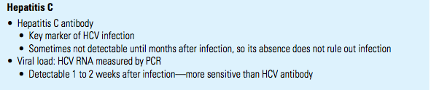

- Treatment:
Interferon (IFN)
Liver transplantation in advanced disease
- No Vaccine
- Complications:
Cirrhosis
Liver Failure
Liver Cancer

Human immunodeficiency virus (HIV)
Etiology:
  - Retrovirus, either HIV-1 or HIV-2.
  - Worldwide, the predominant virus is HIV-1, So when we generally say HIV, we are referring to HIV-1. The relatively uncommon HIV-2 type is concentrated in West Africa and is rarely found elsewhere.
  - HIV-1 and HIV-2 have many similarities including their intracellular replication pathways, transmission modes and clinical effects leading to acquired immune deficiency syndrome (AIDS). However, HIV-2 is less likely to progress into AIDS because of its lower transmissibility. Thus, individuals infected by HIV-2 mostly remain non-progressors for a long period of time, while patients infected by HIV-1 progress faster and contract AIDS.

Modes of Transmission:
  - Sexual intercourse (Vaginal or Anal)
  - Mother-to-child (transplacental, perinatal, breastfeeding).
  - Contaminated blood, blood products and organ transplantation.
  - Contaminated needles

Risk factors and stages of HIV infection:
- STIs (due to open sores).
- Unprotected sexual intercourse.
- Multiple sexual partners.
- Uncircumcised males.
- 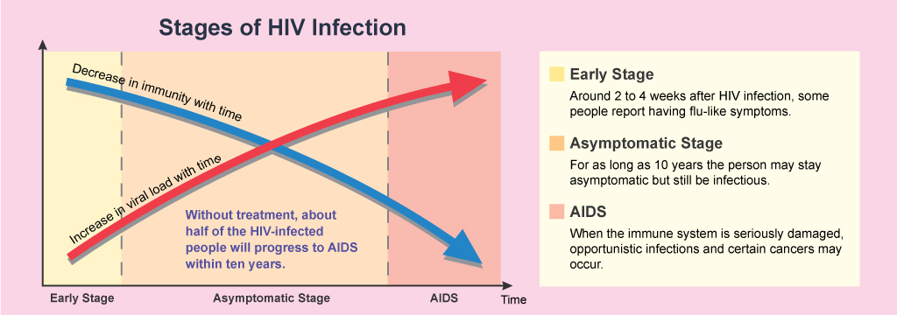

Diagnosis of HIV
ELISA
- Screening
- initial test to detect infection with HIV (Antibodies).
- If antibodies to HIV are present (positive), if not (negative) the test is usually repeated to confirm the diagnosis.
Western blot
- Confirmatory test
- It is done to confirm the results of two positive ELISA tests.
PCR
- This test may be done in the days or weeks after exposure to the virus, before development of the antibodies.
- This test is done to confirm the presence of virus RNA and viral Load.

Treatment of HIV

Antiviral Therapy
Triple therapy HAART:
- Nucleoside reverse transcriptase inhibitors
- Zidovudine, Nevirapine.
- Protease inhibitor
- Saquinavir, Indiniavir.

Prevention
- Use a new condom every time you have sex.
- Tell your sexual partners if you have HIV.
- if you're pregnant, get medical care right away.
- Consider male circumcision.

Complications
- Tuberculosis (TB).
- Cytomegalovirus.
- Candidiasis.
- Toxoplasmosis.
- Kaposi's sarcoma.
- Lymphomas.

