434 Orthopedics Team
Common Shoulder Disorders
___
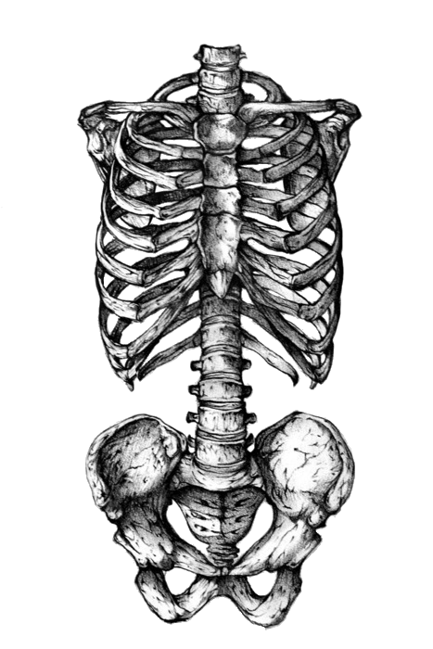

Objectives
•Basic shoulder anatomy
•Impingement syndrome
•Rotator cuff pathology
•Adhesive capsulitis
•Acromioclavicular pathology
•Recurrent shoulder dislocations

Shoulder Anatomy
The greatest range of motion body.
Bony Anatomy :
•Humerus
•Scapula : Glenoid, Acromion, Coracoid, Scapular body.
•Clavicle
•Sternum
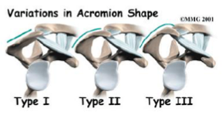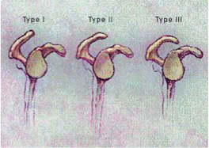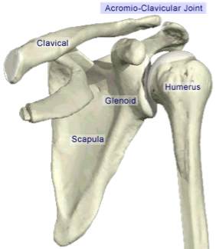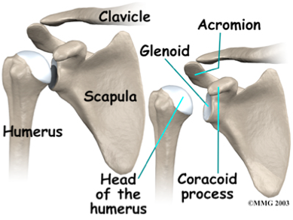
Acromion (has 3 types)
Type I : flat
Type II: curved
Type III: hooked
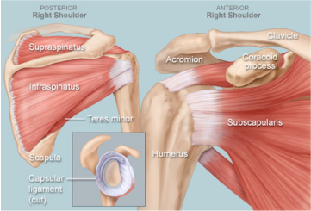

Joints
•Glenohumeral joint: the main joint,Acromioclavicular (AC) joint, Sternoclavicular (SC) Joint, Scapulothoracic joint.
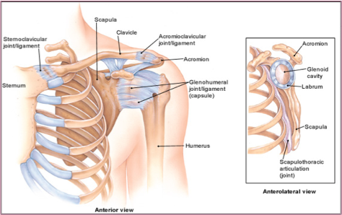
Glenohumeral Joint:
•Most common dislocated joint, Lacks bony stability (it can be easily dislocated unlike the femur)
Composed of:1- Fibrous capsule. 2- Ligaments(it gives the stability not true ligaments it’s actually thickening of the capsule attached to the labrum , in case of dislocation labrum will be pulledينقشع by the ligament we call it Bankart lesion, managed by periosteal elevator u return the labrum to it’s site ). 3-Surrounding muscles. 4- Glenoid labrum (gives depth).

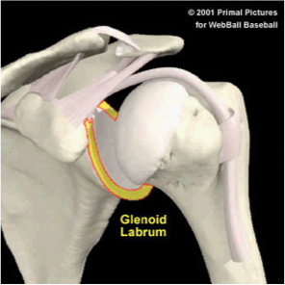
Rotator Cuff Muscles
Depress humeral head against glenoid
Supraspinatus-insertion at Greater tuberosity (GT)-:
  - Initiate Abduction so in pt with supraspinatus injury can’t initiate abduction
Infraspinatus -insertion at GT from behind-:
  - External rotation
Teres Minor-insertion at GT from behind-:
  - External rotation
Subscapularis-insertion at lesser tuberosity -: Internal Rotation
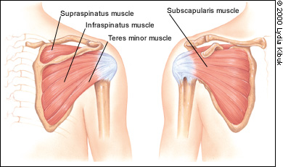
Deltoid:
largest, strongest muscle of the shoulder
Biceps (attached to the labrum so it causes shoulder problem as well )
Pectoralis major

Muscles

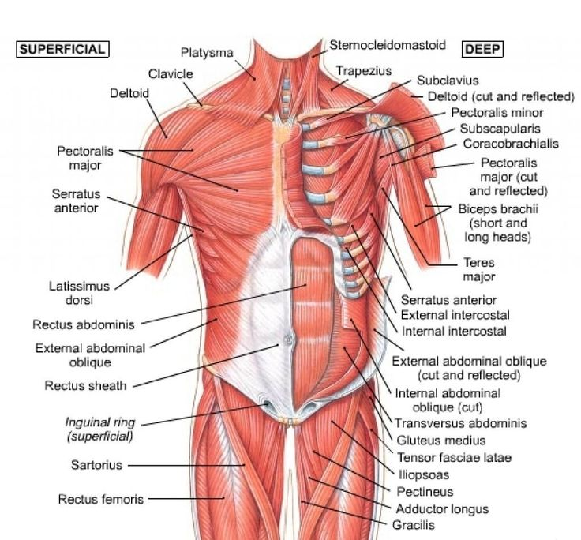
Other Musculature
Posterior scapular muscles
Trapezius (big ms incase of scapular Dyskinesia It push the scapula in weird position)
Rhomboids (if Rhomboids or Trapezius isn’t working it causes winging of the scapula )
levator scapulae
latissimus dorsi
serratus anterior

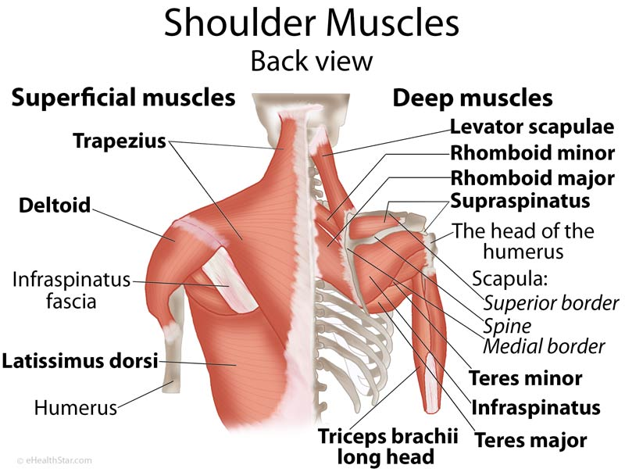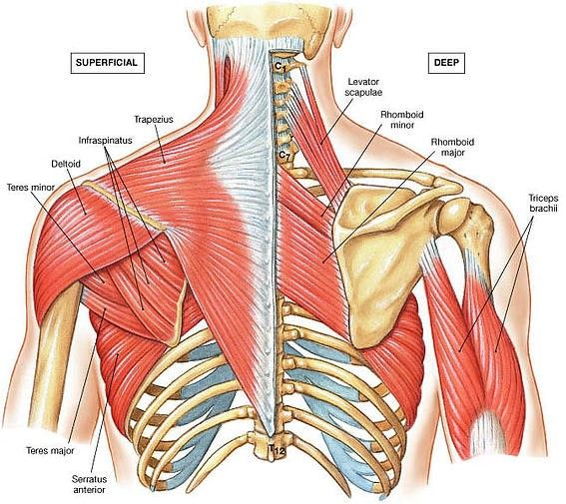
Impingement Syndrome
Risk factors”Important”:
- Age: over 40 years ((middle and older age; 40-85y))
- Overhead activities e.g. lifting, swimming, tennis، ربط النقاب كثير او تسريح الشعر).
- Bursitis and supraspinatus tendinitis
- Acromial shape: type II & III acromion
- AC arthritis or AC joint osteophytes may result in impingement and mechanical irritation to the rotator cuff tendons
- Posterior shoulder capsule stiffness
- Rotator cuff weakness.
SAQ: 40 Y.O baseball player or house wife cooks a lot with pain

Symptoms:
  - Pain
    - acromial area especially with FF and IR
    - Aggrevated by lying on affected side
    - More at night
    - Due to
      - Bursitis
      - RTC(rotator cuff) tendinitis
  - Affected overhead activities تقولك مقدر اربط نقابي ولا اقدر اصلح شعري
  - ↓ abduction
  - Weakness

- supraspinatus and bursa pinched as they pass between greater tuberosity and lateral acromion.
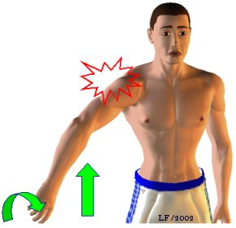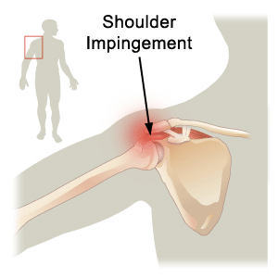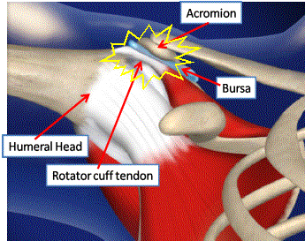
Subacromial bursa:

- Between the acromion and the rotator cuff tendons.
- Protects rotator cuff tendons from grinding against acromion
- Pathology irritation thickening subacromial space narrowing further impingement انحشار
- When we do abduction the GT will go up .The Rotator cuff & mainly supraspinatous tendon is between the GT & the Acromion , if there is no enough space between them impingement will occur. Narrow space is caused by : curved or hooked clavicle or damaged acromion or proximally displaced humerus or injury to supraspinatous that causes it’s swelling which cause narrowing of the space.
                               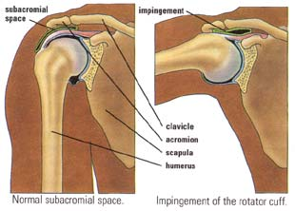

Differential Diagnoses:
- Rotator cuff tears (impengent may cause tear as complication , Rotator cuff tear can occur alone)
- Calcific tendinitis
- Biceps tendinitis
- Cervical radiculopathy
- Brachial plexus compression syndrome
- ACJ arthritis
- GHJ (Glenohumeral joint) instability
- GHJ arthritis

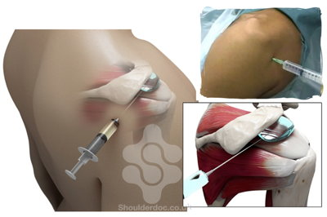
Management:
Conservative treatment(Most of the time): Always start with it
  - Activity modification (u have to say it in the exam), Avoid painful activities especially overhead activities
  - Physiotherapy: ( Stretching and range of motion exercises, Strengthening exercises)
  - NSAIDs (to control the inflammation), Subacromial space steroid injection
Operative:
  - Indicated when conservative measures fail
  - goal improve subacromial space
    - Acromioplasty اقص شوي منها ومن ال GT
    - Subacromial decompression partial bursectomy (remove the bursa)
  - Indication no improvement after 6/12 (6 months it’ll come in the exam) of conservative treatment
  - Success rate 70-90%
  - MCQ : 50 Y.O with sings & symptoms of impingement Treated for 3 months with no signs of improvement what is your next step? Continue physiotherapy
  - If not treated it’ll cause Rotator cuff tear

The Space is Narrowed

Physical Examination:
- RTC muscles atrophy (it’s very important to expose the patient , to see how bad the situation is)
- ↓ ROM IR and ABD (Internal rotation & abduction )
- Weakness

Impingement tests
- Neer’s impingement test(always in the exam):
passive(u move the patient) elevation of the internally rotated arm in the sagittal plane (shoulder forward flexion).
- Hawkins’ impingement test:
with the elbow flexed to 90 degrees, the shoulder passively flexed to 90 degrees and internally rotated.
(forward flexion 30 degees of abduction , then bend the elbow then do internal rotation )
Those 2 test impeng the structures between the humerus & greater tuberosity , +ve test is pain with motion

Neer’s test Hawkin’s test
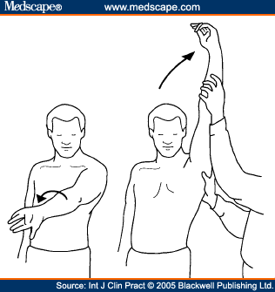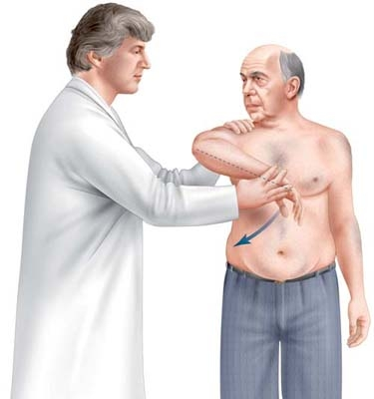

Radiological findings:
- Plain X-rays:
Acromial spurs, AC joint osteophytes , Subacromial sclerosis ,Greater tuberosity cyst (in very bad situation).
- MRI:
confirm dx, Assess RTC integrity tear, More sensitive it shows inflammation of tendon if there is rupture ,tear or partial tear.
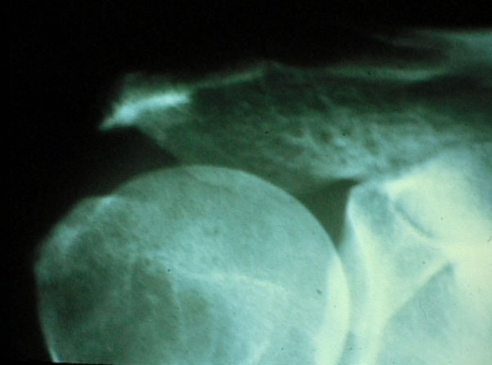
Supraspinatous outlet view
(this view shows the shape of the acromion)
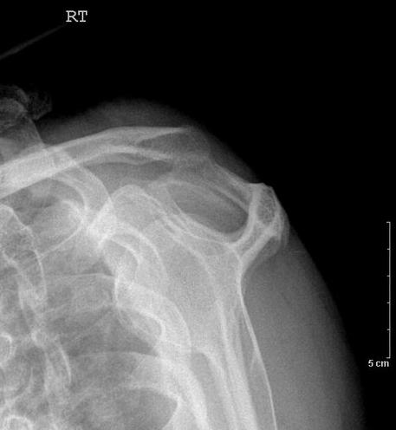

Function of rotator cuff muscles:
- Keep the humeral head centered on the glenoid regardless of the arm’s position in space.
- Generally work to depress the humeral head while powerful deltoid contracts

Causes of rotator cuff tears:
- Intrinsic factors:
  - Vascular
  - Degenerative (age-related as decrease water content or repetitive injuries )
- Extrinsic factors:
  - Impingement
    - Acromial spurs
    - AC joint osteophytes
  - Repetitive use
- Traumatic (e.g. a fall or trying to catch or lift a heavy object –usually young age-)
Focus in the exam traumatic treatment is different from others It’s mostly treated by surgery, while degenerative we can start with non – operative

Diagnosis:
- History (pain & loss of function they can’t do abduction , internal or external rotation )
- Physical examination
- X-rays
- MRI

Wide spectrum:
- Partial
- Complete
  - Small
  - Large
  - Massive (irreparable)

Treatment:
- Degenerative type: (always start with non-operative)
  - Rest
  - Physio
  - NSAIDs
  - Steroid injection
  - If no improvement of 6 months, surgical repair (open or arthroscopic) is indicated
  - Traumatic type: (acute surgical repair)

  - If not treated chronic pain and loss of motion and with time becomes irreparable rotator cuff arthropathy –arthritis-
  - Complications of surgery: not improving, stiffness

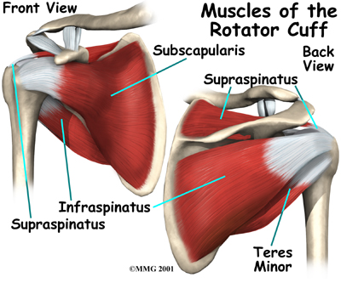
Rotator cuff
- Also called “frozen shoulder”
- It is characterized by pain and restriction of all movements of the shoulder (global stiffness)
- Usually self limiting (typically begins gradually, worsens over time and then resolves but may take >2 years to resolve, they’ll have limitation of movement)
- 10 % is bilateral
Think of it if u have pt with severe pain & limited ROM & doesn't want u to touch him ,
“if u have weird case in the exam think of adhesive capsulitis” .

Risk factors:
  - DM (esp. insulin dependent) – in pt with frozen shoulderاول شي تسئلين عنه-
  - Hypo and Hyperthyroidism
  - Following injury or surgery to the shoulder
  - High cholestrol

Diagnosis:
  - Mainly clinical
  - X-rays and MRI to rule out other pathologies

Stages:
  - Pain (freezing stage, there is range of motion but due to pain they can’t move)
  - Stiffness (frozen stage-the pain improve but they can’t move -)
  - Resolution (thawing stage –gradual improvement-)

Treatment:
- Resolves if untreated over 2-4 years
- Physiotherapy -should be aggressive unless if there is severe pain-
- Pain killers and anti-inflammatory medications
- Steroid injections
- Manipulation under anesthesia
- Arthroscopic capsular release

Adhesive Capsulitis
Dr said I don’t think it’s that important , it’s Not common
- The AC joint is different from joints like the knee or ankle, because it doesn't need to move very much. The AC joint only needs to be flexible enough for the shoulder to move freely. The AC joint just shifts a bit as the shoulder moves.
- The joint is stabilized by three ligaments :
- Superior acromioclavicular & coracoclavicular & coraco acromial Ligament gives stability.

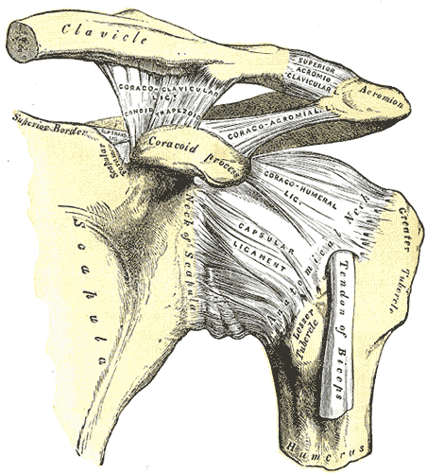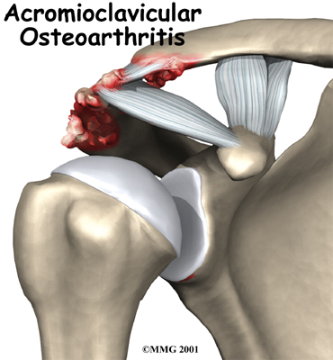
Causes of AC Arthritis:
- Mostly Degenerative osteoarthritis.(wear and tear in old aged people)
- Rheumatoid Arthritis.
- Gouty Arthritis-less likely-.
- Septic Arthritis-less likely-.
- Atraumatic distal claivcle osteolysis in weight lifters الي يلعبون حديد.( result of repeated movements that wear away the cartilage surface found at the acromioclavicular joint)
- Post-traumatic osteolysis of lateral end of clavicle.(like dislocation or a fracture)

AC Arthritis:
- Arthritis is a condition characterized by loss of cartilage in the joint, which is essentially wear and tear of the smooth cartilage which allows the bones to move smoothly.
- Motions which aggrevate arthritis at the AC joint include reaching across the body toward the other arm.

Signs and Symptoms:
Pain , which worsens with movement and progressively worsens & tenderness over the AC joint.( the patient may suffer a night pain which is a sign of arthritis)
It is commonly associated with impingement syndrome

Diagnosis:
Clinical and by x-rays
If someone isn’t clear impingement or rotator cuff or dislocation,: touch the AC joint if it cause tenderness it’s very diagnostic.

Treatment:
Non-surgical Treatment
- Rest , avoid weightlifting and push-ups (if pt want’s to resume his activity do surgery –lateral clavicular excision -)
- Pain medications and NSAID to reduce pain and inflammation
Surgical Treatment:
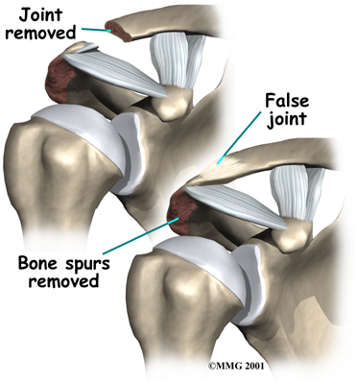

Acromioclavicular Pathology
Dislocation of the Shoulder
2nd most important part of the lecture

- Mostly Anterior > 95 % of dislocations
- Posterior Dislocation occurs < 5 %
- True Inferior dislocation (luxatio erecta) occurs < 1%
Habitual Non traumatic dislocation may present as Multi directional dislocation due to generalized ligamentous laxity and is Painless
Mechanism of anterior shoulder dislocation:
- Usually Indirect fall on Abducted and extended shoulder (common)
- May be direct when there is a blow on the shoulder from behind

Anterior Shoulder dislocation:
- Usually also inferior (i.e Anterior &inferior ).
- Bankart’s Lesion (With dislocation labrum will be pulledينقشع by the ligament).
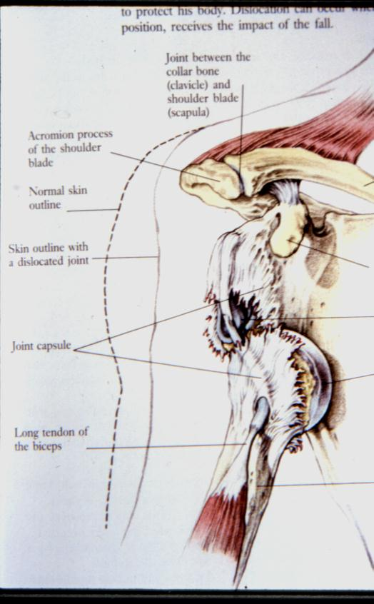
Clinical Picture:
- Patient is in pain -severe-
- Holds the injured limb with other hand close to the trunk
- The shoulder is abducted and the elbow is kept flexed
- There is loss of the normal contour of the shoulder
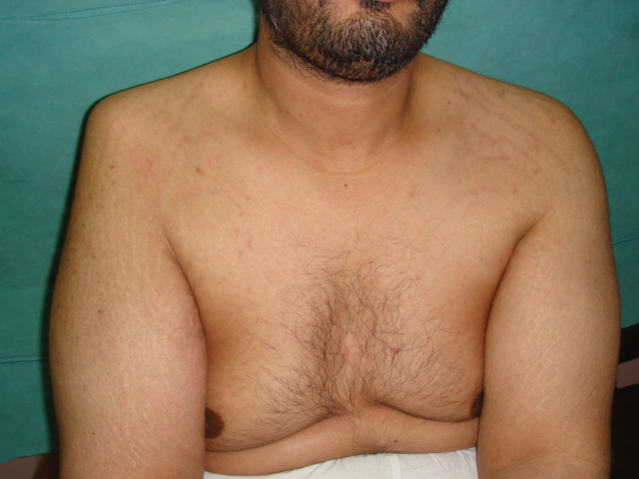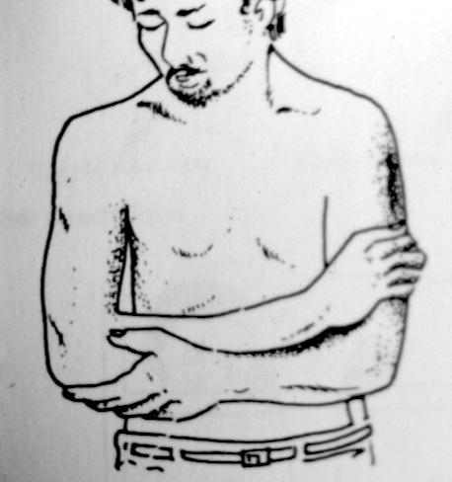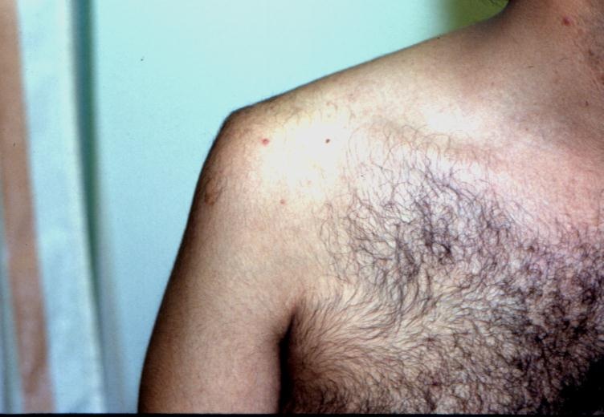
- Loss of the contour of the shoulder may appear as a step (loss of contour of deltoid)
- Anterior bulge of head of humerus may be visible or palpable
- A gap can be palpated above the dislocated head of the humerus

X-ray anterior shoulder dislocation
Lateral veiw is better , axillary is احسن منهم but can’t be done in acute phase , احسن منهم كلهم الCT
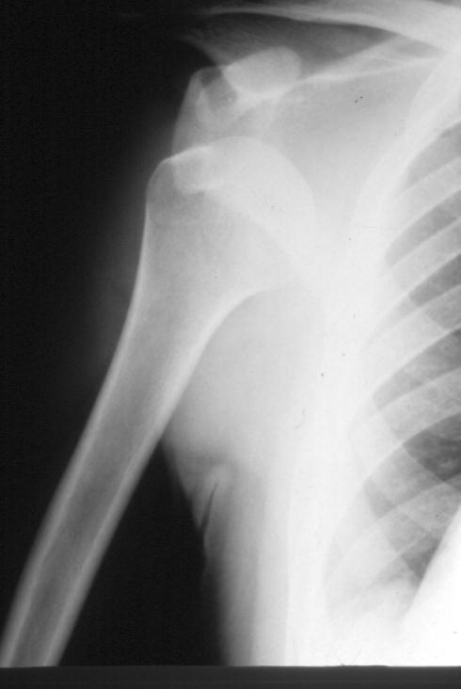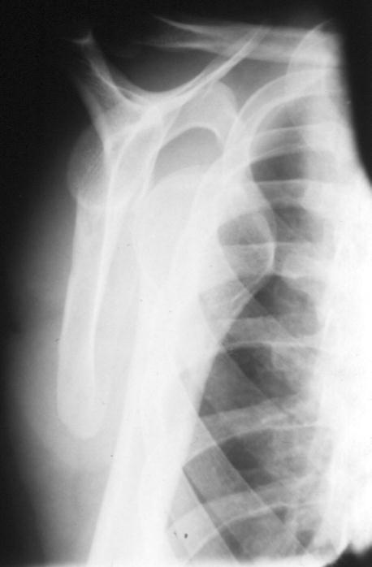

Associated injuries of anterior Shoulder Dislocation
- Injury to the neuro vascular bundle in axilla
- Injury of the Axillary Nerve ( Usually stretching leading to temporary neuropraxia1 –usually in young Nerve injury , but in elderly rotator cuff injury- )
1-you have to document it medicollegaly
- Associated fracture

Complications of anterior Shoulder Dislocation :
Early
- Neuro vascular injury ( rare )
- Axillary nerve injury
- Associated Fracture of neck of humerus or greater or lesser tuberosities
Late
- Avascular necrosis of the head of the Humerus (high risk with delayed reduction)
- Recurrent shoulder dislocations (the younger the patient the higher the risk ie. 20 y.O will have 90% risk of recurrence )

Put the pt in prone position & put weight & reassess after 30 min u will find it relocated by it self or minimal manipulation

1st traction 2nd external rotation 3rd adduction 4th internal rotation
It needs a lot of painkillers & sedation
The more Muscular the patient the more difficult reduction .

Hippocrates Method Stimpson’s technique Kocher’s Technique
Dislocation & GT fracture

Axillary Nerve Injury:
- It is a branch from posterior cord of Brachial plexus
- It hooks close round neck of humerus from posterior to anterior
- It pierces the deep surface of deltoid and supply it (motor)and the part of skin over it
It has motor & sensory function at the time of dislocation You can’t assess b.c the pain , but u can assess the sensory at the beginning but sometimes it’s trick b.c the pt have intact sensory but the motor is affected (specific for the Axillary N.)
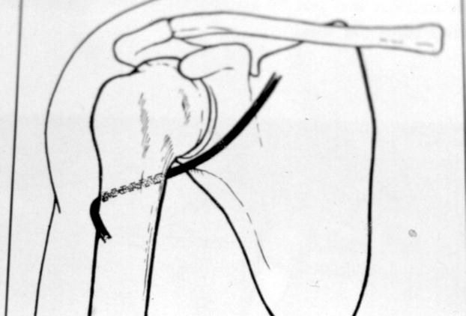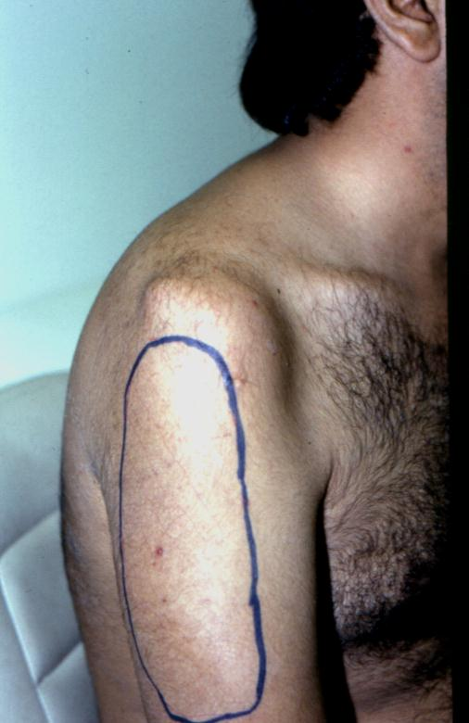
Management of Anterior Shoulder Dislocation:
- Is an Emergency
- It should be reduced in less than 24 hours or there may be Avascular Necrosis of head of humerus
- Following reduction the shoulder should be immobilised strapped to the trunk for 3-4 weeks and rested in a collar and cuff
Methods of Reduction of anterior shoulder Dislocation:
- Hippocrates Method ( A form of anesthesia or pain abolishing is required ) –not used anymore-
- Stimpson’s technique ( some sedation and analgesia are used but No anesthesia is required )
- Kocher’s technique is the method used in hospitals under general anesthesia and muscle relaxation –the best by Dr.hisham-

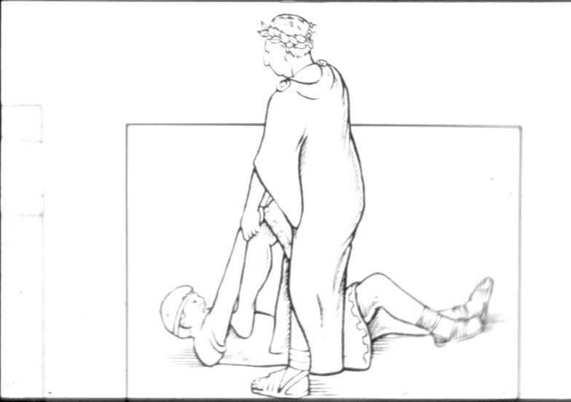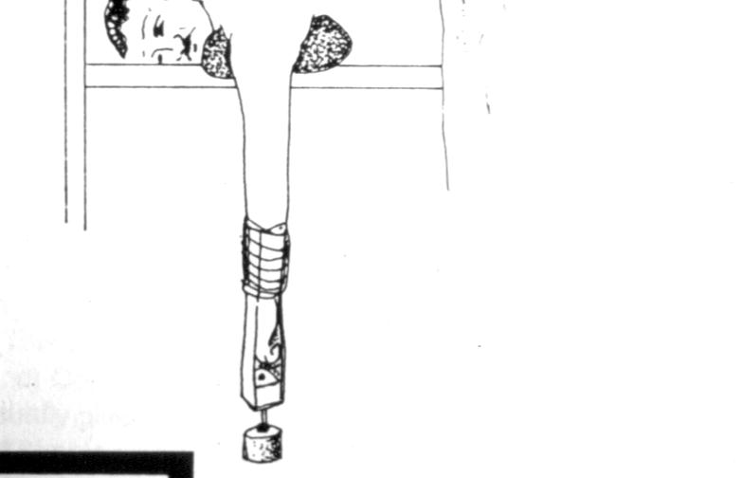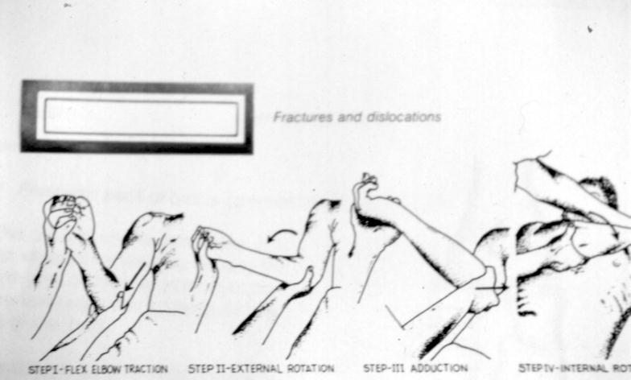
Done by: Lenah AlAseem

