Hyperthyroidism

Definition:
Symptoms:
Hyperactivity, irritability, Heat intolerance, sweating, Palpitations, Fatigue, weakness, Weight loss with increase of appetite, Diarrhoea, Polyuria, Oligomenorrhoea, loss of libido.
Hyperthyroidism is the condition that occurs due to excessive production of thyroid hormone (free T3 and T4) by the thyroid gland. Thyrotoxicosis is the condition that occurs due to excessive thyroid hormone of any cause and therefore includes hyperthyroidism. Some, however, use the terms interchangeably.

Causes:
Prevalence of hyperthyroidism is approximately 1.2%.
Signs:
Tachycardia, Tremor, Goiter, Warm moist skin,Gynecomastia

- Primary
- Diffuse hyperplasia of the thyroid associated with Graves disease (GD) “accounts for 85% of cases”
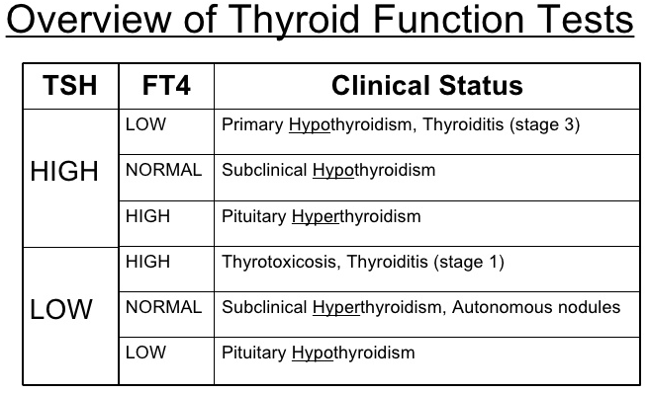
- Toxic multinodular goiter (TMNG)
- Hyperfunctional adenoma of the thyroid
- Secondary:
- TSH-secreting pituitary adenoma (rare)

Investigation:
1- TSH, free T4
2- A radioactive iodine uptake (RAIU) is indicated when the diagnosis is in question (except during pregnancy) and distinguishes causes of thyrotoxicosis having elevated or normal uptake over the thyroid gland from those with near absent uptake.
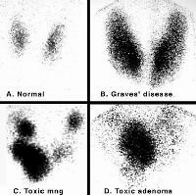
- The pattern of RAIU in GD is diffuse unless there are coexistent nodules or fibrosis.
- The pattern of uptake in a patient with a single toxic adenoma generally shows focal uptake in the adenoma with suppressed uptake in the surrounding and contralateral thyroid tissue.
- TMNG multi focal uptake
- Acute thyroiditis has near absent uptake.

Management
- Graves’ hyperthyroidism using radioactive iodine, antithyroid drugs (propylthiouracil, carbimazol), or surgery.
- toxic multinodular goiter or toxic adenoma using radioactive iodine or surgery.
- Graves’ disease in children, adolescents, or pregnant patients; treat underlying cause.
Hyporthyroidism

Definition:
Symptoms:
Tiredness and weakness, Dry skin, Feeling cold, Hair loss
Difficulty in concentrating and poor memory, Constipation, Weight gain with poor appetite, Hoarse voice, Menorrhagia

Hyporthyroidism is the condition that occurs due to low production of thyroid hormone (free T3 and T4) by the thyroid gland.

Causes:
Prevalence of hyperthyroidism is approximately 1.2%.
- Autoimmune hypothyroidism (Hashimoto’s, atrophic thyroiditis)
Signs:
Puffy face, Delayed tendon reflex relaxation, Bradycardia, Diffuse alopecia

- Iatrogenic (I₁₂₃treatment, thyroidectomy, external irradiation of the neck)
- Drugs: iodine excess, lithium, antithyroid drugs, etc
- Iodine deficiency

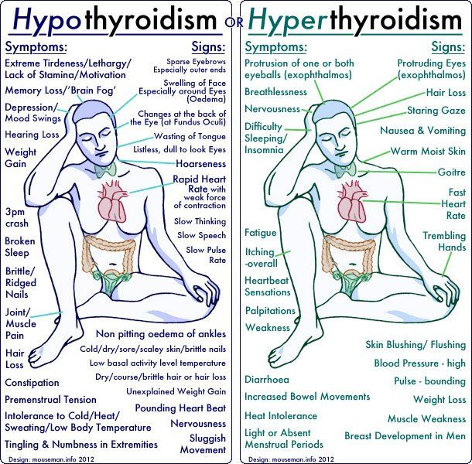
Investigation:

TSH, free T4 

Ultrasound of thyroid – little value

Thyroid scintigraphy – little value

Antithyroid antibodies – anti-TPO

S-CK, s-Chol, s-Trigliseride 

Normochromic or macrocytic anemia

Management
Levothyroxine
Thyroiditis:
Acute: Rare and due to suppurative infection of the thyroid
Subacute: also termed de Quervains thyroiditis/ granulomatous thyroiditis – mostly viral origin
Chronic thyroiditis: mostly autoimmune (Hashimoto’s)

Major complication:
Myxedema coma is defined as severe hypothyroidism leading to decreased mental status, hypothermia, and other symptoms related to slowing of function in multiple organs. It is a medical emergency with a high mortality rate.
Rheumatic Arthritis

Definition:
It is a chronic inflammatory autoimmune disease involving the synovium of the Joint. The inflame synovium can cause damage to the cartilage and bone, it's not only confined to the joint, and the disease severity is variable from moderate to wheelchair.

Prevalence:
3% of the worldwide, with females more than male 3:1, onset 20-40., peak age 25-50.

Etiology:
Is uncertain, it may be caused by an infection or a series of infections (most likely viral), but genetic predisposition is necessary, other factors include: environmental, Infection, autoimmune disorder

Clinical Feature:
Inflammatory polyarthritis, tender, Warm, swollen & symmetrical joints.
- Can involve any joint except distal intra phalangeal joint (DIP)
- pain in the motion of the joint.
- common joint involvement: Hands (PIP, MCP), wrist, elbow, knees, shoulder, back, hip.
- deformities: swan neck, ulnar deviation and boutonnier.
Constitutional symptoms: - Morning stiffness - Low grade fever - Weight loss - Fatigue
These can be either clinical feature or complication:
- Cervical spine involvement C1-C2 (subluxation, instability)
- Cardiac involvement: Pericarditis, Pericardial effusion, valvar
- Pulmonary involvement: Fibrosis or effusion
- Ocular involvement: episcleritis
- Soft tissue swelling.

Investigation & Diagnosis:
1-Labs : RF (not specific), anticitrullated peptide (sensitive and specific), ESR,CRP –Normocytic anemia
2-Radiograph: Loss of bone mass, Bony erosion, Narrowing the joint space.
3-Synovial fluid analysis.
RF is+ve or anricitrullaited peptide. | Symmetric joint swelling for 6 W | Swelling of 3 joints for 6 W | Swelling of wrist MCP, PIP for 6 W | Morning stiffness >1 hour for 6 weeks (W)
Criteria: need 4 of the following

Management:
- NSAID: Aspirin is the best (FIRST LINE)
- Glucocorticosteroids; usually for short course to control the symptoms only.
- Disease modifying agent: DMARDS,
- Antimalaria , gold, sulfalazine, methatoxerate , TNF inhibitors
- Surgery if need it
Benign Prostatic Hyperplasia

Definition
Periurethral hyperplasia of stroma and epithelium in prostatic transition zone.

Pathogenesis:
etiology unknown
DHT required (converted from testosterone by 5-α reductase)
prostatic smooth muscle cells play a role in addition to hyperplasia
“same as androgenic alopecia, increases dihydrotestrone from 5-a reductase cause hyperplasia for the prostate”

Clinical Features
Retention
overflow incontinence
hydronephrosis “late complication”
renal insufficiency “late complication”
infection
gross hematuria
It can have irritated or obstructive symptoms

Investigation:
- urinalysis to exclude UTI and for microscopic hematuria (common sign)
- renal U/S to assess for hydro nephrosis = to rule out other causes
- PSA >10 ng/mL: high likelihood of prostate pathology
- Digital rectal examination
- Examination biopsy,suspicious for malignancy, i.e. elevated PSA or abnormal DRE

Management
5-α reductase inhibitor (e.g. finasteride), α-receptor antagonists (e.g. terazosin)

Gastro-esophageal Reflux Disease

General characteristics:
GERD is a multifactorial problem, inappropriate relaxation of the Lower Esophageal Sphincter (decreased LES tone) is the primary mechanism, leading to retrograde flow of stomach contents into the esophagus, other factors that may contribute:
- Decreased esophageal motility
- Gastric outlet obstruction
- Hiatal hernia (common finding in patients with GERD).
- Dietary factors have modest effect on LES pressure (coffee, tobacco, chocolate,...)

Other risk factors:
- Obesity, Pregnancy, Diabetes mellitus, Smoking, Asthma.

Clinical features:
- Heartburn which is exacerbated by eating and lying down (worse at night).
- Regurgitation.
- Dyspepsia.
- Chronic cough, sore throat, feeling a lump in the throat.
- Postprandial nausea/vomiting and early satiety.
- Dysphagia think of peptic stricture, cancer, motility disorder.

Investigations and Diagnosis:
- Ambulatory esophageal reflux monitoring (24h) is most sensitive and specific (gold standard)
- Endoscopy with biopsy for patients with alarming symptoms (dysphagia , odynophagia , GI bleeding) or those at high risk of complications.
- Barium contrast study to identifying complications, not to diagnosing.
- Manometer if we suspect a motility disorder.

Complications:
- Erosive esophagitis, Peptic stricture, esophageal ulcer, Barret’s esophagus.

Management:
- Lifestyle modification (weight loss , head of bed elevation , avoid meals 2-3 hours before sleep) with antacids
- If symptoms persist, an 8-week course of PPIs is the therapy of choice for symptom relief and healing of erosive esophagitis.
- Traditional delayed release PPIs should be administered 30–60 min before meal for maximal pH control
- H2-receptor antagonist (H2RA) therapy can be used for mild and intermittent symptoms.
- Indications for surgery :
- Failure of medical treatment
- Severe esophageal injury (Barret esophagus , stricture , hemorrhage , ulcer)
- Respiratory complications due to reflux and aspiration
- Surgery options :
- Nissen fundoplication when esophageal motility is intact
- Partial fundoplication when esophageal motility is poor.

Done by: Abdullah Alomari, Abdulaziz alhammad, Nawaf Alfawzan, Ahmed alzhrani.

Ab’s directed against TSH receptor with intrinsic activity, characterized by lid retraction, complication include Pretibial mixoedema, diagnosed by low TSH, high free T4 

