Women Health

Definition of women health: "a state of complete physical, mental and social well-being and not merely the absence of disease or infirmity”

Women health Team:
- Obstetrician/gynecologist
- General surgeons specializing in breast care
- Perinatologist
- Primary care doctor

Causes of mortality in women:
Young age: communicable diseases such as self-inflicted injury and HIV, and respiratory diseases, malaria, and maternal and perinatal conditions

Older age: non-communicable chronic diseases such as heart disease, stroke and cancers (except developing countries communicable diseases is still the highest)

Screening:
Tobacco: Fagerstorm test (when you wake up when you take your first cigarettes, how many per day... etc.
Alcohol: examination: alcohol odor, slurred speech Investigation: GGT, MCV, LFT.

Role aspirin in cardiovascular diseases

Primary prevention:
Only for Women who have CVD Risk; old age, Hypertension, DM ... etc.
Make sure the patient doesn’t have hemorrhagic stroke and gastrointestinal (GI) bleeding.
Common Risk factor CVD with men | Unique risk factor CVD to women’s
Age Family and history. |  | Early menarche appears to be associated with future CVD risk
Dyslipidemia |  | Postmenopausal state as a risk factor for CVD
Hypertension. |  | Oral contraceptives
Diabetes mellitus. |  | Hysterectomy.

Secondary prevention: is well established and beneficial for CVD.

Unique presentations of CVD in women:
- Atypical angina
- stress-induced cardiomyopathy
- Heart failure preserved ejection fraction
- spontaneous coronary artery dissection

Screening for dyslipidemia: (total cholesterol and HDL)

Women above 45: if result came high take full panel
Women above 20: only if family history of multiple cardiovascular risk including premature CVD.

(1)

Screening for DM:
All adults beginning at 45 years of age.
Or any adult with risk factor; Physical inactivity, 1st degree relative with DMT2, Hypertension, Polycystic ovarian syndrome. etc.

Screening for Hypertension:
Age 40: annually

preconception counseling:
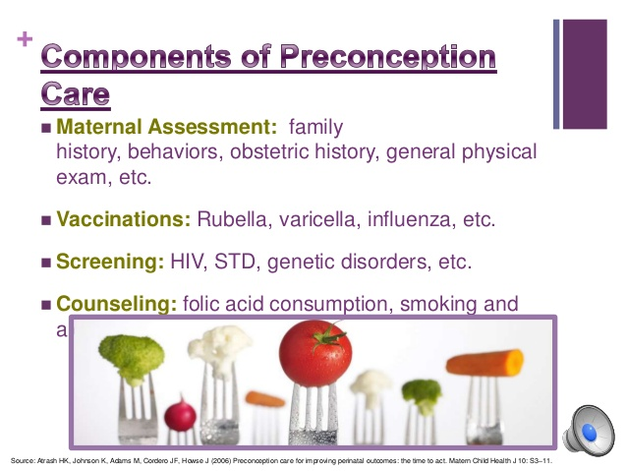

Screening for chlamydia and gonorrhea
- Sexually active women under 25 years of age
- Sexually active women aged 25 years and older if at increased risk
- Retest approximately 3 months after treatment
- Pregnant women with chlamydial infection should have a test-of-cure 3-4 weeks after treatment and be retested within 3 months
Method: Virginal swap, collecting urine

Screening for Cervical cancer:
- -Women 21-29 years of age every 3 years with cytology
- -Women 30-65 years of age every 3 years with cytology, or every 5 years with a combination of cytology and HPV testing
- Early detection: Pap test.
- Tests to confirm: cervical biopsy

Screening for Breast cancer:
Recommendation:
- -Women ages 40 to 44 should have the choice to start annual breast cancer screening with mammograms if they wish to do so.
- Women age 45 to 54 should get mammograms every year.
- -Women 55 and older should switch to mammograms every 2 years, or can continue yearly screening.
We don’t do Mammograms before 40 instead we do ultrasound and physical examination

(2)

Screening for colon cancer:
Recommendation:
  - We start screening over the age of 40
- Patients with average risk + no family history the colonoscopy will be every 10 years, High risk patients the colonoscopy will be every 5 years.
- high-sensitivity fecal occult blood testing annually. blood occult test:
every 2 years to the patients aged 60-74 years.
- flexible sigmoidoscopy every five years with high-sensitivity fecal occult blood testing every three years.

Screening for osteoporosis:
Recommendation:
- -All women above 65-year-old
- - Women younger than 65-year-old with one or more risk factor of osteoporosis
- - Postmenopausal women with fracture
Screening methods:
- (DEXA) dual-energy X-ray absorptiometry every two years for recommendation patients.

Vaccination for Women:
Avoid MMR during pregnancy
T dap is recommended between 27-36 in gestation
The type of vaccine in pregnant women is: inactivated

Menopause:
as the time when there have been no menstrual periods for 12 consecutive months and no other biological(pregnancy) or physiological (hyperthyroidism) cause can be identified and age above 40.

Symptoms: (hair loss, itchy skin, hot flushes, night sweet, breast pain, loss of libido, vaginal dryness, osteprosis, frequint urination).

- FSH Level : more than 35

Management:
- 1- Lifestyle Changes including diet and exercise
- 2- HRT as solution
- 3- Gabapentin decrease flushes by 45%
- 4-Atropine for sexual dysfunction

Thank you and wish you all the best

Done by Abdullah Nasser Al-Omair,

(3)

