Common Psychiatric Problems

Objectives:

- To understand the prevalence of anxiety, depression, and somatic symptom disorder in Saudi Arabia.
- To understand the etiology of anxiety, depression and somatic symptom disorder.
- To understand the clinical features and management of anxiety in setting a family medicine.
- To understand the clinical features and management of depression in a family medicine setting.
- To understand the clinical features and management of psycho-somatic illness in a family medicine setting.
- To have knowledge of counseling and psychotherapy in the management of common psychiatric problems in family medicine.
- To understand appropriate time to consult a psychiatrist.

Anxiety

According to Professor Al-Sughayir, anxiety is defined as the feeling of apprehension accompanied by autonomic symptoms (such as muscles tension, perspiration, tachycardia), caused by anticipation of danger.

Anxiety disorders include panic disorder, agoraphobia, social phobia, specific phobia, generalized anxiety disorder, separation anxiety disorder, selective mutism, substance medication, anxiety disorder due to another medical condition.

Prevalence:

- In a study done on 822 male patients that attended Primary Health Care Centers, Eastern Saudi Arabia, the overall prevalence of anxiety was 22.3% with 17.0% of the attendees having mild degree of anxiety.

Etiology:

- The first consideration is the possibility that anxiety is due to a known or unrecognized medical condition.

- Substance-induced anxiety disorder (over-the-counter medications, herbal medications, substances of abuse) is a diagnosis that often is missed.

- Genetic factors significantly influence risk for many anxiety disorders.
- Environmental factors such as early childhood trauma can also contribute to risk for later anxiety disorders. The debate whether gene or environment is primary in anxiety disorders has evolved to a better understanding of the important role of the interaction between genes and environment.

- Some individuals appear resilient to stress, while others are vulnerable to stress, which precipitates an anxiety disorder.

Clinical Features and Diagnosis:

PRIMARY ANXIETY-SPECTRUM DISORDERS
DSM-IV Diagnostic Criteria

- Generalized anxiety disorder:
- Chronic excessive nervousness, exaggerated worry, tension, and irritability that appear to have no cause or are more intense than the situation warrants.
- Physical signs — such as restlessness, difficulty in falling or remaining asleep, headaches, trembling, twitching, muscle tension, or sweating — often develop.

- Agoraphobia:
- Fear of any open or public space. The condition can be quite disabling.

- Panic disorder:
- Patients with panic disorder usually describe periods of intense fear or discomfort that they call panic attacks.
- Physical symptoms — which may include chest pain, dizziness, nausea, chills, trembling, and palpitations — are caused by a heart attack.
- The combination of panic symptoms and the phobic avoidance can impair the patient’s professional, social, and familial functioning.

- Specific phobias:
- Phobias are manifested by irrational fears when a person is exposed to or is in close physical contact with specific objects or situations that trigger intense anxiety.

- Social phobia (social anxiety disorder):
- Social phobia is manifested by excessive, persistent fear of social and performance situations that is so severe that it disrupts daily life and relationships.

- Obsessive-compulsive disorder:
- Patients with obsessive-compulsive disorder experience repetitive ideas (obsessions) that are distressing and provoke intense symptoms of anxiety. To counteract the anxiety, patients use certain sets of actions, or rituals, and repetitive behaviors (compulsions).
- Patients with obsessive-compulsive disorder may have only obsessions or only compulsions or both obsessions and compulsions.
- Despite patients’ awareness of the irrational nature of their condition, they feel unable to control their obsessions or to prevent their compulsions.

- Acute stress disorder:
- Patients with acute stress disorder experienced a traumatic event in which they were threatened or seriously injured, or they witnessed a traumatic event in which other persons were seriously injured or died.
- The condition is usually associated with dissociative symptoms, such as numbing, detachment, a reduction in awareness of the surroundings, de-realization, or depersonalization; re- experiencing of the trauma; avoidance of associated stimuli; and significant anxiety, including irritability, poor concentration, difficulty in sleeping, and restlessness.
- The diagnosis of acute stress disorder is made when the symptoms occur within 4 weeks of the traumatic event and are present for a minimum of 2 days and a maximum of 4 weeks.

- Posttraumatic stress disorder:
- This disorder develops after one experiences, witnesses, or confronts a physically and/or psychologically distressing event.
- Symptoms of posttraumatic stress disorder include re-experiencing the traumatic event, a consistent pattern of avoidance of themes associated with the traumatic event, and hyperarousal and autonomic hyperactivities that may be manifested by difficulties with sleep or concentration, exaggerated startle reactions and, at times, anger outbursts. The diagnosis is made if the symptoms have been present for at least 1 month and cause clinically significant distress or impairment in functioning.

Management:

- Pharmacotherapy and
- First-line medications
- Selective-serotonin reuptake inhibitors (SSRIs) e.g. paroxetine
- Serotonin-norepinephrine reuptake inhibitors (SNRIs) e.g. Venlafaxine
- Second-line medications
- Tricyclic antidepressant e.g. Imipramine
- Benzodiazepines e.g. diazepam
- cognitive-behavioral (psychosocial) therapy

Depression

Depressive disorders are characterized by persistent low mood, loss of interest and enjoyment, neurovegetative disturbance, and reduced energy, causing varying levels of social and occupational dysfunction.

Prevalence:

- Females are more prone to have depression compared to males 2:1.
- Depression is more common in younger adults.
- Depression is estimated to affect 350 million people worldwide (WHO 2012).
- In a study done on 822 male patients that attended Primary Health Care Centers, Eastern Saudi Arabia: The overall prevalence of depression was 32.8% with mild depression accounting for 22.9%.

Etiology:

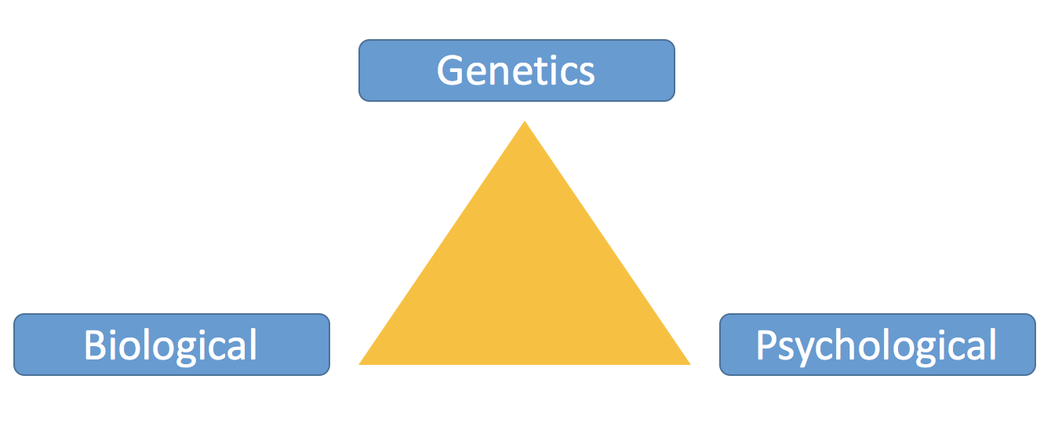

- Multifactorial disorder.
- Previous abuse.
- Certain medications (isotretinoin, interferon-alpha, and corticosteroids).
- Death or loss of loved one.
- Major incidents.
- Social isolation due to other mental illnesses.
- Sometimes depression co-exists with a major illness or may be triggered by another medical condition.
- Substance abuse, nearly 30% of people with substance abuse problems also have major or clinical depression.

Clinical Features and Diagnosis:

Depressive features/symptoms include:
- Depressed mood
- Anhedonia
- Weight changes
- Libido changes
- Sleep disturbance
- Psychomotor problems
- Low energy
- Excessive guilt
- Poor concentration
- Suicidal ideation

DSM-IV-TR Criteria

- Major Depressive Disorder
- Presence of a single or more major depressive episode (each separated by at least 2 months) for at least 2 weeks.
- The major depressive episode is not better accounted for by schizoaffective disorder and is not superimposed on schizophrenia, schizophreniform disorder, delusional disorder, or psychotic disorder not otherwise specified.
- There has never been a manic episode, a mixed episode, or a hypomanic episode.

- Major Depressive Episode
- 1-5 of the mentioned clinical features & at least one of the symptoms is either 1) depressed mood or 2) loss of interest or pleasure.
- 2-The symptoms cause clinically significant distress or impairment in social, occupational, or other important areas of functioning.
- 3-The symptoms are not due to the direct physiological effects of a substance (e.g. a drug of abuse, a medication) or a general medical condition (e.g., hypothyroidism).
- 4-The symptoms are not better accounted for by grief.

- Dysthymia Depressive Disorder
- 1-2 of the mentioned clinical features for at least 2 years.
- 2-During the 2 years there has to be no major depressive episode.
- 3-There has never been a manic episode, a mixed episode, or a hypomanic episode.
- 4-The symptoms are not due to the direct physiological effects of a substance (e.g. a drug of abuse, a medication) or a general medical condition (e.g., hypothyroidism).
- 5-The symptoms are not better accounted for by grief.

Management:

- Pharmacological Therapy:
- Usually 3-5 weeks for desired effect, but unfortunately side effects can start within few days.
- These groups are more beneficial than tricyclic drugs (especially in dysthymic disorder).
- Selective Serotonin Reuptake Inhibitors (SSRI).
- Selective Serotonin–Norepinephrine Reuptake Inhibitors (e.g. Venlafaxine, Duloxetine).
- Monoamine Oxidase Inhibitors (MAOI): Don’t give with SSRI or Tricyclic antidepressants.

- Psychological Therapy
- Supportive Therapy.
- Cognitive & Behavior Therapy.

- Electroconvulsive Therapy (ECT)
- As last resort.
- Safer in pregnant women than antidepressant.

Somatic System Disorder

It is the tendency to experience and communicate mental states and distress as physical symptoms or altered bodily function. It is associated with excessive illness, worry and abnormal illness behavior.

Prevalence:

- A study done in 2008 in Aseer, Saudi Arabia on a sample size of 224. About half of the sample had one or more psychological disorders. The prevalence of Somatic Symptom Disorders was 16%.

- A study done on Patients attending the Primary Health Care Clinics in 2002 in Saudi Arabia. Out of a sample size of 431, the prevalence of somatic symptom disorder was 19.1%.

Etiology:

- Somatic symptom disorder can be conscious or unconscious and may be influenced by a desire for the sick role or for personal gain.
- Women > men with a ratio of 5 – 10: 1.
- The lifetime prevalence in the general population is about 2%.
- More common in patients who bottle up their emotions and are less assertive.

Clinical Features and Diagnosis:

Chronic history of unexplained physical symptoms, which the patient attributes to a non-psychiatric disease.

Somatizing patients present with a wide array of symptoms:
- Pain symptoms, including headache, back pain, dysuria, joint pain, diffuse pain, and extremity pain.
- Gastrointestinal symptoms, including nausea, vomiting, abdominal pain, bloating, gas, and diarrhea.
- Cardiopulmonary symptoms, including chest pain, dizziness, shortness of breath, and palpitations.
- Pseudoneurologic symptoms, including fainting, pseudoseizures, amnesia, muscle weakness, dysphagia, double or blurred vision, difficulty walking, difficulty urinating, deafness, and hoarseness or aphonia.
- Reproductive organ symptoms, including dyspareunia, dysmenorrhea, and burning in sex organs.

Diagnosis:

- 1-Somatization is too often a diagnosis of exclusion.
- The DSM-IV establishes the following five criteria for the diagnosis of this disorder:
- History of somatic symptoms prior to the age of 30
- Pain in at least four different sites on the body
- Two gastrointestinal problems
- One sexual symptom.
- One pseudoneurological symptom.

Screening:

Primary care and other clinicians can use a brief screening instrument to assess for somatoform disorders.

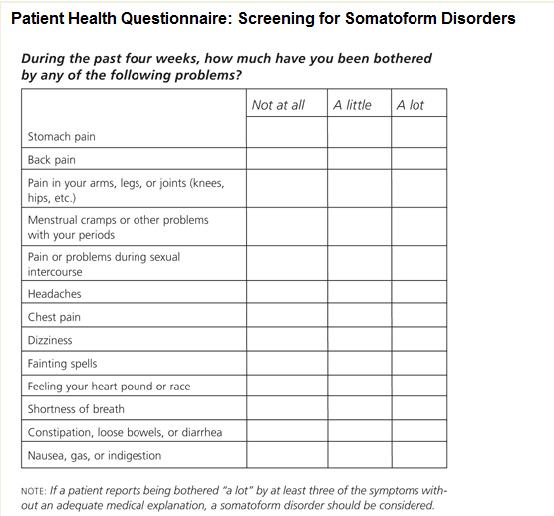

Management:

- After appropriate investigation, inform the patient that no further investigations are indicated.
- Limit the number of doctors consulted.
- Limit the number of invasive investigation.
- Encourage return to normal activities.
- Educate and involve the family in management.
- Diagnose and adequately treat comorbid psychiatric disorders. Be alert for depression and anxiety.

Psychotherapy

Way to help people with a broad variety of mental illnesses and emotional difficulties. Psychotherapy can help eliminate or control troubling symptoms so a person can function better and can increase well-being and healing.

Cognitive behavioral therapy (CBT):
- Helps people identify and change thinking and behavior patterns that are harmful or ineffective, replacing them with more accurate thoughts and functional behaviors.
- Helpful in the treatment of depression, anxiety, trauma related disorders, and eating disorders.
- CBT can help a person with depression recognize and change negative thought patterns or behaviors that are contributing to the depression.

When to Consult a Psychiatrist?

- Questions of suicidality
- Psychotic symptoms
- Diagnostic questions
- Disruptive physician-patient relationships
- Developmental problems (children/adolescents)
- Management review
- Psychopharmacology assessment/advice
- Abnormal bereavement
- Family dysfunction
- Substance abuse/addiction
- Signs of dementia
- Sleep problems
- Sexual dysfunction
- Physician frustration/anger/impotence

