Screening and Prevention

Objectives:
- To define screening / prevention and its uses in family practice.
- To identify Screening types and targeted people for each type with examples.
- To explain pros and cons of screening.
- To identify appropriate approaches for prevention and screening of common problems in primary care.
- To understand the Criteria for screening tests.
- To justify the rational for selection of a screening test with practical case /condition, examples like for CA. breast, Ca. colon, Ca. prostate.

- 1st Objective : To define screening / prevention and its uses in family practice :

A) Screening is defined as:
- The systematic testing of asymptomatic individuals for pre-clinical disease.
- The ability to diagnose and treat a potentially serious condition at an early stage when it is still treatable. (Oxford handbook of general practice).
- The aim of screening is:
- To be able to diagnose and treat a potentially serious condition at an early stage when it is still treatable.
- To prevent or delay the development of advanced disease in the subset with preclinical disease.

B) Prevention is defined as:
- Health promoting and preventing diseases’ occurrence.
- Averting and eliminating diseases and minimizing the impact of diseases.

- 2nd Objective: To identify Screening types and targeted people for each type with examples.

- Mass screening: is screening of a whole population or sub-group.
Ex: Visual defects in school children.

- High risk /selection screening :
Applied selectively to a high risk groups, on the basis of epidemiological research.
Ex: screening of cervix cancer in lower social groups.

- Multi-purpose OR Multi-phasic :
Applying two or more screening tests in combination to a large number of people at one time (usually Expensive).
Ex: chemical and hematological tests on blood and urine specimens.

- Additional: Types of prevention were not mentioned in the objectives but I believe they are important:

- Primary prevention:
Health promoting and preventing diseases’ occurrence.
Ex: Avoiding harmful exposure, Vaccination, Prophylaxis, Education, Structural safety, Sanitation and Sterilization.
- Secondary prevention:

Is to reduce the impact of a disease or injury that has already occurred, by:
- Screening and treating diseases or injuries as soon as possible to halt or slow their progression.
- Encouraging personal strategies to prevent re-injury or recurrence

Ex: Mammograms to detect breast cancer (carcinoma in situ).

- Tertiary prevention:

Prevention of complications once a symptomatic disease is present and has lasting effects.
Ex: - long term management in DM patients.
- Stroke rehabilitation program.

- 3rd objective: To explain pros and cons of screening.
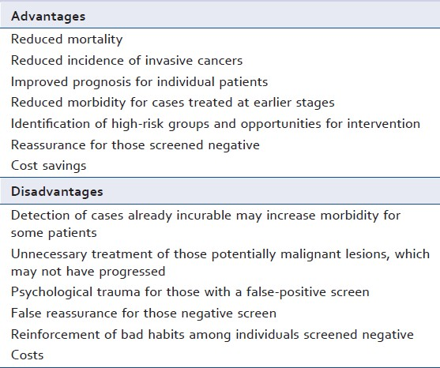

NOTE: The doctor emphasized the importance of differentiation between Screening and Diagnosis:

 | Disease | Symptoms | Individuals | Pre-test probability of the disease
Screening | Pre-clinical satge | Usually Absent | Asymptomatic | Low
Diagnosis | Clinically overt | Usually Present | Symptomatic | High

- 4th Objective : To understand the Criteria for screening tests.

- The Wilson–Jungner criteria for screening:
- All screening tests should meet the following criteria before they are introduced to the target population:
- The condition being screened for is an important health problem.
- Natural history of the condition is well understood.
- There is a detectable early stage.
- Treatment at early stage is of more benefit than at late stage.
- There is a suitable test to detect early stage disease.
- The test is acceptable to the target population.
- Intervals for repeating the test have been determined.
- Adequate health service provision has been made for the extra clinical workload resulting from screening.
- Risks, both physical and psychological, are < benefits
- Costs are worthwhile in relation to benefits gained

- 5th Objective: To identify appropriate approaches for prevention and screening of common problems in primary care.

Diabetes Mellitus:
- Diabetes mellitus is one of the most common diagnoses made by family physicians.
- Lifestyle (Obesity) and pharmacologic interventions decrease progression to diabetes in patients with impaired fasting glucose or impaired glucose tolerance.
- Uncontrolled diabetes can lead to blindness, limb amputation, kidney failure, and vascular heart disease.
- Screening is recommended for abnormal blood glucose and type 2 diabetes in adults 40 to 70 years of age who are overweight or obese, and repeating testing every 3 years if results are normal.
- Screen all adults who are overweight (BMI ≥ 25 kg/ m2) and have additional risk factors.
- Screening for type 1 diabetes is not recommended

Hypertension:
- Hypertension is a major risk factor for CVD
- It is usually asymptomatic until it causes organ damage.
- Usually found during routine BP screening or incidentally
- Changing in the lifestyle habits will help in prevention of hypertension:
- Offer smoking cessation advice and help.
- Decrease weight
- Exercise.
- Dietary salt intake.
Statin For primary prevention in patients >40y
Screening for high blood pressure is recommended in:
- Adults 40 years or older -> annually
- Adults aged 18 to 39 annually if risk factors are present (family history, obesity, 130-139/85-89 mmHg).
- Adults aged 18 to 39 with no risk factors every three years.

- 6th Objective: To justify the rational for selection of a screening test with practical case /condition, examples like for CA. breast, Ca. colon, Ca. prostate.

Breast cancer:
-It is the most common cause of death in women aged 35-55.
-It’s an important health problem, where early diagnosis is critical.
-Mammography is the only screening test shown to reduce breast
Cancer–related mortality.
-screening should be offered at least biennially to women 50 to 74 years of age.
-High-risk women <50y: Women with family history of breast cancer may benefit from earlier screening and/or genetic screening.
-Women known to have a genetic mutation should be offered annual MRI surveillance from 20y if TP53 mutation, and from 30y if BRCA1/2 mutation.

Colorectal Cancer:
- Most common cancer in Saudi males and 3rd in Saudi females.
- 25-30% of patients present with distant metastasis
- Patients at risk:
- Lifestyle factors: Dietary factors. Alcohol. Physical activity.
- First-degree relative.

Medication that will decrease the risk:
HRT-risk. COC pill. Statins. Aspirin.
- Screening in persons at average risk should begin at 50 years of age
- Recommended every 2y to all patients aged 60–74y.

- Screening tests:
- High-sensitivity fecal occult blood testing annually.
- Flexible sigmoidoscopy every five years with high-sensitivity fecal occult blood testing every three years.
- Colonoscopy every 10 years.

Prostate cancer:
Second most common cancer affecting men.
Risk factors: 85% are diagnosed aged >65y
Genetic. Dietary (low intake of fruit, high intake of fat, meat, and Ca2+)
Problems with screening:
Incidental post-mortem evidence of prostate cancer is high (75% men>75y);
Inadequate screening tests
- Screening tests:
- • Prostate-specific antigen (PSA)
- • Digital rectal examination (DRE) Operator-dependent, Annual screening in the USA and Germany has not decrease mortality
- • Transrectal ultrasound (TRUS) Too expensive
- The most effective screening regime involves rectal examination and PSA

- A digital rectal examination and PSA test are recommended for patients with any of the following unexplained symptoms:
-Erectile dysfunction
-Hematuria
-Lower back pain
-Bone pain
-lower urinary tract symptoms
-Weight loss, especially in the elderly

