Adolescence Health

Abdullah M. Khattab
Saleh M. Al-Dosari

  - Objectives
- Define adolescent age: World health organization definition.
- Recognize the importance of adolescent health.
- Understand adolescent’s physiological and behavioral characteristics.
- Determine adolescent health problems: physical, psychological and social problems.
- Recognize common adolescent health problems in Saudi Arabia: Retrieved from available evidence-based studies.
- Understand the comprehensive approach to common adolescent health problems in primary health care.
- Understand the role of family, school and community in adolescent health care.

obj1: Define adolescent age: World health organization definition
  - Definition
Adolescence, transitional phase of growth and development between childhood and adulthood.
The World Health Organization (WHO) defines an adolescent as any person between ages 10 and 19. This age range falls within WHO’s definition of young people, which refers to individuals between ages 10 and 24.
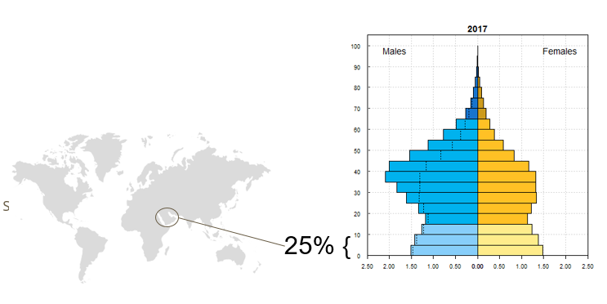
  - Adolescent population in KSA
Saudi population: around 33mill
Adolescent population: around 8mill

obj2: Recognize the importance of adolescent health.
  - Why adolescence period is important?
1- A crucial period to develop knowledge and skills, learn to manage emotions and relationships, and acquire attributes and abilities that will be important for enjoying the adolescent years and assuming adult roles.
2- Adolescence is a sensitive period of social-affective development.
3- Adolescent health behaviors have a direct effect on immediate as well as long term health outcomes and quality of life.
4- Adolescence health is a key ensure the boys and girls grow into healthy and productive men and women.
5- the size of adolescent population grows especially in developing countries.
6- the health of young people will be a major determinant of economic, social development in their countries.

obj3: Understand adolescent’s physiological and behavioral characteristics.
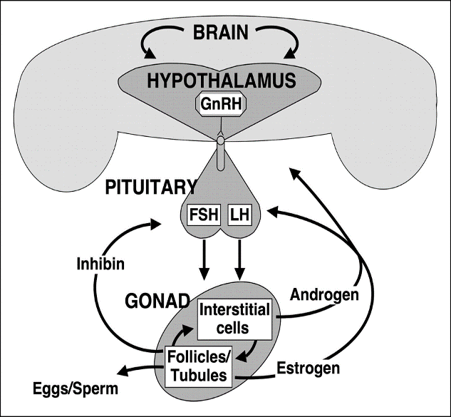
  - Physiological Changes
Puberty development is attributed to the following systems:
- hypothalamic–pituitary–gonadal axis (gonadarche),
- the adrenal system (adrenarche)

changes
Male  Starts: around 11 or 12 years  (Might start early) | Female  Starts: around 10 or 11 years.  (Might start early)
- growth of the penis and testes (testicles)  - changes in body shape and height  - erections with ejaculation  - growth of body and facial hair  - changes to voice. | - breast development  - changes in body shape and height  - growth of pubic and body hair  - the start of periods (menstruation).

  - Behavioral Changes
Behavioral changes are due to changes on the brain via sex hormones effects.

Psychological changes mostly attributed to:
1- The Limbic System: that are responsible for pleasure seeking and reward processing, emotional responses and sleep regulation.
2- Pre-Frontal Cortex: the area responsible for what are called executive functions: decision-making, organization, impulse control and planning for the future. The changes in the pre-frontal cortex occur later in adolescence than the limbic system changes

Examples of changes
- Social changes:

- searching for identity
- Seeking more independence
- Seeking more responsibility
- communicating in different ways
- influenced more by friends

- emotional changes
- shows strong feelings and intense emotions at different times. Moods might seem unpredictable. These emotional ups and downs
- More conscious about physical appearance

obj4: Problems that Faces Adolescents

  - (1) Obesity, Malnutrition And Physical Activity
●Many adolescentt in developing countries are undernourished; making them more vulnerable to disease and early death.
●The number of adolescents who are overweight or obese is increasing in low, middle and high-income countries.
- 18% of children and adolescents aged 5-19 were overweight or obese in 2016 worldwide.
Causes:
1- Decreased physical activity 2- overeating
Future risk:
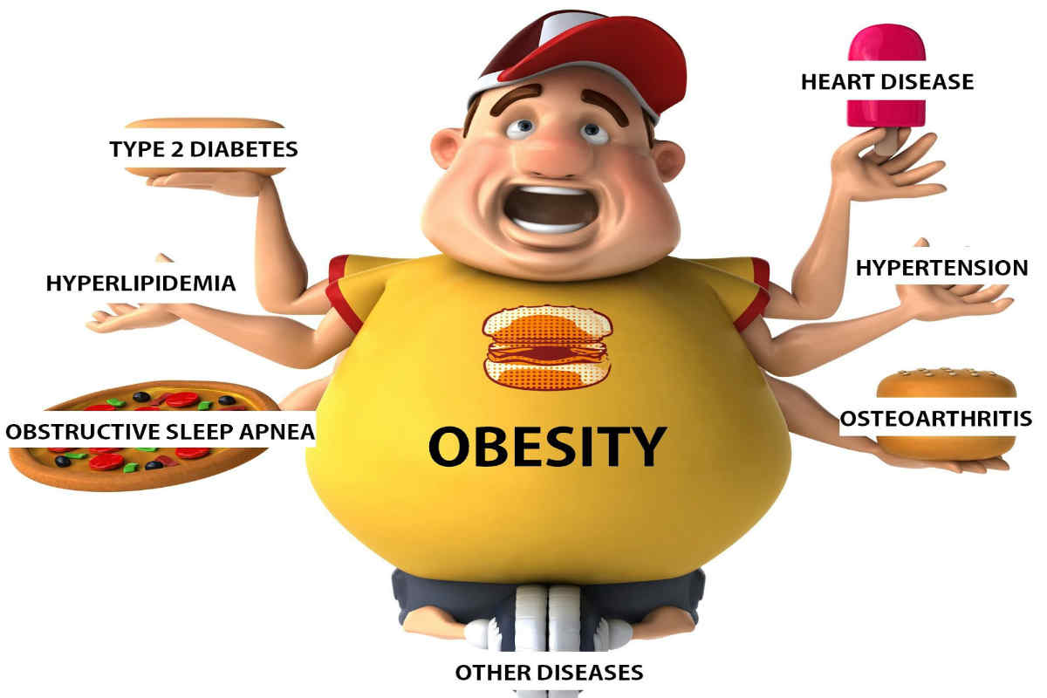

How to Solve this issue:
1- healthy foods.
2- exercise.
3- most importantly, most students spend their time in school. Increasing physical activities can help improve cardiorespiratory fitness, build strong bones and muscles, control weight, reduce symptoms of anxiety and depression, and reduce the risk of developing health conditions such as: Heart disease

  - (2) Injuries
● Injuries are a leading cause of death and disability among adolescents.
● Road traffic injuries were the leading cause of death in 2015
●Other major causes involve drowning, poisonings, fires, Sport injury are the most common
In 2015, over 115000 adolescents died as a result of road traffic accidents.
In 2015, over 57000 adolescents died as a result of Drowning.

  - (3) Mental Health
- Depression is the third leading cause of illness and disability among adolescents
- suicide is the third leading cause of death in older adolescents (15–19 years)
- Violence, poverty, humiliation and feeling devalued can increase the risk of developing mental health problems.
How can you promote good mental health?
1) Building life skills.
2) Providing psychosocial support in schools and other community settings.

  - (4) Alcohol and Drugs and Tobacco
Alcohol:
Harmful drinking among adolescents is a major concern in many countries.
● It reduces self-control and increases risky behaviors, such as unsafe sex or dangerous driving.
● It is a primary cause of injuries (including those due to road traffic accidents), violence (especially by a partner) and premature deaths.
● It can also lead to health problems in later life and affect life expectancy.
Drugs:
Drug use among 15–19-year-old is also an important global concern. Drug control may focus on reducing drug demand, drug supply, or both, and successful programs usually include structural, community, and individual-level interventions.
Tobacco Use:
• The vast majority of people using tobacco today began doing so when they were adolescents.
• At least 1 in 10 younger adolescents (aged 13 to 15) uses tobacco.

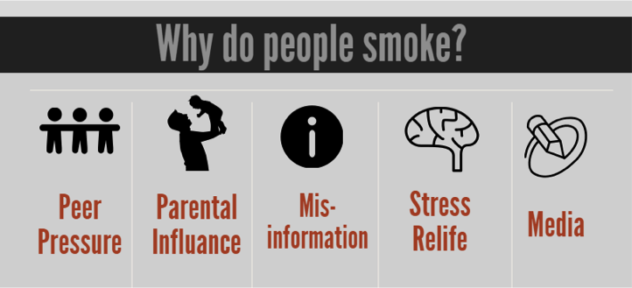

  - (5) Early pregnancy and childbirth
○ The leading cause of death for 15– 19-year-old girls globally is complications from pregnancy and childbirth.
○ 11% of all births worldwide are still to girls aged 15 to 19 years old.
• Infants of young mothers (especially mothers younger than 15 years) are more likely to be born prematurely and to have a low birth weight.

(6) Violence
●Violence is a leading cause of death in older adolescent males
●An estimated 180 adolescents die every day as a result of interpersonal violence.
●Globally, some 30% of girls aged 15 to 19 experience violence by a partner.
●Globally, 1 in 10 girls under the age of 20 years report experiencing sexual violence
  - (7) HIV
More than 2 million adolescents are living with HIV.
● How we can Prevent it?
1. Avoid prohibited relationships
2. Clean needles for those who inject drugs
3. Use condoms

obj5: Adolescent Health Problems In Saudi Arabia

Research: Medical and Behavioral Problems among Saudi Adolescents (2013 Jun )
According to the study:
“Saudi society is different from western societies in many respects. It is conservative society with strong Islamic values. The pattern of adolescent’s problems is expected to be different from that in the west. For example, illegitimate teenage pregnancies are common in western world, but do not exist in KSA.”
https://www.ncbi.nlm.nih.gov/pmc/articles/PMC3883599/

  - (1) CAR ACCIDENT
Adolescents males who drive car 45% of them had a car accident.

  - (2) DRUG USE
The prevalence of drug use in this survey was 6.4%, volatile substance was commonly abused among adolescents

  - (3) Mental Health
That most important problems were:
1. Anxiety (13.5%)
2. Somatic disorders (12.2%)
3. Obsession (10.8%)
4. Aggression (8.1%)
5. Delinquency and depression (4.1%).

  - (4) Malnutrition and Obesity
A study was carried out with the aim of identifying the health risk behaviors and health status of adolescents in Saudi Arabia, in 2015.
It was a cross-sectional, school-based study was in all 13 regions of Saudi Arabia with a total of 12,575 adolescents participated.
- 28% of adolescents reported having a chronic health condition.
- 14.3% reported having symptoms suggestive of depression.
- 30.0% were overweight/obese.
- 95.6% were vitamin D deficient.
- 42% spent at least 2 hours/day watching television.

obj6: Approach to Common Adolescent Health Problems in Primary Health Care

  - Approach to dealing with adolescents
• Primary care physicians are well situated to deal with adolescents and discuss risks and offer interventions.
• we should take care about Environmental factors, including family, peer group, school, neighborhood, and social cause, because they can either support or refute young people’s health.
Physicians can establish a productive relationship with adolescents through the following steps:
- Assess the individual adolescent's ability to understand the consequences of risky behavior
- Assess the role of the parent
- Meet privately and raise sensitive topics
- Use the physician-patient relationship to personalize risk-reduction messages.
- Physicians should use empathic, personal messages to communicate with adolescents about these issues

Examples:
Smoking
●Ensuring smoke-free environments.
●Increasing the price of tobacco products.
●Banning smoking advertising.
●Counseling and explain the dangers of using illegal drug. (role of family, school and community)

Injury and Car Accident:
●Young drivers need advice on driving safely.
●Forbidding adolescents aged less than 18 years from driving.

Obesity and physical inactivity:
●Providing access to healthy foods and opportunities to engage in physical activity.
●Developing healthy eating and exercise habits at adolescents are foundations for good health in adulthood.

obj7: Role Of Family, School, And Community In Adolescent Health Care
  - Role of Family
- Adolescents who have good communication and are bonded with an adult are less likely to engage in risky behaviors.
- Parents supervision and involved with their adolescents' activities are promoting a safe environment.
- The children of families living in poverty are more likely to have health conditions and poorer health status, as well as less access to and utilization of health care.

  - Role of school
- School environment and behavior of teachers play a major role in character building and personality development of adolescents.
- School health clinics for health education & counseling has important role.
- The school social environment affects student’s attendance, academic achievement, and behavior.
- A safe and healthy school environment protects against risky behaviors.

  - Role of Community
- Antismoking program should be established, including prohibition of the sale and use of cigarettes in public places.
- Application of firm traffic laws forbidding adolescents aged less than 18 years from driving.
- Raising awareness of health issues for young people among the public and special groups.
- Supervision over media content because, adolescents who are exposed to media portrayals of violence, sexual content, smoking, and drinking are at risk for adopting these behaviors.

Take Home Message
●Adolescence is a very critical stage in one’s life. It’s where biological, physiological, and psychological maturation happens.
●Taking risks at this age without thinking of the consequences is common. Which may lead to serious illnesses, disabilities, and death.
●Unintentional injuries are the leading cause of death among adolescents, and in most cases they’re preventable.
●The health problems in adolescents globally are to some extent similar to those in Saudi Arabia. Such as the widespread of smoking, obesity, injuries, mental problems, physical inactivity..

Q1. Adolescence age is between:
a)7-18
b)10-23
c)10-19
d)20-26
Q2. What is the adolescent population in Saudi Arabia?
a)10%
b)25%
c)30%
d)50%

Q3. What is the leading cause of death in adolescents?
a)HIV
b)Injuries
c)Cancer
d)Suicide
Q4. What is the most common mental health problem in adolescence?
a)Anxiety
b)Schizophrenia
c)Depression
d)Bipolar

