How to approach Obesity ?

classify the degree of obesity
1-BMI (Metric ) (Imperial)
- -1Metric weight (kg) ÷ height² (m²)
- -2Imperial weight (lb) ÷ height² (in²) × 703
2- Waist circumference is an indicator of health risk associated with excess fat around the waist.
3- Waist to Hip ratio This is calculated as waist measurement divided by hip measurement (W/H). For example, a person with a 25" waist and 38" hips has a waist-hip ratio of about 0.66.
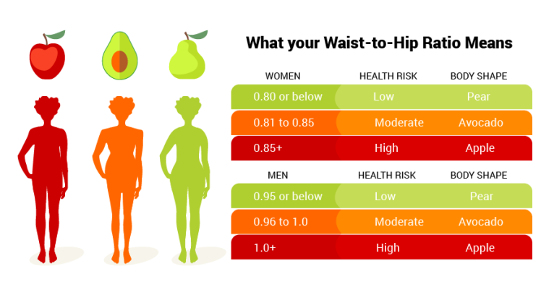
The prevalence in KSA
- According to WHO , the prevalence of obesity in KSA population is 28.7%. Which equal to 24% of male , 33% of female.

Causes of obesity
- family history
- Diet or food style either for individual or families
- Sedentary life style.
- some diseases like: Cushing's syndrome, hypothyroidism and other medical conditions which leads difficulties in daily activities like osteoarthritis.
- Some medications such as: TCAs.
- Sleep disturbance
- Low education
- Aging or being older
- Marital status
- Pregnancy
- •Lack of sleep: Sleep restriction, when compared to sleep extension, was associated with a decrease in serum leptin , an increase in serum ghrelin and increased hunger and appetite. Inadequate sleep could result in excessive eating, obesity, and altered response to dietary therapy.
- Drugs: some medications lead the
body to gain more weight, these drugs
include, diabetes medications, steroids
and beta blockers, anti-seizure
medications, antipsychotic medications
and antidepressants drugs.
Antipsychotics:
- Conventional (first generation) antipsychotics, like thioridazine.
- Atypical (second generation) antipsychotics, clozapine and olanzapine.
Antidepressants :
- Tricyclic antidepressants, in particular, clomipramine, doxepin,and imipramine are associated with significant weight gain.
- Short-term use of fluoxetine and sertraline has been associated with weight loss
Diabetes drugs:
- Insulin stimulates weight gain, possibly through hypoglycemia, and the sulfonylureas that increase insulin release also increase weight.

Obesity co-morbidities
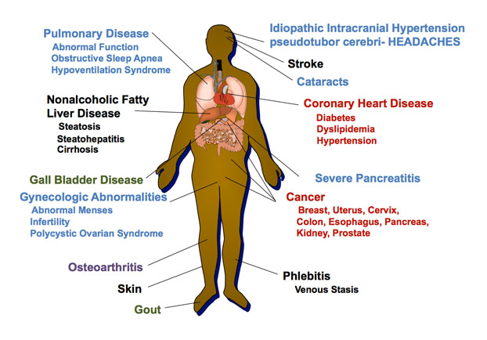

  - Colon CA.
  - Gallstones.
  - Sleep apnea.
  - Gout and gouty arthritis.
  - Osteoarthritis “Knee”
  - Psychological complications “suicide”.
How can we prevent obesity in our community ?
1-Primary Prevention
- Breastfeeding: the likelihood to become overweight is 20 to 40 percent less in babies breastfed for six months or longer
- Be a role model. Parents who eat healthy foods and are physically active set an example that increases the likelihood their children will do the same.
- Encourage physical activity. Children should have an hour of moderate physical activity most days of the week.
- Reduce time in front of the TV and computer to less than two hours a day.
- Encourage children to eat only when hungry, and to eat slowly.
- Avoid using food as a reward or withholding food as a punishment
- Avoid foods that are high in "energy density" or that have a lot of calories in a small amount of food.
- Create community environments that promote and support healthy food and beverage choices and physical activity.
- Prevent childhood obesity through early child-care and schools.
- Expand the role of health care and health service providers and insurers in obesity prevention.
- Expand the role of public and private employers in obesity prevention.
2- Secondary prevention
- Exercise:
- Weight loss is greater in diet plus exercise regimens than in diet-only regimens. Exercise regimens alone, without reduced-calorie diets, are not effective for weight loss.
- Moderate physical exercise is introduced with 3 sessions per week, 30 minutes per session, then later increased, as tolerated.
- Ex:
- walking at 3 miles per hour (350 kcal/hour).
- bicycling on level ground at 10 to 12 miles per hour (600 kcal/hour).

- Dieting:
- At 6-month follow-up, the low-carbohydrate/high-protein diet has been found to produce greater weight loss than the low-fat diet, and patients seemed to prefer the low-carbohydrate/high-protein diet.
- Adherence to the diet (i.e., compliance) and the reliability of patient reporting of caloric intake have been problematic in studies on dietary intervention.
- Reduce consumption of junk food
- Eat 500 to 1,000 fewer calories each day.

Psychological/behavioral interventions
1- Self-monitoring: such as maintaining food diaries.
2-Reinforcement of successful outcomes or rewarding good behaviors is important.
3- Goal setting: Setting realistic goals.
4- Slower eating
5- Nutritional education
6- Increasing physical activity
7- Social support: by including spouses and family members

Treatment when to use ?
- Failure of diet and exercise
- BMI > 30
- BMI > 27 and associated with medical problems related to obesity
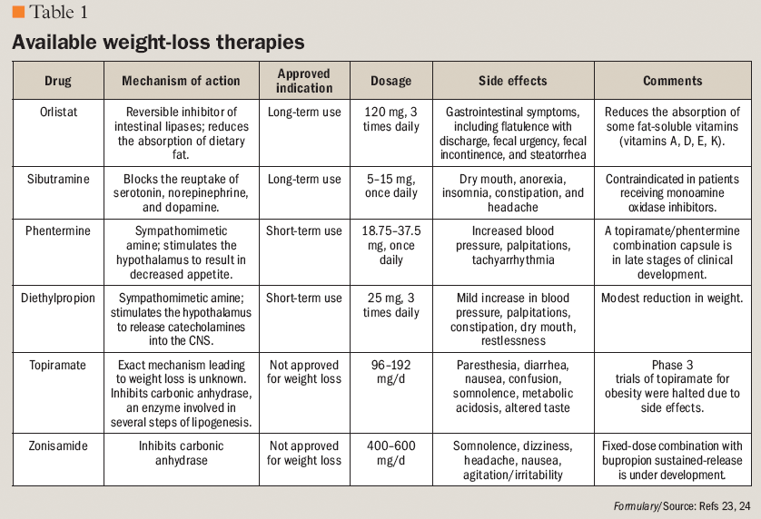

Types of Bariatric surgical intervention:
1-Adjustable Gastric Band
- Often called the band – involves an inflatable band that is placed around the upper portion of the stomach, creating a small stomach pouch above the band, and the rest of the stomach below the band.
Advantages
- Reduces the amount of food the stomach can hold
- Induces excess weight loss of approximately 40 – 50 percent
Disadvantages
- Slower and less early weight loss than other surgical procedures
- Greater percentage of patients failing to lose at least 50 percent of excess body weight compared to the other surgeries commonly performed

2-Gastric Bypass
- The Roux-en-Y Gastric Bypass – often called gastric bypass – is considered the ‘gold standard’ of weight loss surgery.
Advantages
- Produces significant long-term weight loss (60 to 80 percent excess weight loss)
- Restricts the amount of food that can be consumed
Disadvantages
- Is technically a more complex operation than the AGB or LSG and potentially could result in greater complication rates
- Can lead to long-term vitamin/mineral deficiencies particularly deficits in vitamin B12, iron, calcium, and folate
3-Sleeve Gastrectomy
- is performed by removing approximately 80 percent of the stomach. The remaining stomach is a tubular pouch that resembles a banana.
Advantages
- Restricts the amount of food the stomach can hold
- Induces rapid and significant weight loss that comparative studies find similar to that of the Roux-en-Y gastric bypass
Disadvantages
- Is a non-reversible procedure
- Has the potential for long-term vitamin deficiencies

Biliopancreatic Diversion with Duodenal Switch (BPD/DS) Gastric Bypass
- is also a combination procedure that involves removing the lower part of the stomach, and bypassing the duodenum and jejunum to produce significant malabsorption. This procedure tends to be performed in subspecialty centres.
- Advantages
- Results in greater weight loss than RYGB, LSG, or AGB, i.e. 60 – 70%
- Allows patients to eventually eat near “normal” meals
Disadvantages
- Has higher complication rates and risk for mortality than the AGB, LSG, and RYGB
Bariatric surgical intervention:
- Patients with BMI ≥40 kg/m^2 (i.e., morbidly obese category), or ≥35 kg/m^2 with obesity-related comorbidity (e.g., hypertension, diabetes, sleep apnea, GORD) may be candidates for most bariatric procedures
The Health Team and medical students
- Health professionals have an important role in promoting preventive measures and encouraging positive lifestyle Behaviors “ awareness of the population” ..
- Also have a role in counseling patients about safe and effective weight loss and weight maintenance programs.
Schools
- Schools cannot solve the obesity epidemic on their own as well .
- School can also help address obesity by providing:
- Screening
- Health information
- Referrals to students
- The Role of Schools in Obesity Prevention :
- More nutritious food
- Physical activity
- Health services.
- Health education

Take home massage
- One of the best measure of obesity is body mass index (BMI).
- The prevalence in KSA is high among both genders (F>M).
- Obesity is a multifactorial condition “ Genetic, environment and behavior”.
- Obesity is associated with comorbidities “ DM,HTN..etc”.
- Obesity should be managed initially with diet and life style modification followed by pharmacotherapy and surgery as a last option.

