Approach to a patient with back pain
Done by: Khalid Alqarni and Abdullah aldawas
Objectives:
- Common causes
- Diagnosis including history, Red Flags, and examination
- Brief comment on mechanical, inflammatory, Root nerve compression, and Malignancy
- Role of primary health care in management
- When to refer to a specialist
- Prevention and education
Common causes:
- slipped (prolapsed) disc: Posterolateral, central or foramenal bulging of the disc causing compression on the nerve roots leading to the feeling of pain, tingling and numbness along the distribution of nerves involved.
- Sciatica: Back pain that radiates to the rear of the thigh, leg and sometimes foot and toes. Primarily caused by disc herniation, it can also be caused by lumbar stenosis. Can also be present in piriformis syndrome.
- ankylosing spondylitis: This is a type of arthritis, the spinal joints gets inflamed. They might also present with arthritis in other joints. There is a new bone formation, causing some spinal sections to fuse together in a fixed immobile position. The hallmark of the disease is sacroiliac joint erosion. They present with iritis and enthesitis (inflammation of the insertion points of tendons and ligaments to the bones) and 50% present with positive family hx.
- Spondylolisthesis: It is a forward 'slipping' of one vertebra over another. Mostly present with stress fractures.
Diagnosis including history, Red Flags, and examination:
Onset and how it started?
Character?
Site and radiation?
Duration?
Intensity?
Associated symptoms?
Relieving and aggravating factors?
Fever ??
Appetite/ wt loss?
Abdominal pain?
Cough/ sputum?
Bowel habits?
Dysuria, Hematuria?
Menstrual history?
Past medical history:
- Medical & surgical history:
- – Previous trauma
- – Kidney diseases
- – Previous back pain, therapy
- – Malignancy
- – Disc prolepses
- —surgery
- – Female---obstrict diseases
- • medication?? • Corticosteroids , immunosuppressant
Family history:
- Cancer
- Back Pain
- Spondylarthropathies
Social history:
- • Current stresses
- • Occupation:
- • Work, job tasks.
- • Activity level of the job
- • Perception of the pain ,impact on life
RED FLAGS:
- General: •Failure to improve after 4-6wk of conservative therapy •Unrelenting night pain or pain at rest •Progress motor or sensory deficit
- Cancer: •Age > 50 •History of cancer or current cancer •Unexplained weight loss
- Infection: •Fever or chills •Recent infection .. UTI or skin •Immunosuppression • IV drug use
- Fracture: •Age > 50 •History of osteoporosis •Significant trauma •Chronic oral steroid use
- Cauda Equina S.: •Urinary incontinence or retention •Saddle anesthesia •Decrease anal tone or fecal incontinence •Lower extremities weakness
- AAA: •Age > 60 •Abdominal pulsating mass •Pain at rest

PHYSICAL EXAMINATION:
• General appearance
• Vital sings
• Back examination
• Systemic examination
- GENERAL APPERANCE :
• Comfortable or not ?
• Sitting, standing or leaning on something?
• Vital signs :
• Record vital signs
• High Temp. ???
BACK EXAMINATION:
- • look
- • Feel
- • Move
- • Special tests
Look:
- • From side: evaluate spinal curvatures.
- • From behind: Note any scars, swelling, erythema. Shape of the spine.
Feel:
• The spinous processes of each vertebra.
– Tenderness .. Fracture, dislocation , infection or arthritis
• Any step-offs
– in spondylolisthesis or forword slipping of one vertebra, which may compress the spinal cord.
• Muscle spasm or tenderness
– degenerative or inflammatory process , prolong contraction from abnormal posture or anxiety.
• Sacroiliac joint
– tenderness indicate sacroiliitis or ankylosing spondylitis
Move:
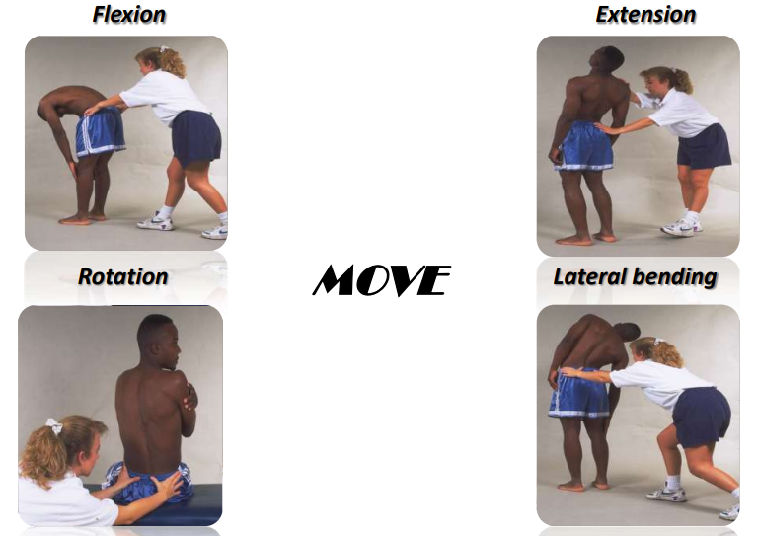
Special tests:
Scobar’s test: – measure forward flexion of the spine > indicates ankylosing spondylitis
Straight leg raising Test > Indicates sciatica
Crossed straight leg raising test > indicates a herniated disc
Examination of the lower limb:
- Muscle strength:
- Hip: » Flexion (L2, 3,4 ) » Adduction (L2, 3,4 ) » Abduction ( L4, L5, S1 ) » Extension (SI)
- Knee: » Extension at the knee (L2,L3,L4) » Flexion at the knee (L4,L5,S1,S2 )
• Dorsiflexion: ( mainly L4,L5)
• planter flexion: (mainly S1).
Deep tendon reflexes:
– The knee reflex (L2,L3,L4) The Ankle reflex (S1) The planter response(L5,S1)
Gait: Walk on heel ( L5) • Walk on toe (S1
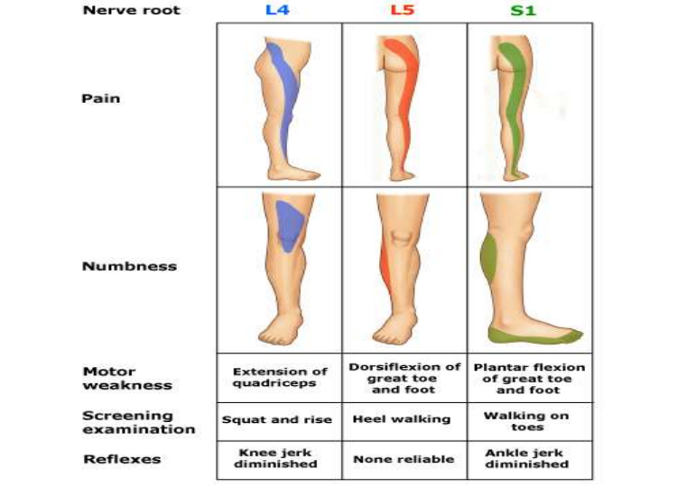
Difference between inflammatory and mechanical back pain:
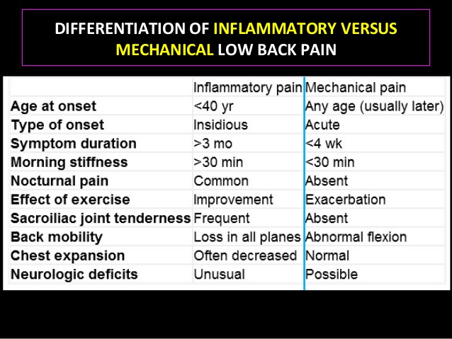

Malignancy in back pain patients:
- Most spinal column tumors have spread from another area of the body (metastatic), with the majority originally coming from tumors in the breast, prostate, kidney, lung or thyroid.
- These malignant tumors usually produce back pain that does not diminish with rest, and the nighttime pain may be worse than daytime pain.
- The metastatic tumors are usually associated with other symptoms such as loss of appetite, unplanned weight loss, nausea and vomiting, or fever/chills/shakes.
#Vertebral tumor is the most common cause of spinal cord compression

ROLE OF PRIMARY HEALTH CARE IN MANAGEMENT:
- Initial evaluation
- Initial management of simple cases
- Referral of complicated cases
- Prevention and education
WHEN TO REFER?
- No significant improvement in symptoms after 4-6 wks of treatment (reassess the treatment plan).
- Referral to spine specialist:
• Cauda equina syndrome
• Intractable pain
• Serious spinal pathology is suspected
• Progressive neurological deficits
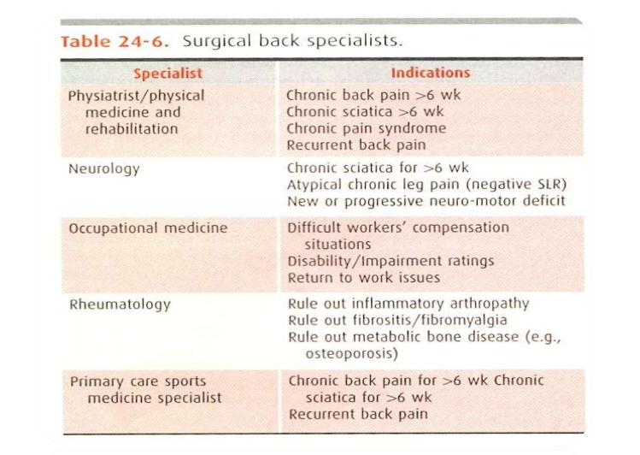

PREVENTION AND EDUCATION:
• Limited number of studies
• Overall , effective strategies for preventing initial or recurrent low back pain are lacking
• Education:
1. Instruction on proper lifting technique (not seem to be helpful)
2. Coping with back pain and encourages activity (small benefit)
3. Back belt and lumbar support (not effective in workers)
4. Most effective prevention strategy seems to be physical exercise

