Objectives:

- Epidemiology of smoking in Saudi Arabia
- Risks of smoking (Morbidity and Mortality)
- Effect of passive smoking on pregnancy, children, ….
- How to quit smoking and overcome withdrawal symptoms.
- Role of PHC physician “smoking cessation clinic’
- Update in pharmacological management, smoking cessation medication.
- Nicotine preparations, Varniciline, Bupropion, …….
- Factors leading to substance abuse.
- Types of substance abuse.
- How to approach subjects with substance abuse.

Definition:
Smoking is the exposure to a substance, most commonly tobacco, that is burned and the smoke either tasted or inhaled.”1

Types of tobacco products:

- 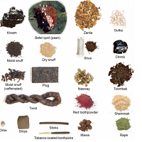

Epidemiology: (a)
- World wide
- Prevalence of tobacco smoking
- In 2015, over 1.1 billion people smoked tobacco. Far more males than females smoked tobacco. Although it is declining worldwide and in many countries, the prevalence of tobacco smoking appears to be increasing in the WHO Eastern Mediterranean Region and the African Region.
Prevalence in Saudi Arabia:
- A study was conducted on 10735 individuals aged 15 years or older (5253 men and 5482 women) which was performed between April and June 2013 to assess the status of tobacco consumption in the Kingdom of Saudi Arabia (KSA).
- Overall prevalence of current smoking was 12.2 % and males were more likely to smoke than females (21.5 % vs. 1.1 %).
- Mean age of smoking initiation was 19.1 years (±6.5 years) with 8.9 % of ever smokers starting before the age of 15 years.
- 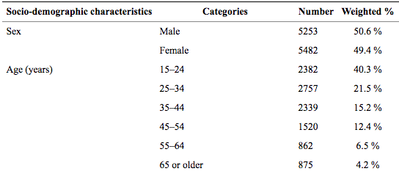Smoking is the leading preventable cause of death:

Morbidity: (b)
- Smoking leads to disease and disability and harms nearly every organ of the body.
- More than 16 million Americans are living with a disease caused by smoking.
- For every person who dies because of smoking, at least 30 people live with a serious smoking-related illness.
- Smoking causes cancer, heart disease, stroke, lung diseases, diabetes, and chronic obstructive pulmonary disease (COPD), which includes emphysema and chronic bronchitis.
- Smoking also increases risk for tuberculosis, certain eye diseases, and problems of the immune system, including rheumatoid arthritis.
Smoking and cardiology (b)
- Cardiovascular diseases is the main cause of death due to smoking.
- Cigarette smokers are two to four times more likely to develop coronary heart disease (CHD), than non-smokers.
- This also applies on second hand smokers as smoking increases the risk for stroke by 20−30%.

Smoking and cancer
- Smoking can cause cancer almost anywhere in your body:
  - Trachea, bronchus, and lung
  - Bladder
  - Esophagus
  - Larynx
- The most common cancer caused by smoking is Lung cancer
- Lung cancer is the most commonly diagnosed cancer.
- The leading cause of cancer death in the United States.
- Most deaths from lung cancer are caused by cigarette smoking and exposure to secondhand smoke.

Smoking and lung diseases
- Lung diseases caused by smoking include COPD, which includes emphysema and chronic bronchitis.
- Smoking can cause lung disease by damaging the airways and the alveoli.

Mortality:
- Smoking causes more deaths each year than all of these combined:
  - Human immunodeficiency virus (HIV)
  - Illegal drug use
  - Alcohol use
  - Motor vehicle injuries
  - Firearm-related incidents
- Every 6.5 seconds someone dies from tobacco use!

Types of smoking:
1. Active smoking:
is the intentional inhalation of smoke using the methods of smoking such as: cigarettes and cigars.
2. Passive smoking (second hand):
is the inhalation of smoke by persons other than the intended 'active' smoke.

Smoking effect on children (c)
- Studies show that older children whose parents smoke get sick more often.
- They get more bronchitis and pneumonia compared to non second hand smokers
- Wheezing and coughing are more common in children who breathe secondhand smoke.
- Secondhand smoke can trigger an asthma attack in a child.

Smoking effect on pregnancy (c)
- Smoking effect on pregnancy doesn’t mean only during pregnancy but also women who are planning to get pregnant, or have a child aged up to 12 months.
- These effects may include:
  - Miscarriage.
  - Low birth weight.
  - Preterm labor.
  - Learning and behavioral deficiencies.
  - Sudden infant death syndrome
  - Cleft palate

Getting Ready To Quit! (d)
- Start your stop smoking plan with START
  - S = Set a quit date.
  - T = Tell family, friends, and co-workers that you plan to quit.
  - A = Anticipate and plan for the challenges you'll face while quitting.
  - R = Remove cigarettes and other tobacco products from your home, car, and work.
  - T = Talk to your doctor about getting help to quit.

Withdrawal symptoms: 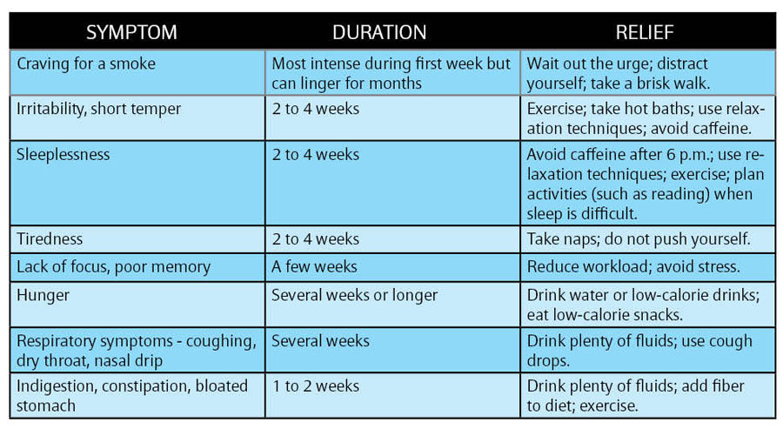

- The role of the PHC physician (in smoking cessation clinics) 9” (e)
- The most effective preventive intervention that a clinician can provide for tobacco-using patients against heart disease, cancer, cerebrovascular disease and chronic obstructive pulmonary disease is an empathic, personalized smoking cessation intervention program with extended assistance and follow-up. The goal of the intervention must be complete smoking cessation. Reduction provides no direct health benefits to the individual smoker. Interventions are readily available, but underutilized, in part due to lack of clinician training and organizational support.
- “Five A's”: Ask, Advise, Assess, Assist and Arrange. Pharmacotherapeutic tools, including nicotine replacement therapies (nicotine gums, patches, nasal sprays, inhalers and new therapies) and non-nicotine therapies (bupropion, clonidine, nortriptyline and other antidepressants and anxiolytics) are considered. Adherence validation methods, new approaches to tobacco and addiction treatment that appear in the recent research literature are reviewed.
5 R’s strategy:
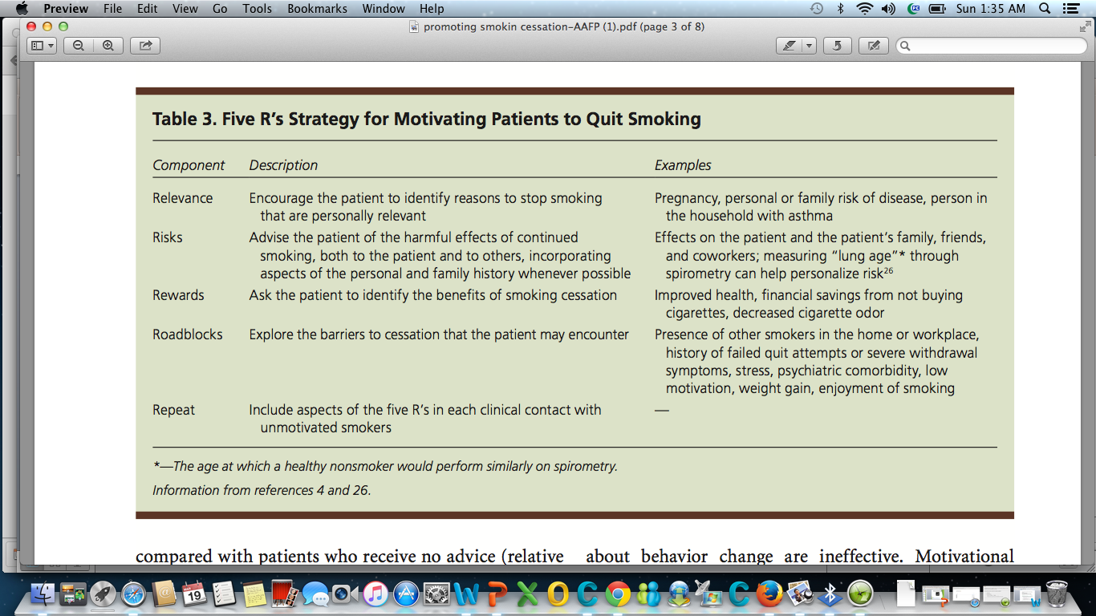
Pharmacotherapy (f)
- Pharmacotherapy can be divided into two groups: nicotine replacement therapy (NRT) and non-NRT. NRT increases abstinence rates by 2 to 3 times that of placebo.³⁵
- All pharmacotherapy treatments approximately double the cessation rates. Therefore, patient preference and prior experience is the basis for treatment choice
- NRT is not advised for patients in immediate post myocardial infarction (within 4 weeks), patients with serious arrhythmias, worsening angina pectoris, or pregnant and lactating women.⁵¹ NRT works by supplanting nicotine from cigarettes and relieving or preventing nicotine withdrawal symptoms. Non-NRT alters or alleviates withdrawal symptoms as well.
- Clinicians may recommend any of 5 pharmacotherapies: nicotine gum, nicotine patch, nicotine nasal spray, nicotine inhaler and non-NRTs.⁵⁹ As with all pharmacologic therapies, concomitant personal and telephone counseling significantly increase cessation rates

Nicotine gum (g)
- The pharmacodynamics of gum cause a gradual rising and falling of nicotine levels throughout the day. Repeated chewing of the nicotine gum delivers nicotine over time. Nicotine levels drop when the gum is not chewed and overnight during sleep. A daily cycle of neuroadaptation and abstinence develops, just like smoking cigarettes, but the amplitude of the cycles is blunted
- Advantages of the gum include having a behavior to use with an urge to smoke that actively controls nicotine mood changes. Disadvantages include great effort to chew enough gum.
- adverse side effects : may include sore mouth, throat or jaw, hiccups, dysgeusia, dyspepsia, nausea, flatulence and gastrointestinal discomfort.

Nicotine patch (g)
- The pharmacodynamics of the transdermal NRT is different from nicotine gum. Nicotine levels rise gradually and then plateau for most of the day as the patch diffuses nicotine through the skin and into the bloodstream at a constant rate. Nicotine patches are the preferred method of NRT because of the ease of use and high concentrations of nicotine delivered. The nicotine patch is available in several formulations that vary in strength and duration of action.
- Advantages of the patch, as mentioned, are ease of use, minimal side effects and demonstrated efficacy. Disadvantages include potential adverse health consequences of sustained levels of nicotine in the body.⁵⁸
- Adverse effects of the nicotine patch include localized skin irritation characterized by erythema, pruritus, or burning under the patch.⁴⁶ Up to 50% of patients have localized skin reaction with less than 5% requiring discontinuation of the nicotine patch therapy. Reactions are self-limiting.
Nicotine nasal spray (g)
- The nasal spray delivers nicotine more rapidly than gum, patch or inhaler, and mimics the nicotine bolus from cigarettes.⁶⁰ Similar to nicotine gum, the nicotine nasal spray is used in place of smoking when the patient craves nicotine. Plasma nicotine levels peak within 10 minutes and are about two-thirds those of cigarette.
- Adverse effects of nicotine nasal spray include headache, burning, rhinitis, watering eyes, nasal or throat irritation, sneezing and coughing. These adverse reactions tend to occur in the first few days and decrease within the first week.

Nicotine inhaler (g)
- As with other NRTs, it doubles the cessation rates comparable to placebo. The inhaler may be the best choice for smokers that need a substitute for the hand to mouth behavior, and the tactile/sensory stimulation that cigarettes provide. It is also effective as a combination therapy with other NRT agents and bupropion.
- The “inhaler” designation is a misnomer. The device does not deliver nicotine to the lungs. Absorption occurs from the oral and pharyngeal mucosa and gastrointestinal tract secondary to swallowing. Therefore, the pharmacokinetics and dependence risks of the inhaler are similar to nicotine gum. The blood nicotine levels are lower with the inhaler than with any other NRT.

Non-NRTs (g)
- BUPROPION HYDROCHLORIDE is an aminoketone antidepressant that weakly inhibits both noradrenergic and dopaminergic uptake. It is believed to work based on the dopaminergic activity affecting the mesolimbic system and nucleus accumbens, which is the pleasure reinforcing area of the brain for addictive drugs. It also affects the noradrenergic activity in the locus caeruleus, which activates higher cortical functions such as alertness, concentration and memory. Lack of norepinephrine stimulation with nicotine withdrawal may account for withdrawal symptoms.
- Advantages: Clinical trials showed cessation rates similar to NRT. Bupropion may also decrease weight gain associated with smoking cessation. Bupropion is a better choice for females and other smokers who use weight gain as an objection to smoking cessation. It is also an option for smokers who do not want to try NRT, who have relapsed, or who have failed on NRT.
- Bupropion is most effective in combination therapy. One study identified bupropion combined with the nicotine patch as having achieved higher cessation rates than with either as a monotherapy
- Adverse effects of bupropion include insomnia and dry mouth. Bupropion can decrease the seizure threshold. Seizures may occur in 0.1% of patients.
- CLONIDINE is a centrally acting α2-adrenergic agonist that dampens sympathetic nervous system activity (used primarily in the management of hypertension). A small number of trials have shown that clonidine may be effective in promoting smoking cessation, but prominent side effects limit its usefulness for this purpose
- ANTIDEPRESSANTS AND ANXIOLYTICS: Nortriptyline is a tricyclic antidepressant that blocks reuptake of norepinephrine and serotonin. It has been studied and shows some promise,^{72,73} but is not yet been approved by the U.S. Food and Drug Administration for smoking cessation treatment.
Because depression and anxiety are associated with cigarette smoking, a variety of other antidepressants and anxiolytics have been tested (buspirone, doxepin and fluoxetine hydrochlorides), but while the results have been promising, investigations are too preliminary yet to draw valid conclusions as to their efficacy.
- Varenicline:
Varenicline is a smoking cessation medicine. It is used together with behavior modification and counseling support to help you stop smoking.
Stop using varenicline and call your doctor at once if you have:
a seizure (convulsions);
thoughts about suicide or hurting yourself;
strange dreams, sleepwalking, trouble sleeping;
new or worsening mental health problems--mood or behavior changes, depression, agitation, hostility, aggression;
heart attack symptoms--chest pain or pressure, pain spreading to your jaw or shoulder, nausea, sweating;
stroke symptoms--sudden numbness or weakness (especially on one side of the body), slurred speech, problems with vision or balance; or
severe skin reaction--swelling or redness of the skin, blisters in your mouth, or skin rash that spreads and causes blistering and peeling.
Your family or other caregivers should also be alert to changes in your mood or behavior.
Common side effects may include:
nausea (may persist for several months), vomiting;
constipation, gas;
sleep problems (insomnia); or
unusual dreams.

Advantages and disadvantages of pharmacologic treatments for smoking cessation (summary)
Treatment | Advantages | Disadvantages
Patch and/or gum | Available over the counter | Not approved by FDA;  avoid use with dentures;  temporomandibular joint disorder;  adhesive allergies
Nicotine nasal spray | Higher, quicker nicotine levels | Unpleasant adverse events initially;  avoid use with chronic nasal allergies
Nicotine inhaler | Mimics hand-to-mouth behavior | Low nicotine levels
Bupropion hydrochloride | Non-nicotine; can be used in combination with patch; decreased weight gain; mood stabilization with nicotine withdrawal | Must screen for seizures

Substance Abuse (h)
- May lead to?
- Genetics contribute to the increased likelihood that an individual will abuse drugs, and to what extent the substance abuse may escalate.
- Environmental risk factors include availability of drugs, poverty, social changes, peer influences, employment status, type of occupation and cultural attitudes.

Alcohol (i)
- Alcohol use is the fourth leading cause of preventable death in the United States.
- Alcohol is responsible for of conditions such as :
- Cirrhosis
- Motor vehicle accidents
- Cancers
- Homicide
- Suicide
- Hemorrhagic stroke

Opioids (i)
- Opioids are powerful pain killers that are highly addictive such as morphine, heroin.

Benzodiazepine (i)
- It is a psychoactive drug that enhances the effect of the neurotransmitter gamma-aminobutyric acid (GABA) at the GABA_{A} receptor, resulting in sedative, hypnotic (sleep-inducing), anxiolytic (anti-anxiety), anticonvulsant, and muscle relaxant properties.
- One of the causes of death
- The combination of BZDs and opioid analgesics can produce significant respiratory depression

Cocaine (i)
is a strong stimulant mostly used as a recreational drug.^{[10]} It is commonly snorted, inhaled as smoke, or as a solution injected into a vein.^{[9]} Mental effects may include loss of contact with reality, an intense feeling of happiness, or agitation

National Survey on Drug Use and Health: Trends in Prevalence of cocaine for Ages 12 or Older, Ages 12 to 17, Ages 18 to 25, and Ages 26 or Older; 2015 (in percent)
 | Age 12 or older | Age 12 to 17 | Ages 18 to 28 | Ages 26 or older
Cocaine | 14.5 | 0.8 | 11.7 | 16.6

Amphetamine (i)
- is a potent central nervous system (CNS) stimulant that is used in the treatment of attention deficit hyperactivity disorder (ADHD), narcolepsy, and obesity.
Acute overdose | Chronic use
Seizures, Hypertension, Tachycardia, Myocardial infarction, Hyperthermia, Psychosis, Stroke, Death. | Severe psychological  depression.

Cannabis (i)
- Cannabis consumption has been associated with multifactorial deaths, including marijuana-related accidents and deaths attributed to abuse of alcohol and other illicit substances
- Clinicians are advised to identify at least 2 or more of the following physical symptoms, occurring within 2 hours of cannabis use, as defined by DSM-5 criteria:
- Conjunctival injection - Increased appetite
- Dry mouth - Tachycardia

Approach to substance abuse (j)
- Identification:
- We need to know is it actually substance abuse or misuse.
- We ask about
- Have they ever used drugs before?
- Quantity
- Frequently
- Last use
- Look for symptoms that suggest drug use such as:
- Acute chest pain in a young person.
- Acute psychosis (EMERGENCY!).
- Mood and sleep disorders.
- Assessment
- Medical, psychological, social and occupational needs
- History of drug use
- Experience of previous treatment, if any
- Goals in relation to his or her drug use
- Treatment preferences.

Brief intervention
- Components of brief intervention:
- Introducing the issue in the context of the patient's health
- Screening, evaluating, and assessing
- Providing feedback
- Talking about change and setting goals
- Summarizing and reaching closure
- Counseling
- Psychosocial interventions:
- Contingency management
A set of techniques that focus on changing specified behaviors.
- Behavioral couples therapy : interventions to service users in close contact with a non-drug-misusing family member
- A range of evidence-based psychological interventions,
such as cognitive behavioral therapy.
- medical intervention

