Women Health

Definition of women health: "a state of complete physical, mental and social well-being and not merely the absence of disease or infirmity”

Women health Team:
- Obstetrician/gynecologist
- General surgeons specializing in breast care
- Perinatologist
- Primary care doctor

Causes of mortality in women:
Young age: communicable diseases such as self-inflicted injury and HIV, and respiratory diseases, malaria, and maternal and perinatal conditions

Older age: non-communicable chronic diseases such as heart disease, stroke and cancers (except developing countries communicable diseases is still the highest)

Screening:
Definition: The ability to diagnose and treat a potentially serious condition at an early stage when it is still treatable.

Tobacco: Fagerstorm test (when you wake up when you take your first cigarettes, how many per day... etc.

Alcohol: examination: alcohol odor, slurred speech Investigation: GGT, MCV, LFT.
CAGE Questionnaire for detecting alcoholism

Screening for dyslipidemia: (total cholesterol and HDL)
Women above 45: if result came high take full panel
Women above 20: only if family history of multiple cardiovascular risk including premature CVD.
Total Cholesterol: 200<
HDL: 40>

Screening for DM:
All adults beginning at 45 years of age.
Or any adult with risk factor; Physical inactivity, 1st degree relative with DMT2, Hypertension, Polycystic ovarian syndrome. etc.
Screening for diabetes:
Fasting plasma glucose test (FPGT)
Oral glucose tolerance test (OGTT)
Random plasma glucose test (least accurate)

Screening for Hypertension:
Age 40: annually
- 140 / 90 mm HG considered hypertensive

Depression screening:
The Edinburgh Postnatal (post partum) Depression Scale
Patient health Questionnaire for depression (for all types of depression)

Intimate partner violence (Domestic Violence):
HITS and WATS Screening tools for Domestic Violence

Role aspirin in cardiovascular diseases
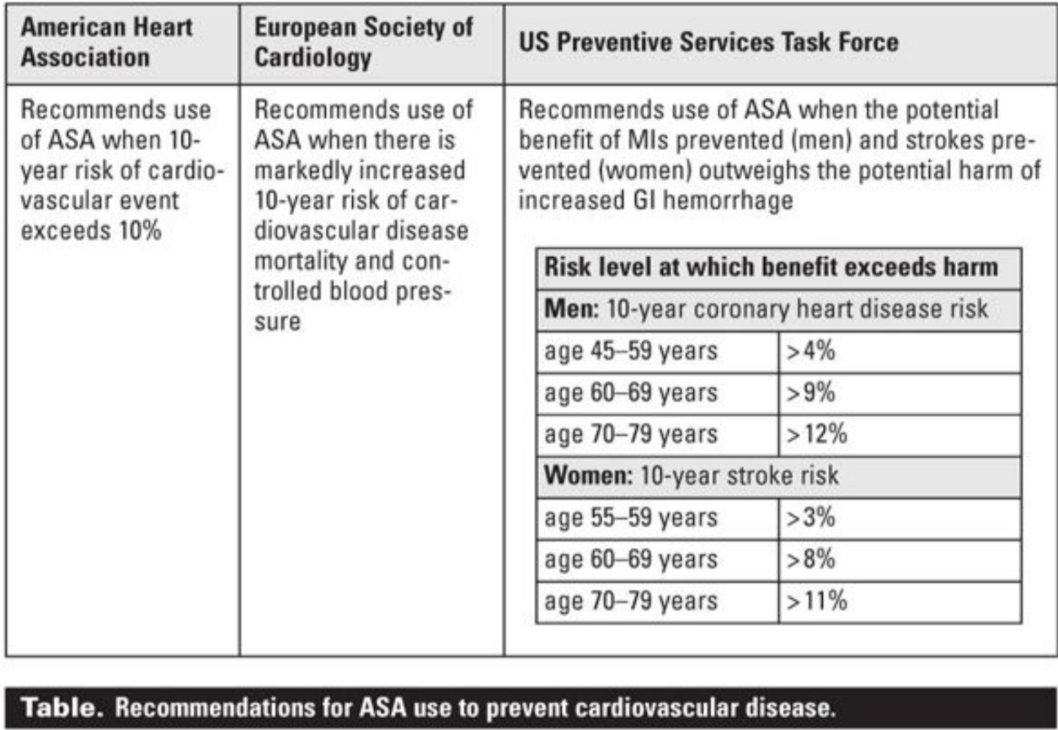

Primary prevention:
Only for Women who have CVD Risk; old age, Hypertension, DM ... etc.
Make sure the patient doesn’t have hemorrhagic stroke and gastrointestinal (GI) bleeding.
Secondary prevention: is well established and beneficial for CVD.

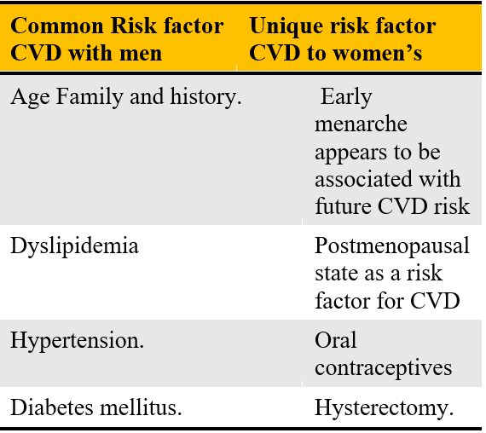
Unique presentations of CVD in women:
- Atypical angina
- stress-induced cardiomyopathy
- Heart failure preserved ejection fraction
- spontaneous coronary artery dissection

- Preconception counseling: Preconception care is defined as a set of interventions that aim to identify and modify biomedical, behavioural and social risks to the woman's health or pregnancy outcome through prevention and management. Certain steps should be taken before conception or early in pregnancy to maximize health outcomes.

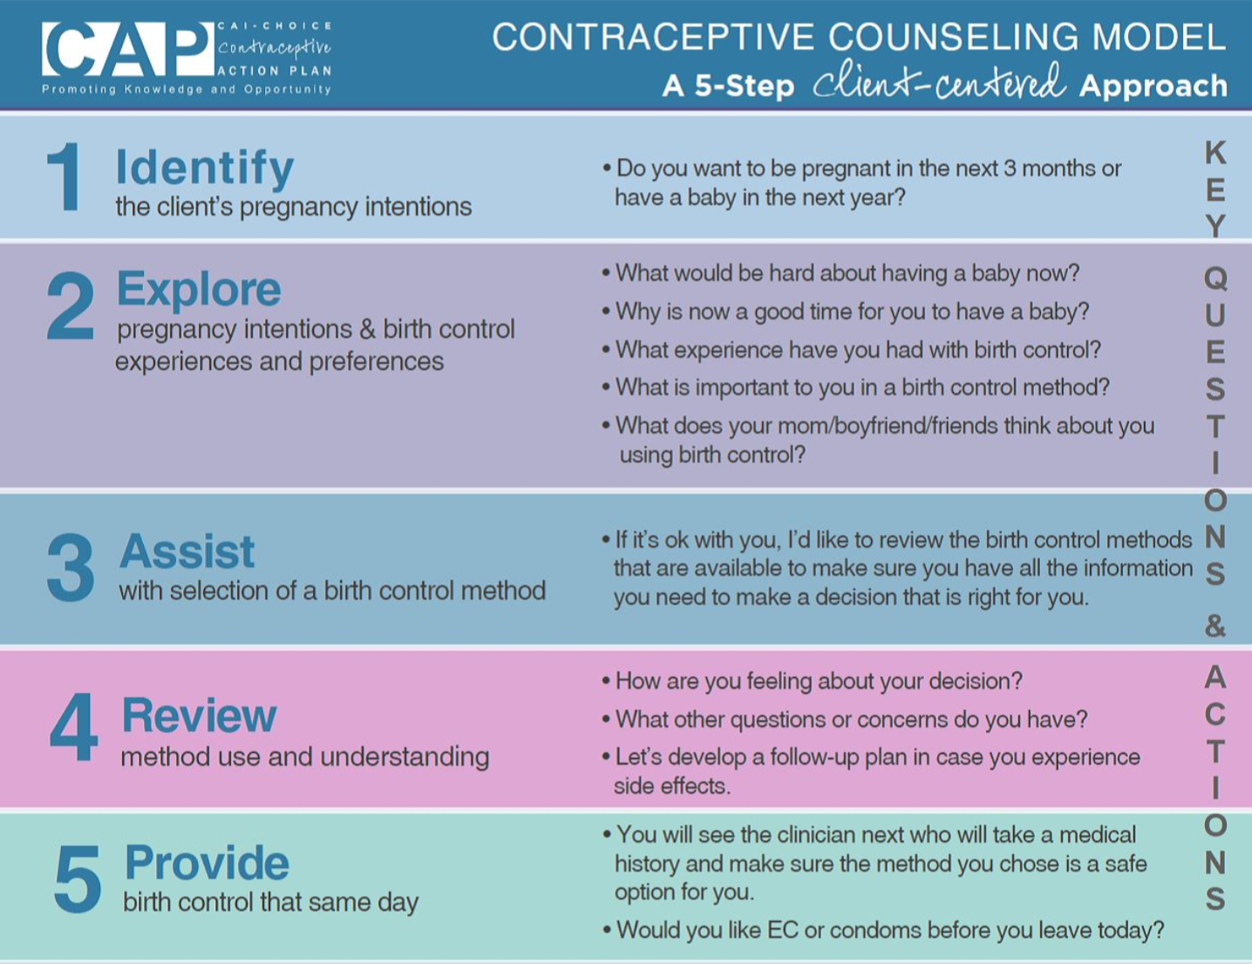
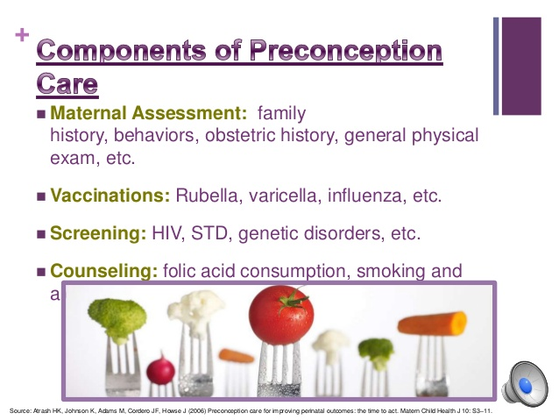

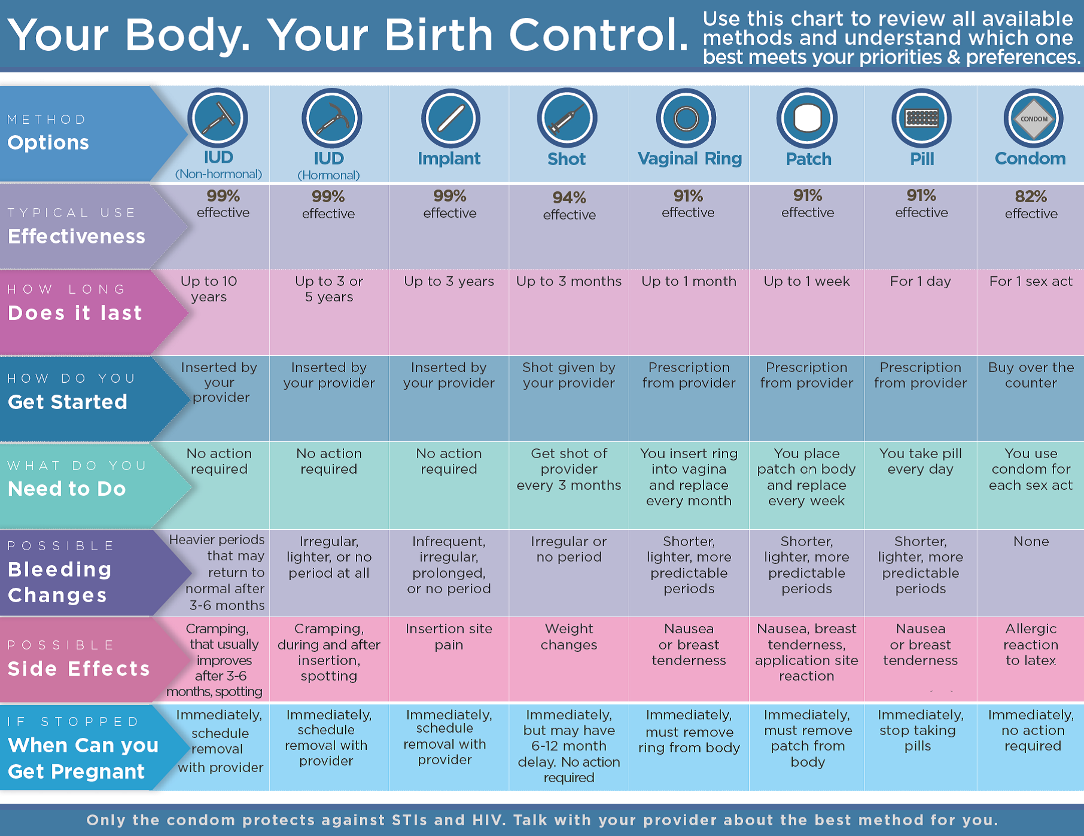
Screening for chlamydia and gonorrhea
- Sexually active women under 25 years of age
- Retest approximately 3 months after treatment
- Pregnant women with chlamydial infection should have a test-of-cure 3-4 weeks after treatment and be retested within 3 months
- NAAT is a molecular test that detects the genetic material (DNA) of Chlamydia trachomatis. It is generally more sensitive and specific than other chlamydia tests and can be performed on a vaginal swab on women, or urine from both men and women which eliminates the need for a pelvic exam in women.

Why are they the same?
Because they are co-existing infections

Method: Virginal swap, collecting urine

Syphilis
Syphilis is cause by a Bacterium called Treponema pallidum and it has four stages Primary, secondary, latent, and tertiary. They are characterized with chancres, rash, asymptomatic, and then organ failure respectively. For screening we have to major types of tests Non-treponemal antibody test and Treponemal antibody test. The first is sensitive and the second is specific. Rapid Plasma Regain is the non-treponemal and Treponema Pallidum Particle Agglutination assay is the more specific test. We usually need blood test for it but CSF sample also can be used.
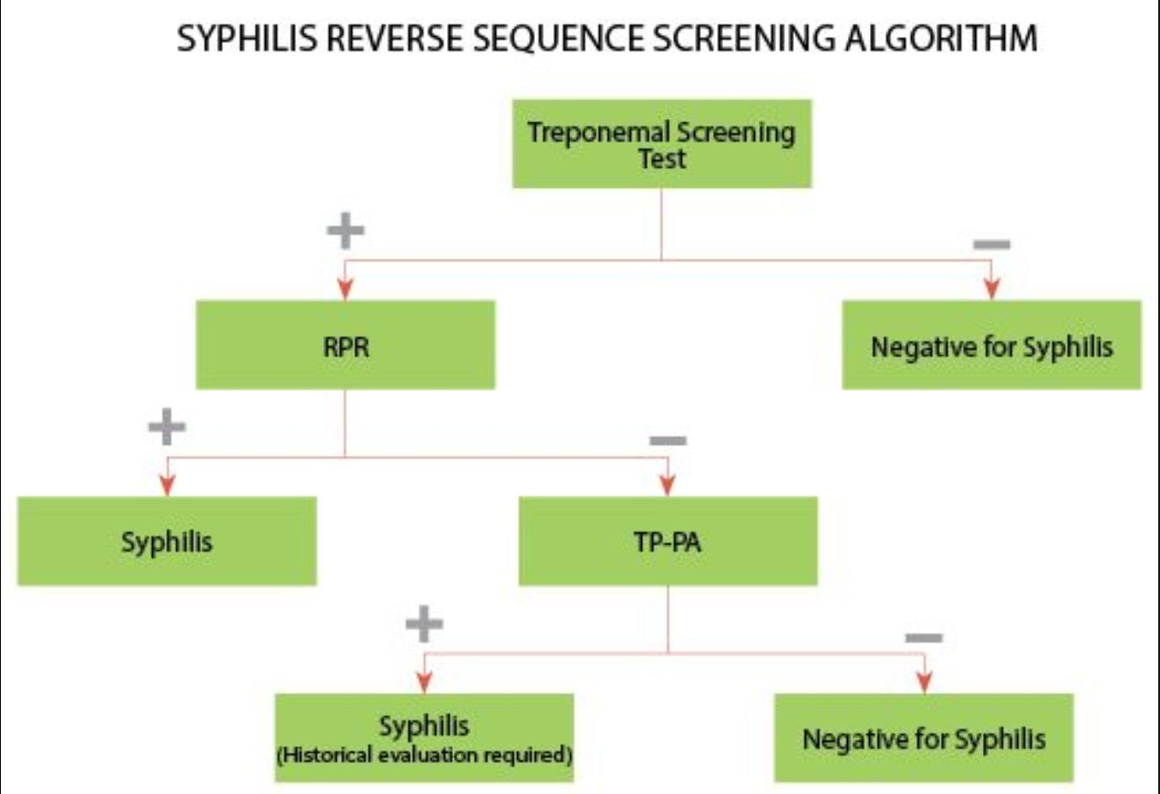

RPR: Rapid plasma regain
TP-PA: Treponema pallidum particle agglutination assay
Method: Blood test or CSF sample

STI complications:
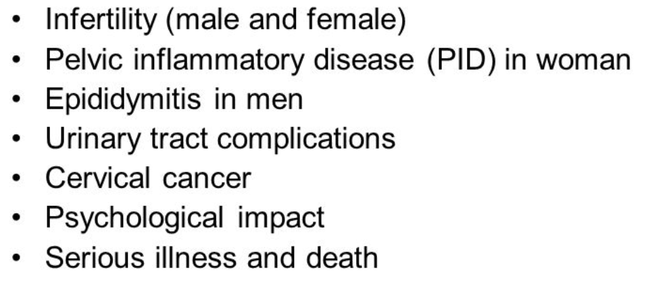
Screening for Cervical cancer:

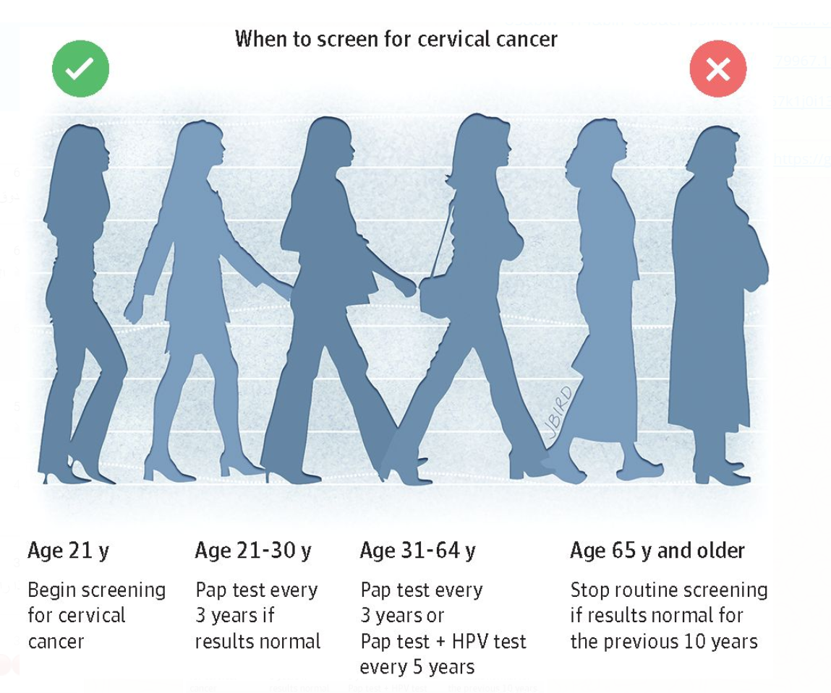

- Women 21-29 years of age every 3 years with cytology
- Women 30-65 years of age every 3 years with cytology, or every 5 years with a combination of cytology and HPV testing
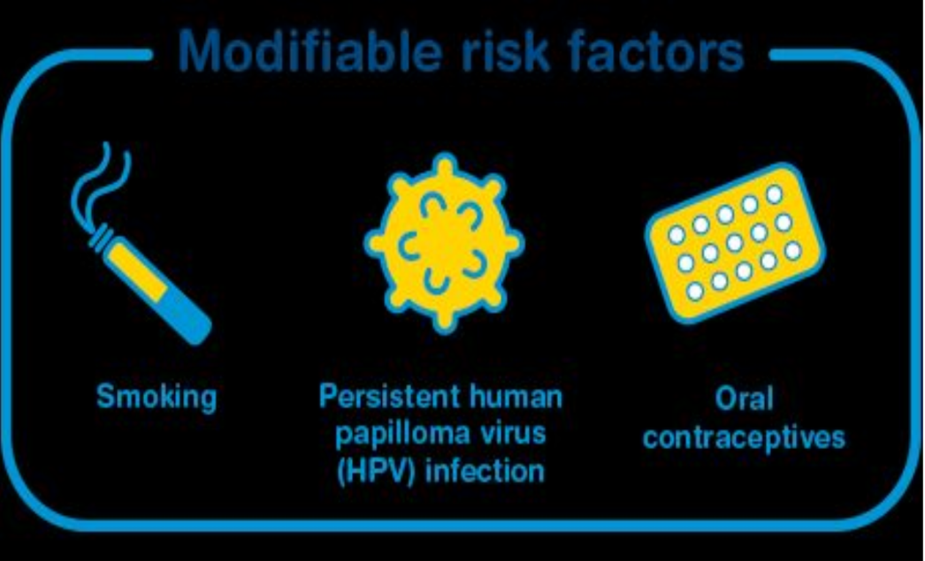
- Early detection: Pap test.
- Tests to confirm: cervical biopsy
- Characterized with vaginal bleeding after sexual intercourse, urinary symptoms, and pelvic pain.

- Almost always caused by HPV, other risk factors:
- Multiple sexual partners
- Early marriage
- Early child birth
- Having more than 3 children

Screening for Breast cancer:
Breast Cancer is the most common cancer among women, signs and symptoms varies from feeling of a lump in the breast, discharge, pain, and retracted nipple. And this diagram demonstrate the types of breast cancer such as Ductal carcinoma in situ, Lobular carcinoma in situ, and invasive ductal cancer.
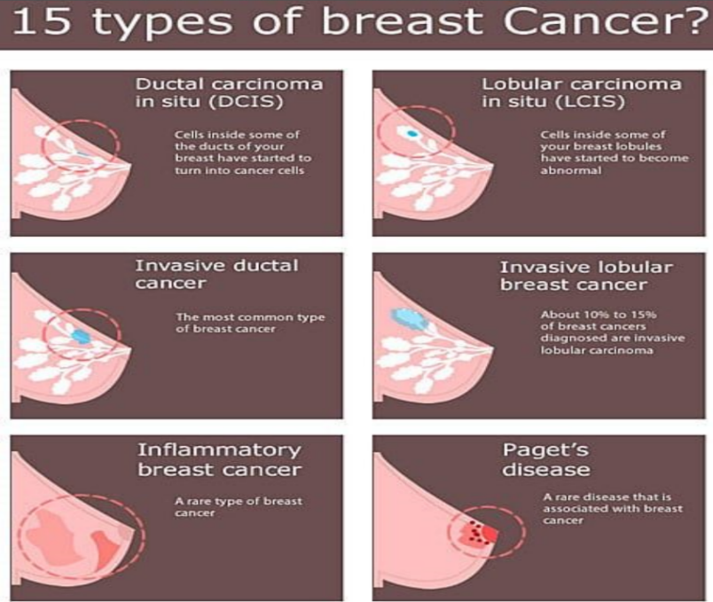
Recommendation:
- -Women ages 40 to 44 should have the choice to start annual breast cancer screening with mammograms if they wish to do so.
- Women age 45 to 54 should get mammograms every year.
- -Women 55 and older should switch to mammograms every 2 years, or can continue yearly screening.
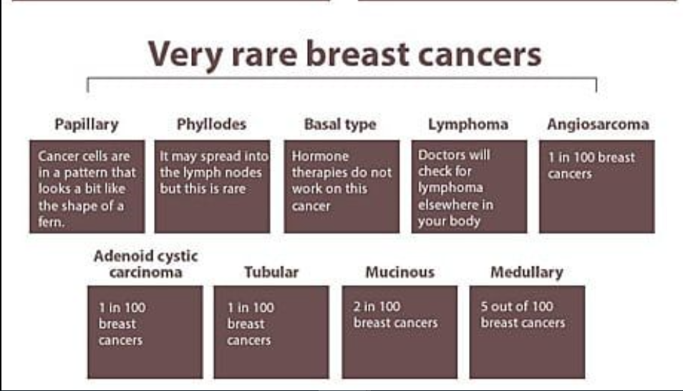
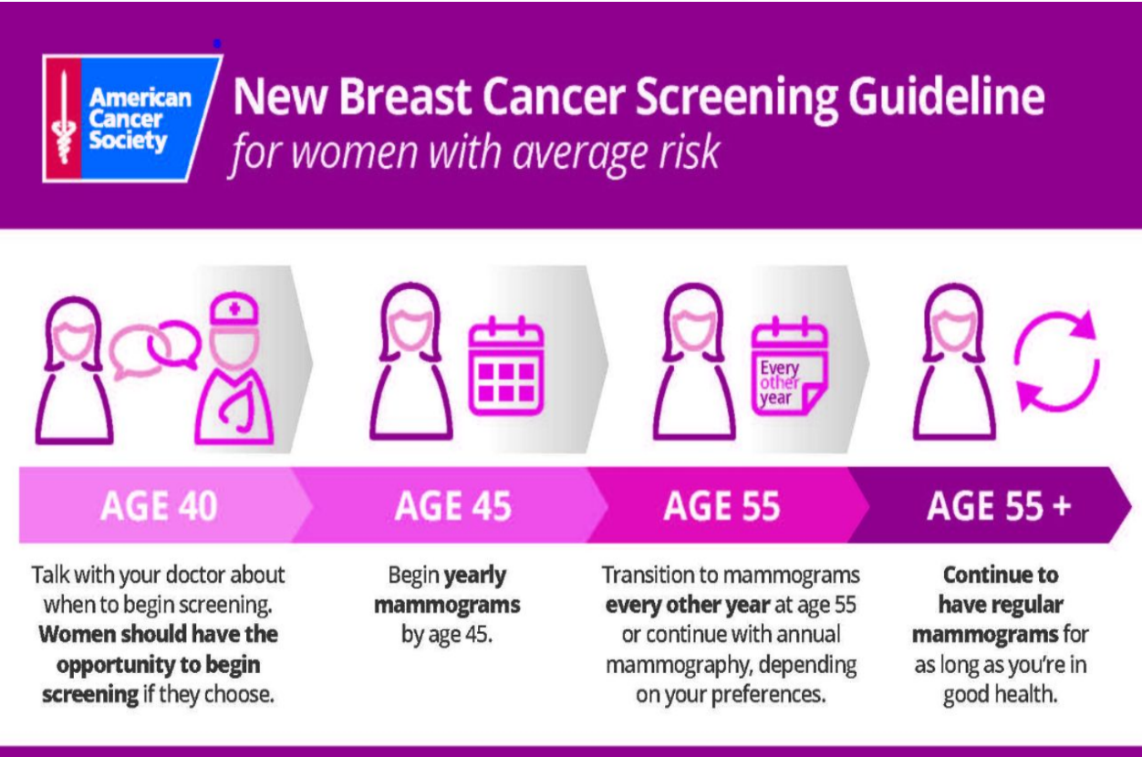
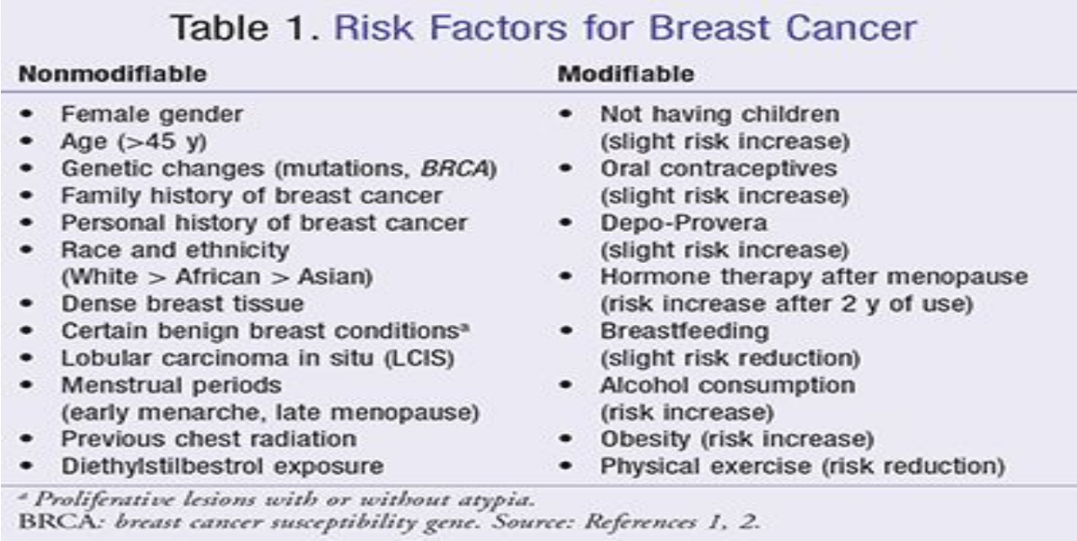
We do not do Mammograms before 40 instead; we do ultrasound and physical examination

Screening for colon cancer:
Characterized with abdominal discomfort, alternating bowl movement, bleeding per-rectum, and tenesmus. Generally, we screen for patients from the age of 50 till 75 years old with either colonoscopy every 10 years, flexible sigmoidoscopy every 5 years, or Fecal occult blood test. But there are some variations if there is increased risk of colorectal cancer is present. For instance, those with family history will start earlier screening (10 years earlier than the family history diagnosis age or at 40 years old), and those with previous history of colorectal cancer will go through screening every 2 years.

  - We start screening over the age of 50
- Patients with average risk + no family history the colonoscopy will be every 10 years, High risk patients the colonoscopy will be every 5 years.
- high-sensitivity fecal occult blood testing annually. blood occult test:
every 2 years to the patients aged 60-74 years.
- flexible sigmoidoscopy every five years with high-sensitivity fecal occult blood testing every three years.

Screening for osteoporosis:
Osteoporosis is a disease in which the density and quality of the bone is reduced.
Multiple fractures is a sign of osteoporosis especially in the hip, spine, and the wrist.

Recommendation:
- -All women above 65-year-old
- - Women younger than 65-year-old with one or more risk factor of osteoporosis
- - Postmenopausal women with fracture
Screening methods:
- (DEXA) dual-energy X-ray absorptiometry every two years for recommendation patients.

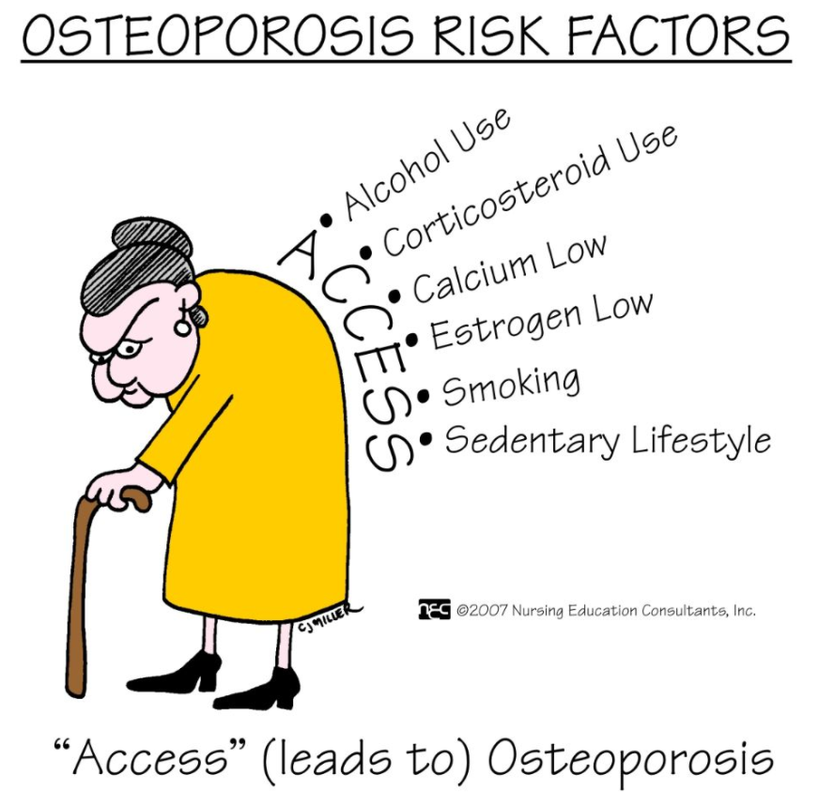
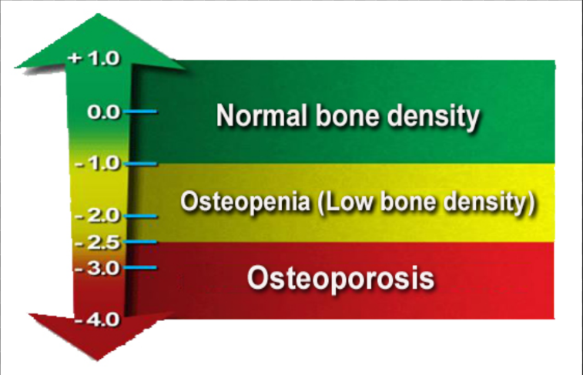

Vaccination for Women:
Avoid MMR during pregnancy
T dap is recommended between 27-36 in gestation
The type of vaccine in pregnant women is: inactivated
Maternal immunization protects both the mother and fetus from the morbidity of certain infections
Ideally, women should be vaccinated against preventable diseases in their environment prior to conception according to the recommended adult immunization schedule

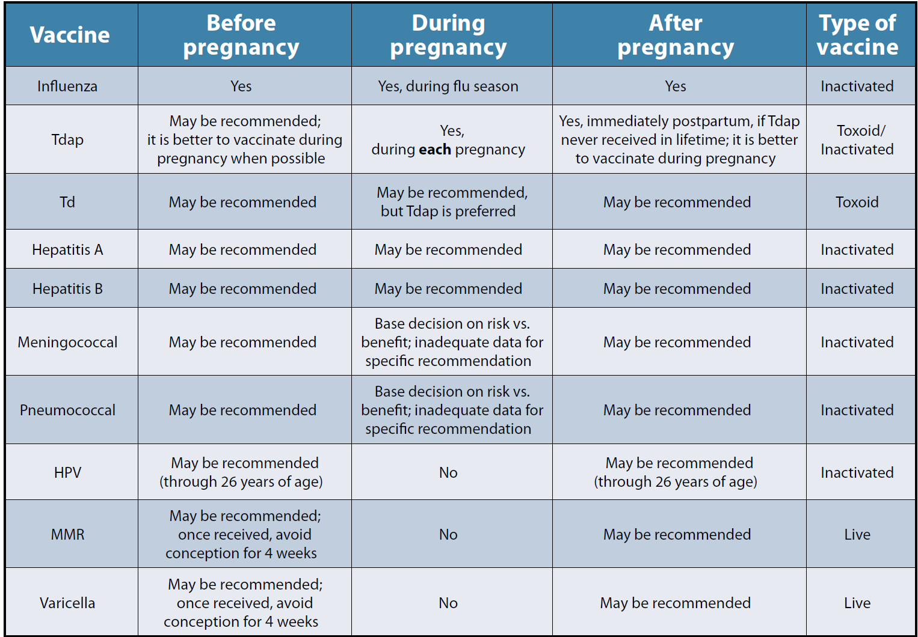

- Pertussis: can be life threatening for the new born.
- Influenza virus: increase the chances of pre-mature labor and delivery.
- immunizations routinely recommended for all pregnant women: tetanus, diphtheria, pertussis, and influenza.
- Live attenuated are not recommended during pregnancy (e.g. MMR and Varicella) while HPV isn’t recommended due to lack of evidence.
Menopause:
as the time when there have been no menstrual periods for 12 consecutive months and no other biological(pregnancy) or physiological (hyperthyroidism) cause can be identified and age above 40. The process of menopause does not occur overnight, but rather is a gradual process. This so-called perimenopausal transition period is a different experience for each woman.

Symptoms: (hair loss, itchy skin, hot flushes, night sweet, breast pain, loss of libido, vaginal dryness, osteprosis, frequint urination).

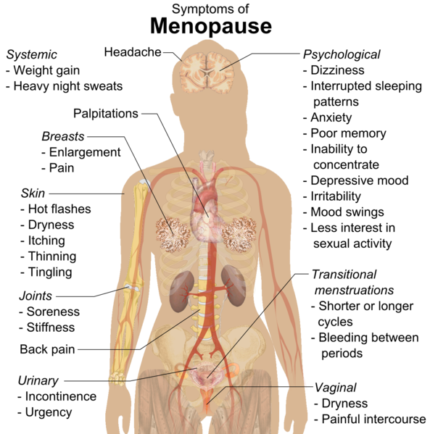

- BLOOD TESTS: FSH Level : more than 35
- thyroid function test (rule out hyperthyroidism)
- a lipid profile
- tests for liver and kidney function

Management:
- 1- Lifestyle Changes including diet and exercise
- 2- HRT as solution
- 3- Gabapentin decrease flushes by 45%

