Review of Neuroanatomy & Neurophysiology:
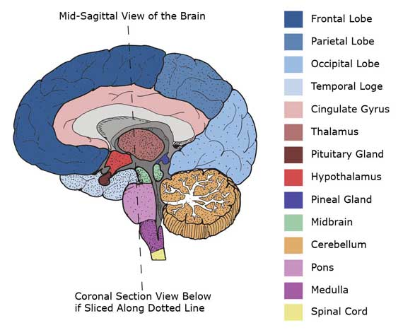
 | Functions:
Frontal Lobe: | Cognitive and intellectual functions:  Attention, concentration, registration, orientation (to time, place & person) reasoning, understanding, analysis, comparison, critical thinking, problem-solving, planning and judgment. |  | Control of behavior, voluntary movements, sphincters. | Motor language:  Processing information to produce speech (dominant frontal). |  | Control of emotion:  RT frontal lope contain negative emotions (anger, fear….) Brain lesions affecting RT hemisphere lead to unusual euphoria and inappropriate laughter.  Whereas LT controls such negative emotions and contain positive emotions. Brain lesions affecting LT lead to exaggeration of fear and worries.
Temporal Lobe | Retention and comprehension of auditory and visual information. |  | Recall of recently registered information (dominant hippocampus) |  |  | Emotions and sexual activity.
Partial Lobe | Interpretation of sensations: Touch, pressure (stereognosis). |  | Appreciation of body image (spatial orientation) |  |  | Constructional skills:  dressing, drawing … (non-dominant lobe)
Occipital Lobe | Perception and analysis of visual sensation (color, Shape, dimensions…)
Cerebellum | Coordination of muscle concentrations and motor activity. |  |  | Maintenance of posture and body balance.
Basal Ganglia | Subconscious control of tone and movements of the skeletal muscles, such as swinging the arms while walking.
Midbrain | -Consciousness and arousal (function of the reticular formation which extends also through pons and medulla) |  | -Control of reflexive head and eye movements. |  |  | -Raphe nuclei function: serotonergic neurons in the brainsteam projecting to a large number of brain structures.
Pons | -Connection of various parts of the brain with each other |  | -Cranial nerve function (5,6,7 & 8) |  |  | -Locus Cerulus is the most important noradrenergic nucleus in the brain, which has very high density of noradrenaline neurons, and numerous projections to other brain regions, especially the cortex and hippocampus. It is essential for the behavioral and physiological expression of anxiety and fear.
Medulla | Medulla contains:  -Vital centers: cardiac, respiratory and vasomotor centers.  -non-vital centres: vomiting, swallowing, sneezing, coughing and hiccupping centers. |  | -Cranial nerve function (9, 10 & 11) |  |  | -Connection of the spinal cord with the brain.
Reticular | - Consciousness and alertness. |  | - Control of skeletal muscles. |  |  | -Control of somatic and visceral sensations.
Thalamus | -Sensory relay station: processing tactile, proprioceptive, pain and temperature information,  Sending it to sensory cortical areas. |  | - Integrating a large variety of sensory and motor information, and the relation of this  Information to one’s emotional feelings, subjective states, and personality. |  |  | -Influencing the level of consciousness and alertness through connections with the reticular  Formation and cortical centers.
Hypothalamus  preserves body homeostasis through regulation of: | -Food intake: Feeding/hunger center, located in the lateral side of hypothalamus, which is  chronically active and its activity is transiently inhibited by the activity in the satiety center,  Located in the ventro-medial side, after the ingestion of food.  - Water intake (superiolateral part of Hypothalamus).  -Sleep (suprachiasmatic nucleus: light reduces melatonin in pineal gland whereas darkness  Enhances melatonin secretion).  -Temperature :  *Antirising center in the anterior hypothalamus, mediates the parasympathetic system to increase body heat loss, thus reducing body temperature.  *Antidrop center in the posterior hypothalamus mediates the sympathetic system to reduce body heat loss.  - Higher control of hormones: Catecholamines-vasopressin-oxytocin-ACTH-TSH-FSH-LHProlactin and growth hormones.  - Higher control of the autonomic nervous system  *Parasympathetic (by anterior hypothalamus). *Sympathetic (by posterior hypothalamus).
Autonomic Nervous System | It is distributed throughout the central and peripheral nervous system, divided into two parts:  The sympathetic and the parasympathetic.
 | - The sympathetic nervous system  β1 stimulation : acceleration in the heart rate and increase in the myocardial contractility.  β2 stimulation: vasodilatation of skeletal muscles and coronary artries, bronchodilatation, and  Relaxation of uterus, intestines and bladder.  α receptor stimulation : constriction of the arterioles of the skin and intestine, mydriasis,  piloerection, sweating, ejaculation, closure of the sphincters and reduction of salivary glands  Secretion. |  |  |  | - The parasympathetic nervous system  It aims at restoring energy. It slows the heart rate, constricts the pupils, increases peristalsis  Of the intestine and glandular activities (increasing secretions), opens the sphincters and contracts the bladder wall. The parasympathetic neurons also facilitate erection
Limbic System: | - Components: Cingulate gyrus - hippocampus(temporal lobe) - amygdala- parahippocampal  gyrus- hypothalamus-anterior nucleus of thalamus - major tracts connecting the system.
 | -Sexual feelings and pleasure: norepinephrine is involved in ejaculation (males) and orgasm (females). | - Emotional and behavioral responses (anger, fear, etc.).  -Neocortical activates modify emotional behavior and vice versa. However, one of the characteristics of emotion is that it cannot be turned on and off at will. Anther characteristics of limbic circuits is their prolonged After-discharge following stimulation. This may explain in part the fact that emotional responses are general prolonged rather than evanescent and outlast the stimuli that initiate them. |  |  |  |  | -Recent memory
Gate Control Theory of Pain | Cortical and subcortical centers process and filter afferent pain impulse though a gating mechanism in the dorsal horn of the spinal cord, competing signals and neurotransmitters can open or close the gate on painful perceptions. Serotonin in descending pathways has an inhibitory effect (closing the gate). Endorphin deficiency seems to correlate with the augmentation of afferent stimuli. Substance P is involved in altering the pain threshold.  Thus, neurobiological factors play a large role in the onset and perpetuation of pain experience.

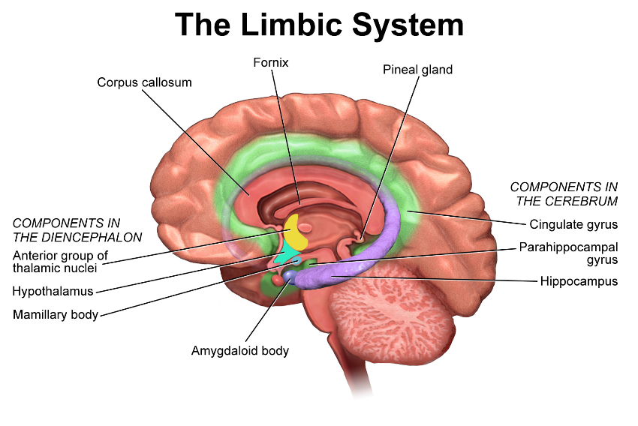
REVIEW OF NEUROTRANSMITTERS:
SEROTONIN  (5 Hydroxytryptamine = 5HT) |  | Serotonin is indolamine synthesized from an essential amino acid L-tryptophan, found in the gastrointestinal tract, platelets, monocytes (5HT1A: enhances activity of natural killer cells/psychoneuroimmunity), the brain, and the spinal cord. The major site of serotonergic cell bodies in the brain is the raphe nuclei in the brainstem, from which fibers  project to many brain structures, these include projections to:  -Frontal cortex: regulation of emotional reaction to stress and impulsive behavior (5HT 1A).  - Limbic system: anxiety and panic feelings (5HT 2A-2C).  - Basal ganglia: movement control and compulsions (5HT2A).  - Hypothalamus: appetite and eating regulation (5HT 3).  - Brainstem chemoreceptor trigger zone: vomiting (5HT 3).  - Brainstem sleep centers: deep sleep (5HT 2A).  Ingestion of food rich in tryptophan rapidly increases brain serotonin synthesis, which  Accounts for their mild sedative effects.  - Spinal cord: sexual spinal responses, orgasm (5HT 2A).  - Peripheral serotonergic receptors in the intestine regulate intestinal secretions and motility (5HT 3,4 &7).  Serotonin deficiency is found in depression, anxiety, panic disorder, phobias, obsessive  Compulsive disorder and bulimia nervosa. Serotonin Metabolized to an inactive metabolite by MAO-A enzyme.
DOPAMINE  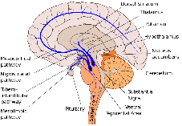 |  | Dopamine is a catecholamine synthesized from tyrosine. There are four major dopaminergic tracts:
 |  | 1. The mesolimbic dopamine pathway: emotional behavior,  Reward reinforcement, pleasure feelings and sex drive.  Pathological hyperactivity of the pathway accounts for active psychotic  (Hallucinations, delusions, aggression…).  Nucleus accumbens is a dopamenergic nucleus , located in  the mesolimbic pathway, involved in the physiological  Reward system. Its reinforcing effects are stimulated by  Caffeine, nicotine, cocaine and other CNS stimulants.  Its stimulation increases sex desire and behavioral response, and suppresses appetite. |  |  | 2. The mesocortical dopamine pathway: mental arousal  And cognitive functions. Pathological underactivity  of this pathway (mesocortical defect: due to primary  dopamine neuron defect, glutamate excitotoxic  overactivity, or serotonergic over-activity) is responsible  for most negative features and cognitive defects seen in  Some schizophrenic patients. |  |  | 3. The nigrostriatal tract:  low dopamine levels are associated with motor symptoms of Parkinson’s disease. Antidopaminergic drugs lead to Parkinsonian extrapyramide side  Effects. Serotonin 2A receptors on dopamine neurons inhibit dopamine release. |  | 4. The tuberoinfundibular tract: dopamine inhibits prolactin release from the anterior  Pituitary.
Dopamine Receptors:
- D1 receptors may play a role in negative symptoms (D1 antagonist treat negative symptoms).
- D2 receptors blocked by anti-psychotic drugs for the treatment of positive psychotic Symptoms. D2 agonists are used for the treatment of Parkinson’s disease.
- Other dopaminergic receptors (D3, D4 & D5) : it is not clear to what extent these receptors
Contribute to the clinical properties of anti-psychotic drugs.
NOR-ADRENALINE(NOREPINEPHRINE) | Noradrenaline is a catecholamine synthesized through hydroxylation of dopamine. The major concentration of noradrenergic cell bodies in the brain is in the locus Cerulus from which neurons project to:
 | - Frontal cortex: regulation of mood (Beta 1 receptors) and regulation of cognitive functions (Alpha-2 receptors) |  |  | - Limbic system: energy, emotions and psychomotor activity control. |  | -Cerebellum: regulation of motor movements. |  | - Cardiovascular centers in the brainstem: -blood pressure regulation.  Noradrenergic innervation regulates the heart rate (via Beta 1 receptors in sympathetic neurons) and controls bladder emptying (via Alpha –receptors).  Alpha –2 presynaptic noradrenergic autoreceptors (on adrenergic neurons) and heteroreceptors (on serotonergic  Neurons) have a negative feedback effect; inhibiting excessive release of noradrenaline and serotonin respectively.  Noradrenaline at low concentrations has stimulatory effects on immune function but it inhibits effects at high concentrations.  Noradrenaline is involved in ejaculation in men and orgasm in women.
Noradrenaline – Serotonin Interactions
There are two types of presynaptic noradrenergic receptors on serotonin neurons that regulate
serotonin release:
- α-1 receptors (in the brainstem; a pathway from locus cerulus to raphe nuclei), when stimulated, these receptors enhance serotonin release.
- α-2 heteroreceptors (in the cortex): when stimulated, they turn off serotonin release.
ACETYLCHOLINE (ACH) | Acetylcholine is synthesized from choline and acetyl coenzyme A. The major brain center for  cholinergic neurons is the nucleus basalis of Meynert, which projects to cerebral cortex and the  Limbic system. These neurons have the principal role in mediating short-term memory.  Additional cholinergic neurons are found in:
 | - The reticular formation: REM –sleep induction. |  | - Basal ganglia (extrapyramidal tract) and cerebellum: regulation of body posture, muscle  Tone and motor movements. |  |  |  | - The autonomic nervous system; parasympathetic (both pre and post synaptic pathways)  Some sympathetic pathways (presynaptic /sweet glands). |  | - Acetylcholine is involved in erection. N.B.: nitric oxide (NO), not nitrous oxide (N2O), is also involved in erection .It is synthesized in the body from l-arginine.
GAMA AMINOBUTYRIC ACID (GABA) | GABA is an amino acid neurotransmitter with a very fast inhibitory action. It is found almost  Exclusively in the brain, and synthesized from glutamate.  GABA is thought suppress seizure activity, anxiety and mania. There are three types of GABA  Receptors A, B&C. The GABA-A receptors have binding sites for benzodiazepines and  Barbiturates, which increase the affinity of the GABA-A receptors for GABA.
GLUTAMATE | Glutamate is an amino acid excitatory neurotransmitter synthesized from deamination of glutamine. Many sensory organs – including the cochlea, the olfactory bulb, the retina, and  thalamocortical fibers– use glutamate as their principal neurotransmitter. Pyramidal neurons  In the cortex are glutamartergic. Glutamate is involved in the highly organized information  Flow through the brain. In the hippocampus, glutamate may be specifically relevant to the  Pathophysiology of dementing illness (Alzheimer's disease). Glutamate excitotoxicity is  suggested as a possible cause of neuronal degeneration in schizophrenic patients with negative  features.Sigma receptors (1&2): related to glutamate receptors (NMDA) and involved in enhancement of memory and cognitive functions, when stimulated by fluvoxamine they  Improved the negative symptoms in schizophrenic patients.
SUBSTANCE – P | It is an excitatory neurotransmitter associated with mediation of pain perception and thought to play an important role in the pathogenesis of migraine, cluster headache and chronic pain.  Abnormalities affecting substance P have also been hypothesized for mood disorders,  Alzheimer’s dementia and Huntington’s disease.
HISTAMINE | Histamine is synthesized from histidine. located in the hypothalamus and fibers projecting to cerebral cortex, the limbic system, and the thalamus. There are three types of histamine receptors: H1 receptors regulate appetite and arousal, and have a role in allergic symptoms. When antihistamines are used for allergic symptoms they exert marked sedative effects and weight gain; H2 receptors are involved in gastric acid output; when H2 – receptors antagonist are used they heal gastric and duodenal ulcers. H3 – receptors: stimulation of these receptors thought to be expressed on histamine nerve terminals, suppresses histamine release.
MELATONIN | Hypnotic hormone produced by the pineal gland stimulated by darkness and inhibited by light (suprachiasmatic nucleus), involved in regulation of sleep-wake 24-hour cycle.
ENDOGENOUS OPIOIDS | Enkephalins, endorphins and dynorphins are involved through their receptors (mu, kappa and delta) in many mental functions: pain perception (analgesics), learning, memory, mood and dependence.

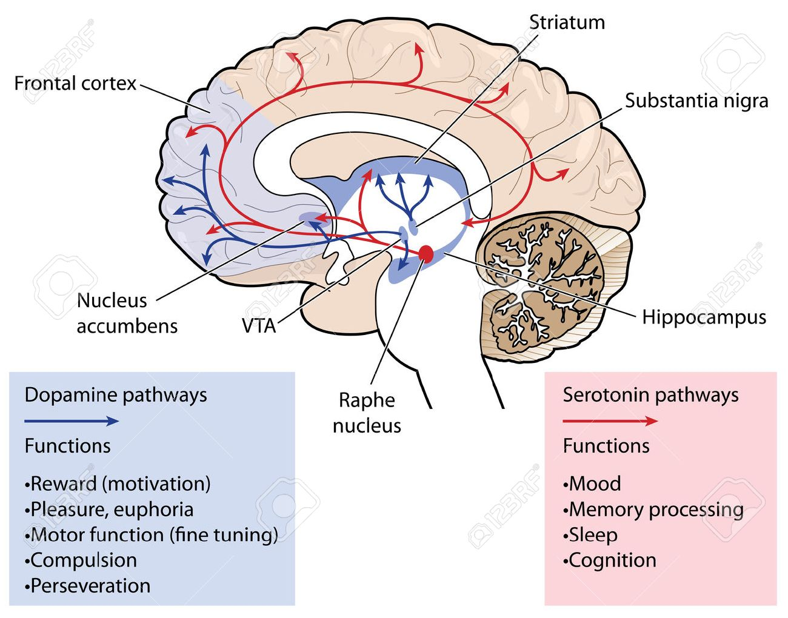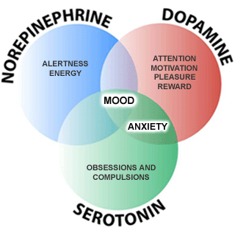
- Serotonin-Dopamine Interactions:
- Serotonin inhibits dopamine release in various dopamine pathways (understanding this is critical to understanding atypical antipsychotics )

CLINICAL PSYCHOLOGY
1. LEARNING THEORIES:
Learning is a relatively permanent change in behavior brought about by prior experience. There are three basic learning theories:
I. Classical Conditioning: | Stage 1: Unconditioned stimulus (e.g. food) > Unconditioned response (e.g. salivation) Stage 2: Conditioned stimulus (e.g. sound of the bell) + Unconditioned stimulus (food) > Unconditioned response (salivation).  Stage 3: Conditioned stimulus (sound of the bell) > Conditioned response (salivation).
I. Operant Conditioning | Behavior, which is followed by advantageous consequences, is likely to be repeated, whereas behavior followed by noxious consequences will become less frequent. Reinforcement: the process of increasing the frequency of a particular piece of behavior by presenting a reinforcing stimulus. Positive reinforcement: enhancement of behavior by a desired reward. Negative reinforcement: enhancement of behavior by removal of undesirable event.
III. Modeling | occurs when the behavior of an individual (the observer) is affected by the opportunity to observe the behavior of another person (the model)
Clinical Uses of Learning Theories: | - Treatment of phobias (systemic desensitization and flooding).  - Treatment of obsessive rituals (exposure and response prevention).  - Relaxation training (for anxiety).  - Aversion therapy (for alcoholism and sexual deviation).

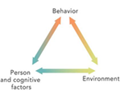 2. COGNITIVE THEORY
It emphasizes the impact of interpretation of events, expectations, and process of thinking about oneself, people, the environment, the past, and the future on the mood and behavior.
Depression and anxiety result from, and complicated by, wrong automatic thoughts e.g. “I am bad person”.
Correction of erroneous thoughts with cognitive therapy usually relieves patients from negative emotions

3. PSYCHOANALYTIC THEORY
A -Topographic model of the mind:  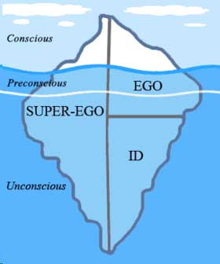 | 1. The conscious: | The part of the mind in which perceptions coming from the mind, the body and from the outside world are brought into awareness. Its content can be communicated by means of language or behavior.
 | 2. The unconscious: | The part of the mind that contains the instinctual wishes and drives (selfpreservative drives and sexual instincts) and represses them; keeping them out of conscious awareness through resistance to remembering.
 | 3. The preconscious: | The part of the mind that comprises those mental processes, contents and events that are capable of being brought into conscious awareness by deliberate focusing of attention on the memory.
B - Structural Theory Model (Ego Psychology):  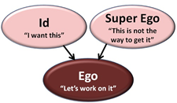 | It divides the psychological apparatus into the id, the ego and the super ego.  1. The “id”: It includes the unconscious instinctual wishes and drives, and operates according to the pleasure principle (it lacks the capacity to delay or modify the instinctual drives).  2. The “ego”: It attempts to achieve and coordinate optimal gratification of instinctual wishes and drives while maintaining good relations with the demands of the outer world and external reality.  3. The “superego”: It includes internalized moral values, prohibitions and standards; and offers approval or disapproval. The superego conducts an ongoing scrutiny of the person’s feelings, thoughts, and behavior. It establishes and maintains the person's moral conscience.
Defense Mechanism: | These are dynamic psychological strategies used by a person to deal with unpleasant situations or distressing internal conflicts, to manage instincts drives or affect.

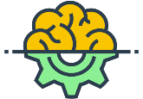 4. INTELLIGENCE TESTING
Intelligence is the ability to solve environmental problems and to adapt to changes. Two common tests are:
A. Binet test | B. Wechsler scales (for children and adults).
Intelligence Quotient (IQ) = (mental age/chronological age) x 100 | The tests include two selections verbal and performance
IQ scores:
average normal (100 +10), bright normal (120), superior (> 130), dull normal (80-90), borderline (70-79), mild mental retardation (50-70), moderate mental retardation (35-49), severe mental retardation (20-34), and profound mental retardation (< 20).

5. PERSONALITY TESTING
Personality is the distinctive patterns of thought, emotion, and behavior that define an individual’s personal style and influence his or her interactions with the environment.
The objective assessment of personality serves a number of practical needs in clinical psychiatry. Good personality test must have reliability and validity.
reliability | The extent to which there is repeatability of consistent results.
validity | The extent to which a test measures what it is designed to measure.
There are many personality tests. The two main tests widely used in clinical practice are:
- Eysenck personality Inventory (EPI):  It measures the following personality dimensions: extroversion (vs. introversion) neuroticism (vs. stability), psychoticism(vs. stability) |  | - Minnesota multiphasic personality Inventory (MMPI): it consists of “yas” or “No” self-answered questions. The results are given as scores in 10 subscales.
- Several intelligence and personality tests are available in Arabic language, and validated in some Arabic communities.
- The clinical psychologist plays an important role within psychiatri team for both patients assesmant (personality,IQ..) and treatment (behavioral, cognitive, psychodynamic …)
Good Luck. Done by: Futoon Alnemari

