URTI SLS Objectives

A-Rhinosinusitis

Classify Rhinosinusitits according to etiology?
Infectious (viral, bacterial, fungal) and non-infectious (allergic rhinitis, nasal polyps, tumors, mucus plug, septal deviation).

Classify infectious Rhinosinusitits according to etiology?
- Viral: Influenza viruses, Rhinoviruses , coronaviruses and adenoviruses.
- Bacterial: S. pneumonia, H. influenzae and M. catarrhalis
- Fungal: Aspergillus

Classify viral Rhinosinusitits according to etiology?
Common cold & Influenza

How many types of viruses can cause Influenza?
3 A, B & C.

What is the family of Influenza viruses?
Orthomyxoviridae

What are other viruses’ families that can cause common cold?
Rhinoviruses, Coronaviruses, and adenoviruses, human respiratory syncytial virus (in adults), parainfluenza viruses.

Harrison's Principles of Internal Medicine, 19e >
Chapter 223
Table 223.1

Compare between the 3 influenza viruses types in terms of the following: causing epidemics, & antigenic stability.

1-Influenza type A is antigenically highly variable and is responsible for most cases of epidemic influenza.
2-Influenza type B may exhibit antigenic changes and sometimes causes epidemics.
3-Influenza type C is antigenically stable and causes only mild illness in immunocompetent individuals.

Type D primarily affect cattle and are not known to cause illness in humans.
Jawetz, Melnick, & Adelberg’s Medical Microbiology, 27e >
Chapter 39: Orthomyxoviruses (Influenza Viruses)
INTRODUCTION

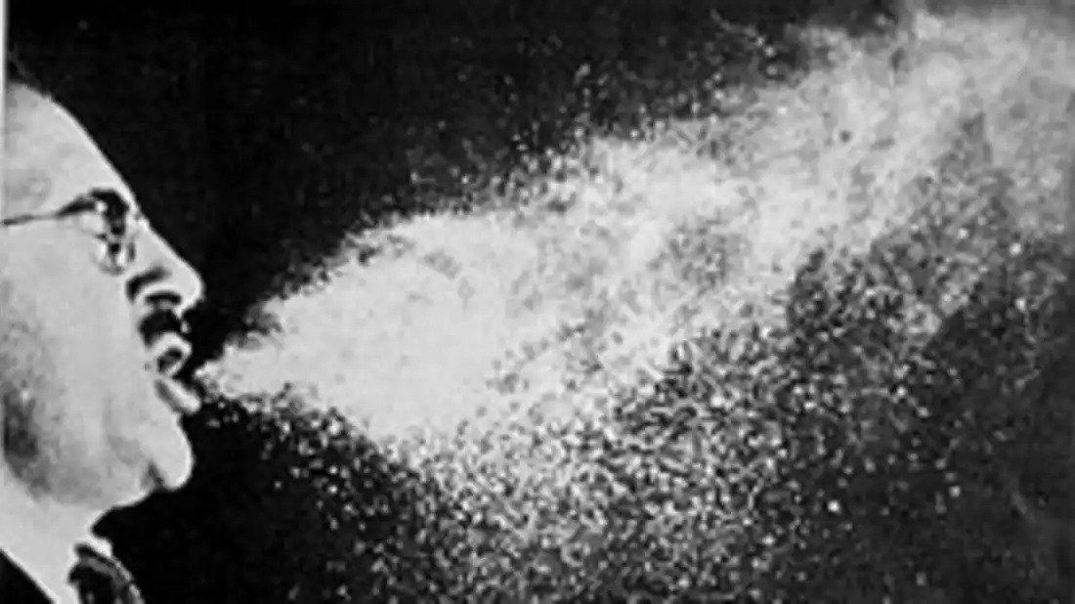

What are the mechanisms of influenza transmission?
mechanisms of transmission:
-Main transmission mechanism:
Large respiratory droplets:
-exposure to large particle (>5 micrometer) respiratory droplet when someone coughs, sneezes, or talks.
-These travel only for short distance (0-2 meters).
-droplet do not remain suspended in the air.
-transmission via large particle droplets require close contact between source and recipient individuals.
-Secondary transmission mechanisms:
1-Self contamination through hand-to-nose, hand-to-eye, hand-to-mouth transmission:
-after touching virus contaminated clothes, objects, surfaces, or skin/hands of another person, and then touching own nosem eye, or mouth.
2- small particle transmission at several meters:
-can be suspended as small particle in air (but only with procedures such as suction, intubation, aspiration,...).

How to differentiate between common cold and influenza?
1-it can be difficult to tell the difference between them based on symptoms alone. In general, the flu is worse than the common cold.
2-Flu can have very serious associated complications:
such as pneumonia, bacterial infections, or hospitalizations.

https://www.cdc.gov/flu/about/qa/coldflu.htm

What is the incubation period of influenza?
1-7 days

What are the symptoms of rhinosinusitis?
Two or more symptoms:
– Nasal obstruction/blockage/congestion
– Nasal discharge (rhinorrhoea / postnasal drip)
± Facial pain / pressure
± Reduction or loss of smell

How to properly exam a patient with rhinosinusitis?
-vital sign: temperature, respiratory rate, other vitals.
-Nose:
Anterior rhinoscopy :
Mucosal edema and erythema and nasal discharge (purulent, greenish or brownish)
then you should examine the throat, and ears
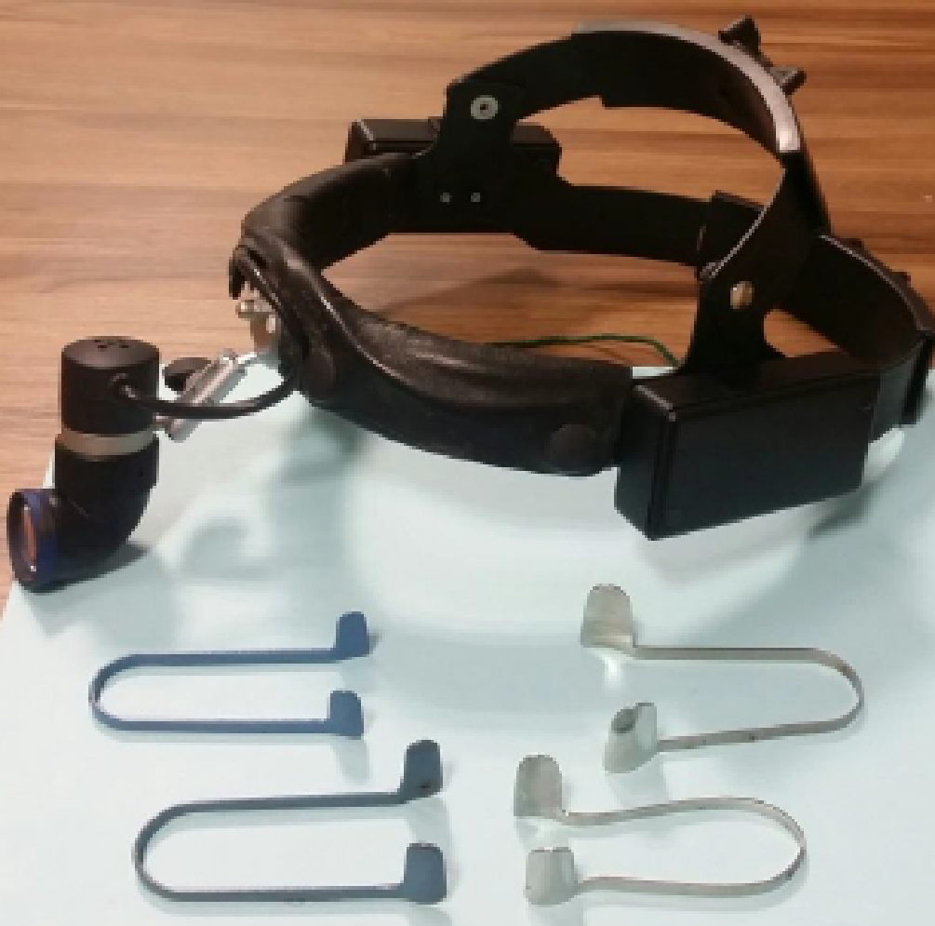

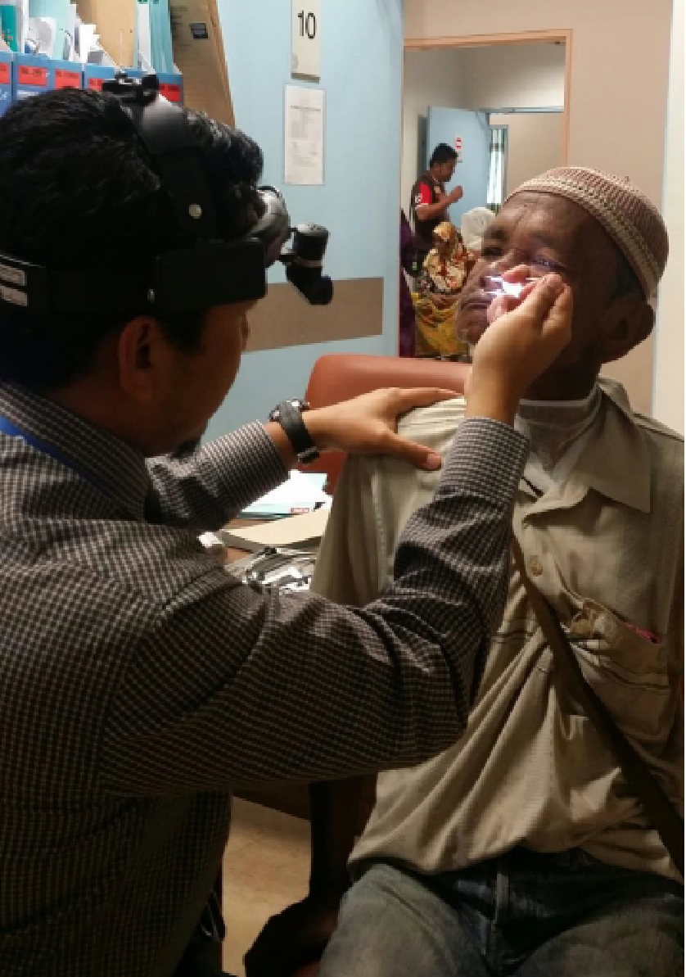

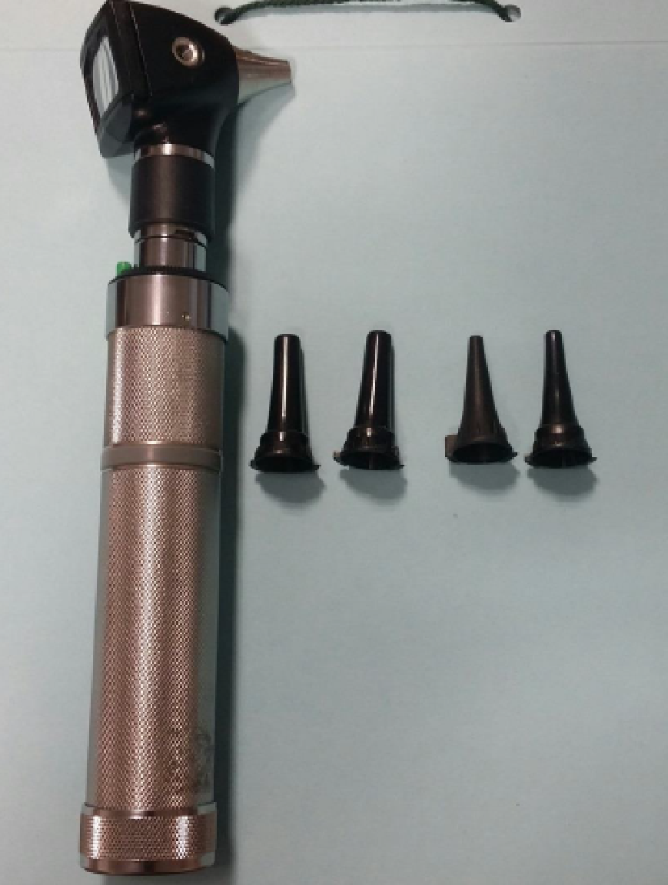

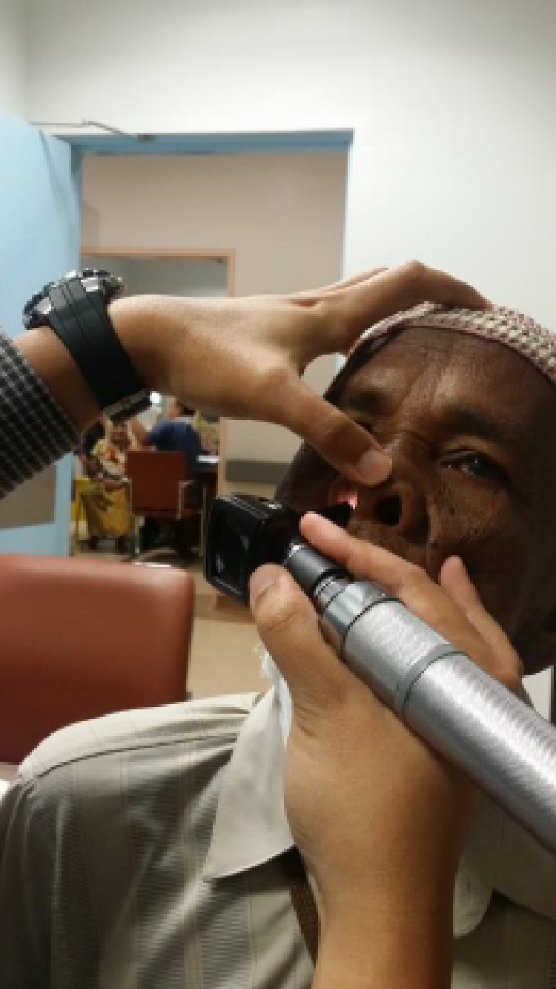

Pictures are from: Management Of Rhinosinusitis In Adults In Primary Care Professor Dr Salina Husain
What are the diagnostic tests for influenza?

Test | description | Advantages
Rapid Influenza Diagnostic Tests (RIDTs) | antigen detection tests | Quick results | -sensitivity 62.3%  -specificity 98.2%  -False negative results occur more commonly than false positive results.  - a negative result does NOT exclude a diagnosis of influenza in a patient with suspected influenza.
RT-PCR | More accurate but takes longer time.  When influenza is suspected and antiviral treatment is indicated, antiviral treatment should begin as soon as possible and should not wait for the results of testing.
Viral culture

https://www.cdc.gov/flu/professionals/antivirals/summary-clinicians.htm

How to differentiate between bacterial & viral rhinosinusitis?

1. The following clinical presentations (any of 3) are recommended for identifying patients with acute bacterial vs viral rhinosinusitis:

i. Onset with persistent symptoms or signs compatible with acute rhinosinusitis, lasting for ≥10 days without any evidence of clinical improvement (strong, low moderate);
ii. Onset with severe symptoms or signs of high fever (≥39_C [102_F]) and purulent nasal discharge or facial pain lasting for at least 3–4 consecutive days at the beginning of illness
(strong, low-moderate); or
iii. Onset with worsening symptoms or signs characterized by the new onset of fever, headache, or increase in nasal discharge following a typical viral upper respiratory infection (URTI) that lasted 5–6 days and were initially improving (‘‘double sickening’’)
(strong, low-moderate).

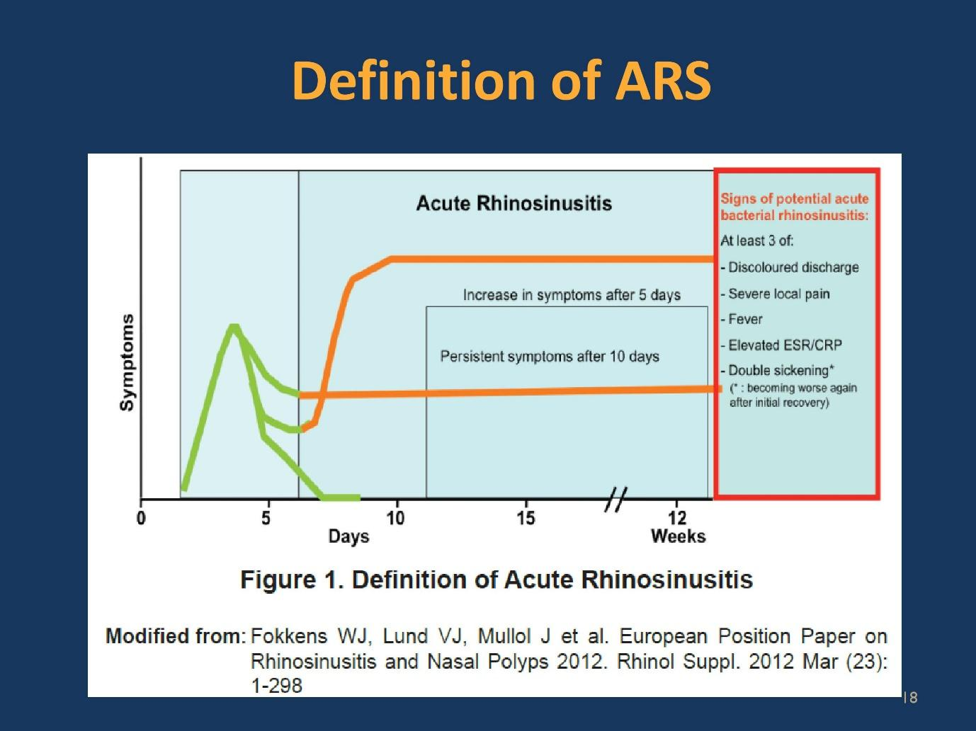
IDSA Clinical Practice Guideline for Acute Bacterial Rhinosinusitis in Children and Adults

A patient presents to you with a rhinosinusitis that is most likely viral in nature, he asks you to prescribe him an antibiotic in order to prevent secondary bacterial infection, what should you do?
You should not prescribe him an antibiotic, and explain to him than only 0.5%-2% of viral rhinosinusitis are complicated by by bacterial infection, and give him follow up so in case his symptoms persists or worsen you can reexamine and prescribe him an antibiotic if he really develops a bacterial infection.

Clinical Practice Guideline (Update): Adult Sinusitis Richard M. Rosenfeld
P s.9

When do we call bacterial rhinosinusitis acute or chronic?
Acute: <4 weeks
Subacute:4-12 weeks
Chronic: >12 weeks

Clinical Practice Guideline (Update): Adult Sinusitis Richard M. Rosenfeld
Figure 1

What is the rule of imaging in acute rhinosinusitis?
Clinicians should not routinely obtain radiographic imaging for patients who meet diagnostic criteria for acute rhinosinusitis (bacterial or viral), unless a complication or alternative diagnosis is suspected.
Complications of ABRS include orbital, intracranial, or soft tissue involvement. Alternative diagnoses include malignancy and other noninfectious causes of facial pain.

Clinical Practice Guideline (Update): Adult Sinusitis Richard M. Rosenfeld
P s.10&s.11

How to manage viral and bacterial rhinosinusitis symptomatically?
-Acute VRS may not completely resolve within 10 days but is expected to improve after 1 week, but sometimes the cough can last even longer, especially if the patients is a smoker.
-inform the patient about the self-limited nature of the viral rhinosinusitis can help manage his expectations, limit antibiotic use, and avoid unnecessary over-the- counter purchases.

Non pharmacological therapy
Symptom | Rest | fluids | Saline irrigation | Humidified air | Honey
Fatigue | √ | √
fever |  | √
Nose/sinus congestion |  |  | √
cough |  |  |  | √ | √ in children (don’t give it to less than 1 year old)

pharmacological therapy
Symptom | Paracetamol | NSAIDS  (mainly ibuprofen) | Antihitamisne  Oral/topical* | Decongestants  Oral/topical | camphor, menthol, & eucalyptus oils ointment (in children ≥2 years)
Fatigue | √ | √
fever | √ | √
rhinorrhea |  |  | √
Nose/sinus congestion |  |  | √ | √ | √
cough |  |  |  |  | √

Treat complications, e.g. antibiotics for secondary bacterial infection; treatment of exacerbations of COPD or asthma.

Clinical Practice Guideline (Update): Adult Sinusitis Richard M. Rosenfeld
Table 3

Besides symptomatic management, how would you initially approach a bacterial rhinosinusitis?

Either:
1-offer watchful waiting (without antibiotics).
2-prescribe initial antibiotic therapy for adults with uncomplicated ABRS.
-Watchful waiting should be offered only when there is assurance of follow-up, such that antibiotic therapy is started if the patient’s condition fails to improve by 7 days after ABRS diagnosis or if it worsens at any time.

Clinical Practice Guideline (Update): Adult Sinusitis Richard M. Rosenfeld
Table 3

What is the preferred 1st line antibiotic for bacterial rhinosinusitis?
amoxicillin with or without clavulanate as first-line therapy for 5 to 10 days for most adults.

Clinical Practice Guideline (Update): Adult Sinusitis Richard M. Rosenfeld
Table 3

When we consider the treatment for acute bacterial rhinosinusitis a failure?
-If the patient fails to improve with the initial management option by 7 days after diagnosis or worsens during the initial management, the clinician should reassess the patient to:
1-confirm ABRS.
2-exclude other causes of illness.
3-detect complications.
(you have to see the patient again in your clinic).
-If ABRS is confirmed in the patient initially managed with observation, the clinician should begin antibiotic therapy.
-If the patient was initially managed with an antibiotic, the clinician should change the antibiotic.

Clinical Practice Guideline (Update): Adult Sinusitis Richard M. Rosenfeld
Table 3

Who are the candidates for antiviral therapy for influenza?
- children aged younger than 2 years;¹
- adults aged 65 years and older;
- persons with chronic pulmonary (including asthma), cardiovascular (except hypertension alone), renal, hepatic, hematological (including sickle cell disease), and metabolic disorders (including diabetes mellitus), or neurologic and neurodevelopment conditions (including disorders of the brain, spinal cord, peripheral nerve, and muscle, such as cerebral palsy, epilepsy [seizure disorders], stroke, intellectual disability [mental retardation], moderate to severe developmental delay, muscular dystrophy, or spinal cord injury);
- persons with immunosuppression, including that caused by medications or by HIV infection;
- women who are pregnant or postpartum (within 2 weeks after delivery);
- persons aged younger than 19 years who are receiving long-term aspirin therapy;
- persons who are morbidly obese (i.e., body mass index is equal to or greater than 40); and
- residents of nursing homes and other chronic care facilities.

In summary: patients who are at extremes of Age, patients with chronic diseases, patients who are immunosuppressed, pregnant patients

https://www.cdc.gov/flu/professionals/antivirals/summary-clinicians.htm

What is the preferred antiviral agent for pregnant women?

Oral oseltamivir is preferred for treatment of pregnant women

https://www.cdc.gov/flu/professionals/antivirals/summary-clinicians.htm

How to prevent influenza & common cold?
1-Try to avoid close contact with sick people.
2-If you are sick with flu-like illness, CDC recommends that you stay home for at least 24 hours after your fever is gone.
3-Cover your nose and mouth with a tissue when you cough or sneeze. Throw the tissue in the trash after you use it.
4-Wash your hands often with soap and water. If soap and water are not available, use an alcohol-based hand rub.
5-Avoid touching your eyes, nose and mouth.
6-Clean and disinfect surfaces and objects that may be contaminated with germs.
7-Influenza vaccination yearly.

The influenza vaccine is recommended for whom?
Recommended for all persons six months and older who do not have contraindications.

What is the frequency of influenza vaccination?
Yearly.
Children six months to eight years of age who have not received influenza vaccination before require two doses for the first season. They should receive their first dose as soon as vaccine becomes available, followed by a second vaccination no earlier than four weeks later.
What does the influenza vaccine contain?
3-4 strains. it changes from season to season, with one or more vaccine strains replaced annually to provide protection against viruses that are anticipated to circulate during the upcoming season.

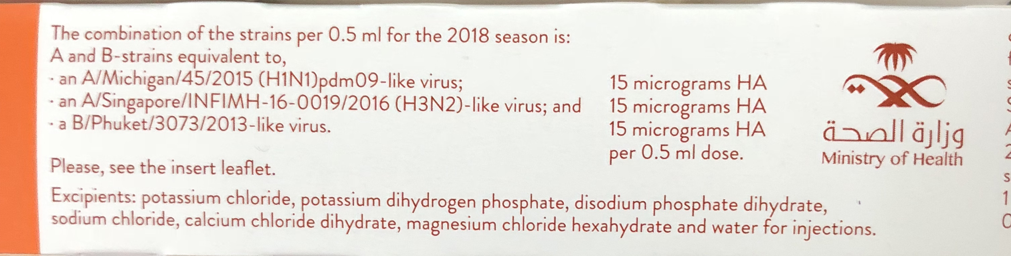
When should the influenza vaccine be offered?
During fall season.

A patient planning for Hajj asked you when is the best time to take the influenza vaccine?
It is preferred to be taken at least 2 weeks before Hakk in order for antibodies to develop.

Which food allergy you should ask about before giving influenza vaccine?
Egg

What are the Advisory Committee on Immunization Practices (ACIP) recommendations regarding persons with egg allergy and influenza vaccination?

ACIP recommends that persons with a history of egg allergy who have experienced only hives after exposure to egg should receive any of the recommended influenza vaccines appropriate for the recipient’s age and health status. Persons who have had reactions to egg involving symptoms other than hives (e.g., angioedema, respiratory distress, lightheadedness, recurrent emesis) or who required epinephrine or another emergency medical intervention may receive the cell culture–based or recombinant influenza vaccines appropriate for the recipient’s age and health status.

What are the contraindications to the influenza vaccine?

A previous severe allergic reaction to influenza vaccine is a contraindication to future receipt of the vaccine.

What are the Precautions to the influenza vaccine?
- Moderate or severe acute illness with or without fever.
- Guillain–Barré syndrome within 6 weeks following a previous dose of influenza vaccine.

------------------------------------------
define sore throat?
a sore throat refers to pain, itchiness, or irritation of the throat. patients may have difficulty swallowing food and liquids, and the pain may get worse when they try to swallow.

Classify pharyngitis?
Pharyngitis [C07.550.781]
- Nasopharyngitis [C07.550.781.500]
- Retropharyngeal Abscess [C07.550.781.625]
- Tonsillitis [C07.550.781.750]
  - Peritonsillar Abscess [C07.550.781.750.500]

https://meshb.nlm.nih.gov/record/ui?ui=D014069

list infectious etiologies of pharyngitis.
1-viruses:
-most common 50-80%.
-influenza virus, parainfluenza virus, rhinovirus, coronavirus, adenovirus, respiratory syncytial virus, epstein-barr virus.
2-Bacteria:
-Group A β-hemolytic streptococcus (GAS) also called streptococcus pyogenes (most common bacterial etiology 15-30% in children & 10% in adults).
-Group C & G streptococcus.
-Fusobacterium necrophorum (Lemierre's syndrome) rare but can cause serious complications ( thrombophlebitis of the internal jugular vein).
-chlamydia pneumonia.
-mycoplasma pneumonia.
3-Fungal.

http://dfcmopen.com/wp-content/uploads/2014/11/Approach-to-The-Patient-With-Sore-Throat.pdf

List non-infectious etiologies of pharyngitis?
post-nasal drainage due to rhinosinusitis, gastroesophageal reflux disease, acute thyroiditis, persistent cough, passive or active smoke inhalation, foreign body, post intubation.

http://dfcmopen.com/wp-content/uploads/2014/11/Approach-to-The-Patient-With-Sore-Throat.pdf

Why GAS is important?
Because it’s complications such as rheumatic fever and scarlet fever.
Essentials of medical microbiology 2016 p174

What are the complications of rheumatic fever and scarlet fever?
Rheumatic fever:
Carditis (valve damage).
Migratory polyarthritis
Sydenham’s chorea

Scarlet fever:
acute glomerulonephritis

Oxford handbook p276 & p655

What are the symptoms and findings suggestive of viral etiology of pharyngitis?
Conjunctivitis
• Coryza
• Cough
• Diarrhea
• Hoarseness
• Discrete ulcerative stomatitis
• Viral exanthem (rash)

IDSA Guideline for Managing Group A Streptococcal Pharyngitis p.6
What are the symptoms and findings suggestive of bacterial etiology of pharyngitis?
Tonsillar exudates (White patches or pus on tonsils)
Fever
Tender anterior cervical adenopathy
abdominal pain (especially in children due to abdominal lymphadenopathy).

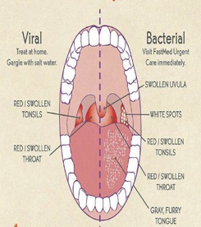

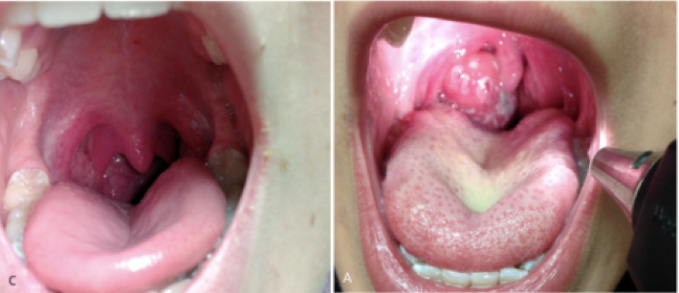

What are the alarming symptoms for someone with sore throat (suggests serious etiology or a complication)?
Drooling (might be due to epiglottitis which might cause airway obstruction requiring intubation)
Respiratory distress
Inability to open mouth fully (trismus=lockjaw, suggestive of retropharyngeal abscess)
Muffled voice or hot potato voice* (peritonsiallr or retropharyngeal abscess)
Stiff neck (meningitis)
Erythema of neck
Rigors
Night sweat
History of recent foreign body impaction or oropharyngeal procedure (trauma)
The patient history, an evidence based approach to differential diagnosis 2e p.192

* https://www.youtube.com/watch?v=dSBmpC1G52U

What is the best way to use the clinical examination to diagnose group A beta-hemolytic streptococcal (GAS) pharyngitis?

Modified centor criteria
Can’t be used in <3 years old
Symptoms onset should be <3 days
Score (1 point is given for each item, unless otherwise specified) | Fever >38  Cervical adenopathy in anterior cervical chain  Tonsillar exudate or swelling  No cough  Age (1 point for age 3-14 years,0 point for age 15-44, –1 point for age > 44 years)

Interpretation (point/ item total and % strep)
Rapid test and/or culture and/or immediate prescription of antibiotics | ≥ _4 points (55%)
Rapid test and/or culture and/or delayed prescription of antibiotics | 2 or 3 (29%)
Symptomatic therapy only, No further testing or antibiotics. | ≤ _1 (12%)

https://www.mdcalc.com/centor-score-modified-mcisaac-strep-pharyngitis#next-steps
Diagnosis of Streptococcal Pharyngitis
MARK H. EBELL,

Which age group is primarily affected by GAS pharyngitis?
Children 5-15 (37%), it is lower in younger children (24%), and even lower in adults (5-15%).

IDSA Guideline for Managing Group A Streptococcal Pharyngitis

How to test for GAS Pharyngitis?
Swabbing the throat and testing for GAS pharyngitis by rapid antigen detection test (RADT)
-not indicated for children <3 years old because acute rheumatic fever is rare in
children <3 years old and the incidence of streptococcal pharyngitis
and the classic presentation of streptococcal pharyngitis are
uncommon in this age group.
-Selected children <3 years old who have other risk factors, such as an older sibling with GAS infection, may be considered for testing

IDSA Guideline for Managing Group A Streptococcal Pharyngitis
how to take a throat swab
https://www.youtube.com/watch?v=vX3CJKueq18

If Rapid antigen test (RADT) is negative, should I do a throat culture?
RADT may miss cases of GAS pharyngitis depending on the sensitivity of the RADT available in your setting (ranges from 59%-95% and it is higher in newer kits).

A negative RADT should be accompanied by a follow-up or back-up throat culture in children and adolescents, while this is not necessary in adults under usual circumstances
(Because children are at higher risk of complications such as peritonsillar abscess, rheumatic fever, and poststreptococcal glomerulonephritis)

IDSA Guideline for Managing Group A Streptococcal Pharyngitis p.8
What are the complications of pharyngitis?
A-supporative:
-Quinsy (peritonsillar abscess)
Signs: unilateral peritonsillar swelling, difficulty swallowing (even saliva), and trismus (difficulty opening jaw).
Rx: refer for IV antibiotics + incision and drainage
-Retropharyngeal abscess: Occurs in children
Signs:inability to swallow, fever.
Rx: for IV antibiotics + incision and drainage
B-nonsupporative:
-Rheumatic fever:
60% develop chronic rheumatic heart disease (70% mitral valve) Likelihood correlates with severity of initial disease
Recurrence may occur after further streptococcal infection or be precipitated by pregnancy or combined hormonal contraception
-Scarlet fever (occurs at the same time with pharyngitis).
-Acute glomerulonephritis.

What is the symptomatic treatment for pharyngitis?
Warm fluids and foods such as teas soups
Foods that coat the throat, including honey and hard candies
Paracetamol
Nsaids (beware of gi and renal side effects, aspirin should be avoided in children)

IDSA Guideline for Managing Group A Streptococcal Pharyngitis p.2
When to consider giving antibiotics immediately?
-Acute sore throat where more than 4 centor criteria are present
-Patient is systemically very unwell
-Symptoms and signs suggestive of serious illness and/or complications (e.g. peritonsillar abscess, peritonsillar cellulitis)
-High risk of serious complications because of pre-existing comorbidity (e.g. significant heart, lung, renal, liver, or neuromuscular disease, immunosuppression, cystic fibrosis, and young children born prematurely)

What is the 1st line antibiotic for the treatment of GAS Pharyngitis?
Penicillin or amoxicillin for 10 days

IDSA Guideline for Managing Group A Streptococcal Pharyngitis p.2

What are the alternative antibiotics for the treatment of GAS Pharyngitis for people allergic to penicillin?
first generation cephalosporin (eg cephalexin) for 10 days, clindamycin or clarithromycin for 10 days, or azithromycin for 5 days

IDSA Guideline for Managing Group A Streptococcal Pharyngitis p.2
What are the benefits of antibiotic therapy?
-Antibiotics give a modest benefit in symptom relief (8h less symptoms) and may confer slight protection against some complications (e.g. quinsy = peritonsillar abscess, otitis media).
-In a meta-analysis of 14 randomized trials comparing penicillin with placebo in over 8000 adults and children with sore throat, penicillin decreased the risk of rheumatic fever by about two-thirds.
-Antibiotics probably prevent poststreptococcal glomerulonephritis based on a meta-analysis of 10 randomized trials comparing antibiotics with placebo in adults and children with sore throat

What are the two main possibilities for a patient with a pharyngitis, who tests +ve for GAS at close intervals?

- chronic pharyngeal GAS carrier who is experiencing repeated viral infections
- they really have >1 episode of GAS pharyngitis at close intervals

IDSA Guideline for Managing Group A Streptococcal Pharyngitis p.2
Are chronic GABHS carriers at increased risk of rheumatic fever?
no

do chronic GABHS carriers carry an increased risk of infecting close contacts?
no

do chronic GABHS carriers need antibiotic therapy?
no

IDSA Guideline for Managing Group A Streptococcal Pharyngitis p.3
Do we have to test or treat contacts of GAS Pharyngitis?
Diagnostic testing or empiric treatment of asymptomatic
household contacts of patients with acute streptococcal
pharyngitis is not routinely recommended

IDSA Guideline for Managing Group A Streptococcal Pharyngitis p.2
When should you suspect & test for MERS-CoV for someone with acute URTI?

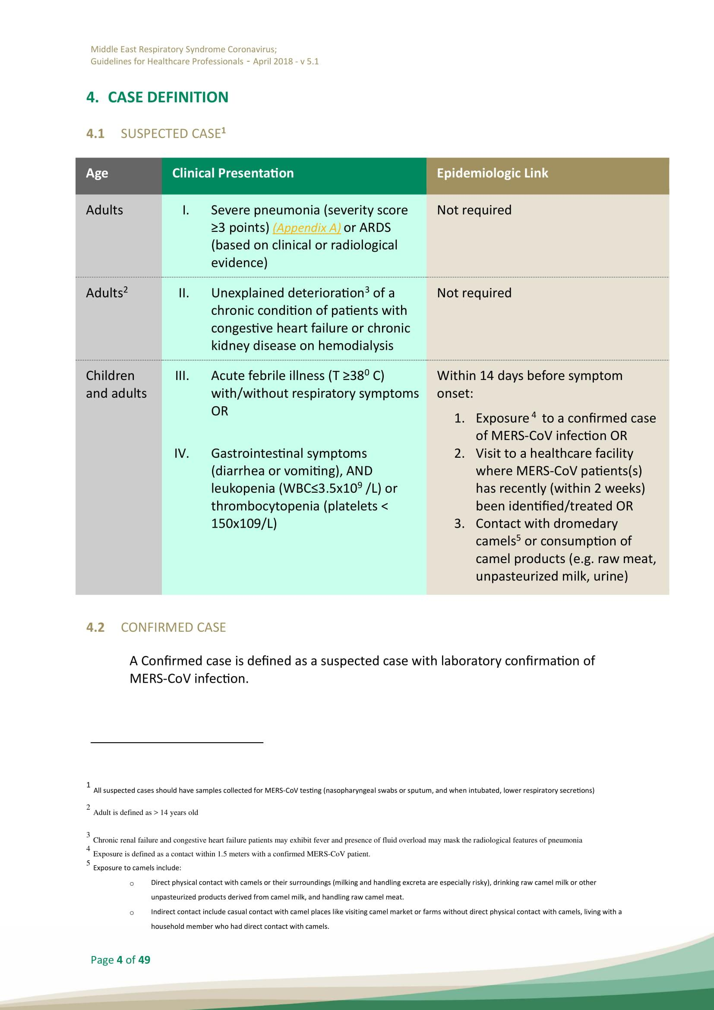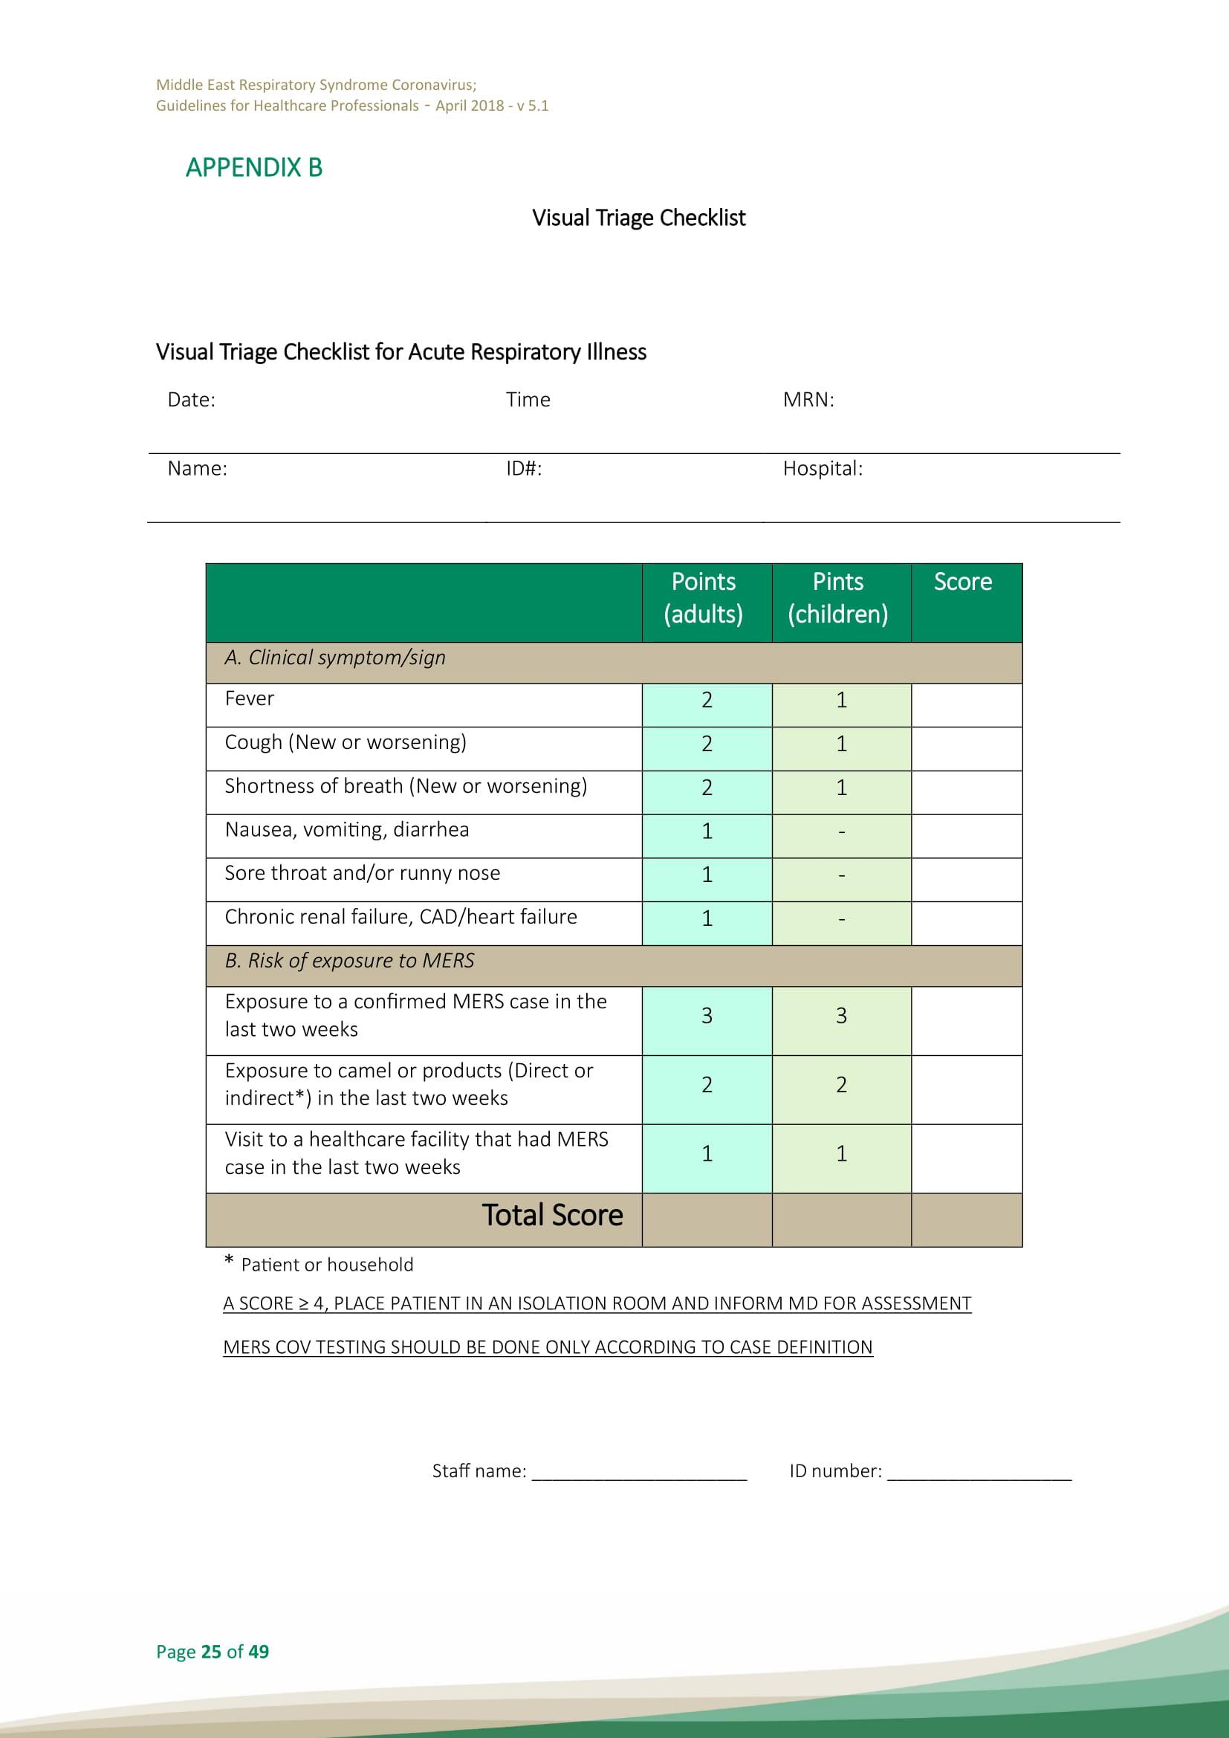

MIDDLE EAST RESPIRATORY SYNDROME CORONAVIRUS; GUIDELINES FOR HEALTHCARE PROFESSIONALS
https://www.moh.gov.sa/CCC/healthp/regulations/Documents/MERS-CoV%20Guidelines%20for%20Healthcare%20Professionals%20-%20May%202018%20-%20v5.1%20%281%29.pdf

Otitis media (OM)

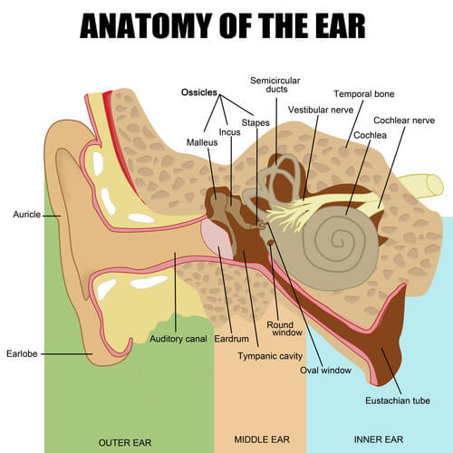
Which age group commonly suffer from OM?
Children
http://www.aafp.org/afp/2013/1001/p435.html

What are the 3 most common organisms that causes OM?
Bacterial: Streptococcus pneumoniae, Haemophilus influenzae* (nontypable), and Moraxella catarrhalis
*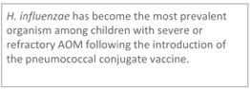
viral: rhinovirus, parainfluenza virus, influenza virus
http://www.aafp.org/afp/2013/1001/p435.html

What are the risk factors for OM?
Pediatrics:
Age (children before school age are the most common affected group)
No breastfeeding (supine bottle feeding)
Pacifier use
Gastroesophageal reflux
attending group day care
All age groups:
Allergies
Craniofacial abnormalities
Exposure to environmental smoke or other respiratory irritants
Family history of recurrent acute otitis media
Immunodeficiency
Upper respiratory tract infections

http://www.aafp.org/afp/2013/1001/p435.html

What is the main mechanism responsible for acute otitis media?
Eustachian tube dysfunction/obstruction/abnormality due to:
-swelling of tubal mucosa (e.g. rhinosinusitis)
-obstruction/infiltration of Eustachian tube ostium.
-inadequate tensor palatini function: cleft palate (even after repair)
-Abnormal Eustachian tube

What are the symptoms of acute otitis media?
Otalgia (earache)
Fever (especially in younger children)
Otorrhea
decreased hearing
Irritability
Vomiting
loss of appetite
Headache

Which instruments can help diagnose OM & OME?
Otoscopy
Pneumatic otoscopy
Tympanometry

http://www.aafp.org/afp/2013/1001/p435.html

What are the findings on clinical examination?
Otoscopy of TM :

Bulging .
Decreased mobility of the tympanic membrane (can be assessed using pneumatic otoscopy).
Redness or cloudiness of the tympanic membrane.

When should you diagnose acute otitis media?

1-children who present with moderate to severe bulging of the tympanic membrane (TM) or new onset of otorrhea not due to acute otitis externa.
2-children who present with mild bulging of the TM and recent (less than 48 hours) onset of ear pain (holding, tugging, rubbing of the ear in a nonverbal child) or intense erythema of the TM.
3-you should not diagnose AOM in children who do not have middle ear effusion (MEE) (based on pneumatic otoscopy and/or tympanometry).

http://www.aafp.org/afp/2013/1001/p435.html

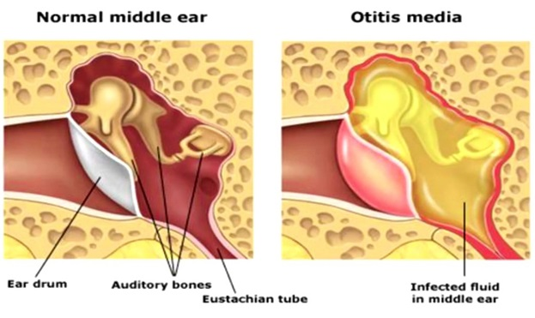
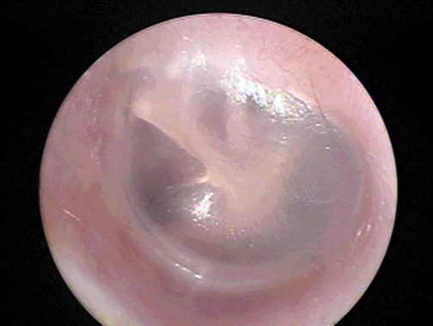
Normal left tympanic membrane with pearly gray color.

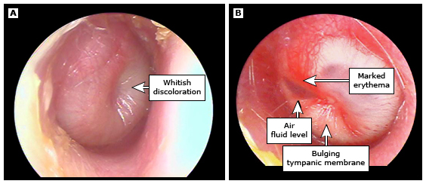
Examples of the white, bulging tympanic membrane seen in acute otitis media. Panel A demonstrates a bulging tympanic membrane with minimal erythema. Panel B demonstrates tympanic membrane bulging, marked erythema along the handle of the malleus, and an air-fluid level in the anterosuperior portion of the tympanic membrane.

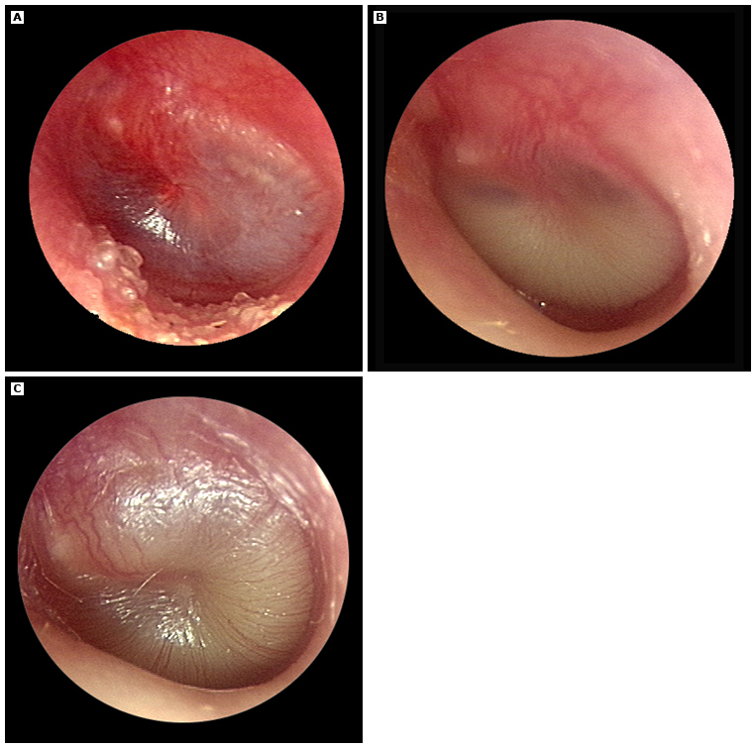
(A) Early acute otitis media with inflammation; subsequently progressed to effusion.
(B) Purulent effusion with air-fluid level.
(C) Bulging purulent effusion filling the middle ear.

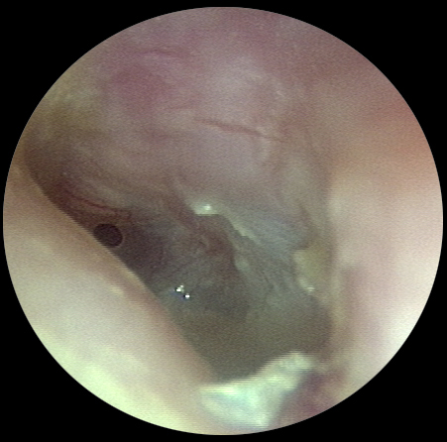
Acute tympanic membrane perforation with otorrhea

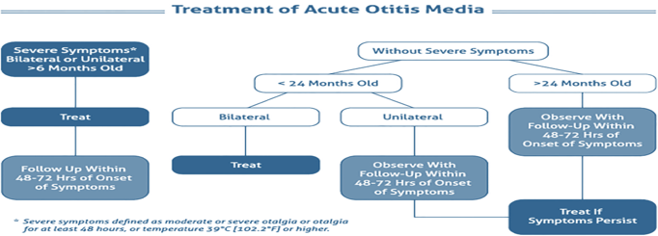

What is the symptomatic treatment for OM?
Paracetamol or ibuprofen
Ibuprofen and acetaminophen are recommended for symptoms of ear pain, fever, and irritability.

http://www.aafp.org/afp/2013/1001/p435.html

When it is a must to treat with antibiotics for OM?
-otorhea without otitis externa
- severe signs or symptoms at any age (moderate or severe otalgia, otalgia for at least 48 hours, or temperature of 102.2°F [39°C] or higher)
-Bilateral OM in 6-24 months old.

http://www.aafp.org/afp/2013/1001/p435.html

When you have a choice whether to start antibiotic therapy or observation?
Unilateral without severe signs and symptoms or >24 months without severe signs and symptoms

http://www.aafp.org/afp/2013/1001/p435.html

If observation was chosen, what are the mechanisms that must be in place to ensure appropriate treatment if symptoms persist for more than 48 to 72 hours?

Strategies include a scheduled follow-up visit or providing patients with a backup antibiotic prescription to be filled only if symptoms persist

http://www.aafp.org/afp/2013/1001/p435.html

What is the antibiotic of choice for OM?
Amoxicillin
◦ High-dose Amoxicillin (80-90 mg/kg/day divided into two doses).

http://www.aafp.org/afp/2013/1001/p435.html

What if the patient was allergic to penicillin?
2nd generation cephalosporins (eg cefuroxime)
http://www.aafp.org/afp/2013/1001/p435.html

What if symptoms persist 48-72 hours after initiating antibiotic therapy?
Repeat ear examination for signs of otitis media
If otitis media is present, initiate or change antibiotic therapy
If symptoms persist despite appropriate antibiotic therapy, consider amoxicillin+clavulanate, if penicillin allergic consider intramuscular ceftriaxone , clindamycin, or tympanocentesis
http://www.aafp.org/afp/2013/1001/p435.html

What is a common side effect to antibiotic treatment of OM?
Diarrhea
You can suggest probiotics, or yogurt containing active culture.

http://www.aafp.org/afp/2013/1001/p435.html

When tympanostomy can be considered for recurrent OM?
three or more episodes in six months, or four episodes within 12 months with at least one episode during the preceding six months
http://www.aafp.org/afp/2013/1001/p435.html

What are the strategies for preventing recurrent OM?
Check for undiagnosed allergies leading to chronic rhinorrhea
Eliminate bottle propping and pacifiers
Eliminate exposure to passive smoke
Routinely immunize with the pneumococcal conjugate and influenza vaccines
Use xylitol gum in appropriate children (two pieces, five times a day after meals and chewed for at least five minutes)
http://www.aafp.org/afp/2013/1001/p435.html

What are the complications of acute otitis media?
Intertemporal Complications:

•Hearing loss and Language delay
•Mastoiditis (most common serious complication of AOM in children)
•Facial Nerve Paralysis
•Labyrinthitis
•Labyrinthine fistula

Intracranial Complications:

• Extradural Abscess
• Subdural Abscess
• Meningitis
• Sigmoid Sinus Thrombosis
• Brain Abscess

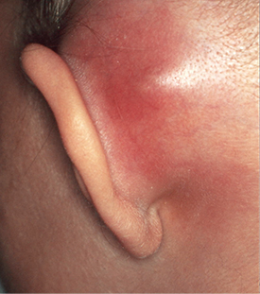
Mastoiditis

