Hematuria & proteinuria
Prof. ABDULLAH AL SALLOUM
Done by: Alaa Alaqil
(slides= black, notes= green)
_________________________________________________________
Hematuria & proteinuria are early presentation of renal diseases, so its important to pick them up and manage them early to prevent renal failure.
Hematuria
Hematuria (it’s the presence of RBCs in the urine and not colored urine)
is a common finding on urinalysis with a prevalence rate between 1% and 2% worldwide.

Presentations of Hematuria
- Gross hematuria
- Microscopic hematuria with clinical symptoms (like: rash, arthralgia, alopecia)
- Asymptomatic microscopic (isolated) hematuria
- Asymptomatic microscopic hematuria with proteinuria (this presentation is the most serious, which requires immediate admission and investigation)

Diagnosis:
The most sensitive test for detecting the presence of blood in the urine is abnormal urine strip test (the best, sensitive, and cheapest test).

Urine Strip Test: (skiped)
The reagent utilizes the pseudoperoxidaze activity of hemoglobin (or myoglobin) to catalyze a reaction between hydrogen peroxide and the chromogen tetramethylbenzidine to produce an oxidized chromogen, which has a green blue color.

Urine Strip Test:
Strips can detect concentration of 2-5 RBC/HPF

False negative urine dipstick: (skipped)
- High specific gravity urine
- High ascorbic acid concentration in the urine.
False positive urine dipstick: (skipped)
- Delayed reading
- Cross contamination of urine from other chemicals such as oxidized agent, (household bleach)

Confirmation of hematuria :
Urine Microscopy: (after urine dipstick test to confirm), (not required to know the technique)
- Centrifuge 10 ml of urine for 5 minute
- Decant the supernatant
- Re-suspend the sediment in 0.5 ml of urine
- Place on a slide with a cover slip
- Count the number of RBC. In 20 fields and report the average
Positive Test: (> 5 RBC/HPF)

Definition of hematuria (by the microscope):
5 RBC’s /HPF in three occasions of three consecutive weeks, fresh, centrifuged urine specimens obtained at least 1 week apart.

Localization of hematuria: (upper urinary tract or lower, glomerular or non-glomerular)
Limits diagnostic possibilities for patients and prevent unnecessary testing.

Classification:
- Glomerular hematuria (more sever)
- Non-Glomerular hematuria
(we can differentiate between them by the clinical presentation)

Clinical presentation of the glomerular hematuria:
- Oliguria(less than 1ml/kg/hr), anuria, edema
- Hypertension
- May or may not have Symptoms of systemic disease (e.g. arthritis, rash).

- Brown tea, cola-colored urine
- Concomitant proteinuria
- Cellular cast (collection of RBCs with protein sheath)
- Dysmorphic erythrocytes in phase-contrast microscopy
- Low MCV of erythrocyte by automated analyzer

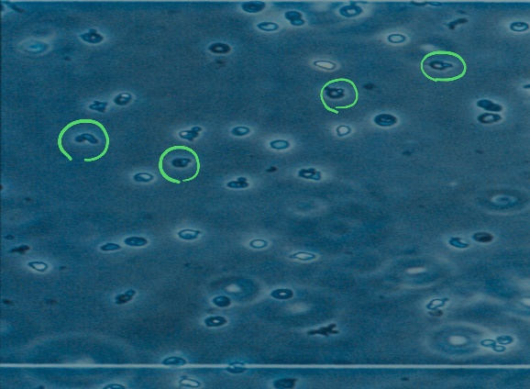
This is face contrast microscope test showing elongated RBCs.
If there is more than 15% of abnormal RBCs = glomerular hematuria.

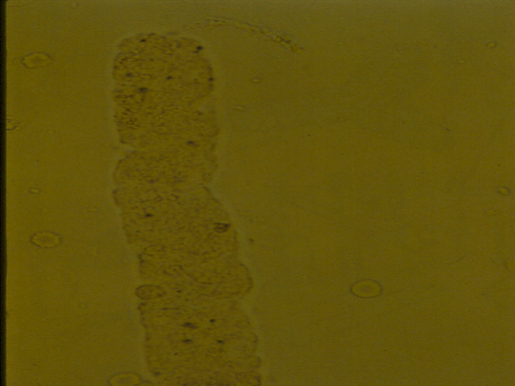
this shows RBC cast which indicates acute nephritis (specifically PIGN)

RBC CASTS:
RBC casts are best visualized at the edges of the cover slip and tend to dissolve in urine of high PH.
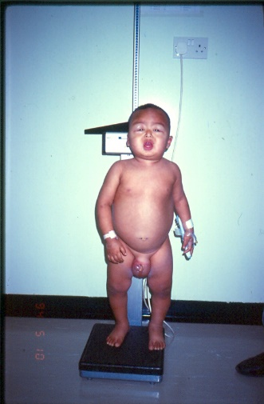
this shows a child with generalized edema (anasarca)
This child presented with high BP, anasarca, hematuria, proteinuria, anuria for 2days and high creatinine.
What is the condition? Acute nephritis

nephrotic | nephritic
- No Hematuria  - Proteinuria  - Normal BP  - Edema  - Normal renal function | - Hematuria  - Proteinuria  - HTN  - Generalized edema  - Oliguria  - High serum Cr (poor renal function)
Causes of Glomerular hematuria:(causes of nephritis)
- Post-infectious glomerulonephritis
- IgA nephropathy (IgA nephropathy & Henoch-Schönlein purpura are the same disease but IgA nephropathy affect only the kidney, whereas HSP affect the kidney and the skin)
- Henoch-Schönlein purpura
- Hereditary nephritis (Alport disease)
- Benign familial hematuria (not nephritis)
- Membranoproliferative glomerulonephritis
- Lupus nephritis

Postinfectious GN:
- Begins 7-21 days after group A before-hemolytic streptococcal infection
- 50% are group A before-hemolytic streptococcal, and the other 50% are viral.
- Antibiotic treatment for the infections will not prevent the nephritis
- Present with tea colored urine, edema and hypertension.
- May present with only microscopic hematuria.

- ASO may be negative early in the course.
- C₃ low in 90% of patients for 6 weeks
- C₄ normal
- Microscopic hematuria my persist for 2 yrs.
- Self-limited and few patients will require dialysis.

IgA nephropathy:
- The most common chronic GN in Europe and Asia.
- The most common cause of hematuria in children. (MCQ Q)
- 15% of children with Prolonged hematuria (> 1 year) will have IgA nephropathy
- Present with recurrent gross hematuria during viral illness (in the 1st or 2nd day).
- Microscopic hematuria present between episodes of gross hematuria
- There is no laboratory test diagnostic of GN
- The only test to confirm is renal biopsy
- Diagnosis by histopathologic demonstration of mesangial deposition of IgA
- 25% of children with IgA nephropathy will progress to chronic renal insufficiency.
- Poor outcome: cresentic GN, older age group, hypertension, nephrotic range proteinuria.
- May end up with renal failure and it may reoccur even after renal transplant.

Alport hereditary nephritis:
- Episodes of recurrent or persistent microscopic hematuria.
- Family History: male individuals with nerve deafness and progression to ESRD
- Type IV collagen is abnormal and the basement membrane is disrupted.
- The diagnosis is confirmed by renal biopsy.
- Hearing test should be done regularly to prevent speech or educational handicap.
- Good-posture diseases post transplant (small risk)
- Female may have a hearing deficit without any urinary abnormalities.

Benign Familial Hematuria:
- Thin glomerular basement membrane nephropathy.
- Occurs in at least 1% of the population.
- Inherited as AD or AR manner.
- Absence of proteinuria, renal failure, hearing deficits, or ophthalmologic abnormalities, HTN.
- Microscopic hematuria only, dysmorphic RBC’s

Rapidly Progressive GN: (skipped)
- Presents with symptoms and signs similar to APIGN
- Require the urgent attention of a Pediatric Nephrologist.
- Laboratory Studies show ARF
- Renal biopsy demonstrates glomerular crescent.
- Untreated RPGN can result in ESRD in a few weeks.

Causes of non-Glomerular hematuria:(non-Glomerular is usually benign with no renal failure)
- Hypercalciuria
- Infections (bacterial or viral). (UTIs)
- Papillary necrosis (HbS). (in sicklers which happens due to ischemia)
- Urolithiasis
- Trauma
- Foreign body
- Exercise-induced hematuria

Hypercalciuria: (advise the patient to drink lots of water)
- Increased urinary excretion of ca despite normal s.ca
- Present in 5% of healthy children
- Most frequent cause of isolated hematuria in non-glomerular hematuria patients.

Idiopathic Hypercalciuria: (skipped)
- Renal hypercalciuria: result from a tubular leak of calcium.
- Absorptive hypercalciuria : results from increased gastrointestinal absorption of calcium.
- There is often a family history of renal stones.
- Symptoms include dysuria, suprapubic pain, renal colic.
- Present with microscopic hematuria and episodic gross hematuria.
- Urine RBC’s are shaped normally with no cast.
- The mechanism of the hematuria involve irritations to the renal tubules by ca-containing crystals.
- High risk of development of renal stones.
- Screening for hypercalciuria: spot urinary ca/ creatinine ratio.
- A ration of > 0.21 is indicative of hypercalciuria.
- Confirmation of hypercalciuria by collecting a timed (either 12 or 24 hours) urine for ca excretion.
- An excretory rate of greater than 4 mg/kg/day is abnormal.
- Increase fluid intake to dilute the urine.
- Severe ca restriction should be avoided.
- Hydrochlorothiazide (HCT) decrease urinary ca excretion.
- HCT in a child with isolated hematuria with no previous nephrolithiasis is not recommended.

History clues:
(make sure that the patient has real hematuria and not just change in the urine color. For example: rifampicin can cause red colored urine without presence of RBCs (not real hematuria).
- Duration and pattern of hematuria
- Family history (hematuria, renal failure, deafness, urolithiasis)
- Pharyngitis, URTI
- Dysuria or other symptoms of urinary infections
- Rash (HSP)
- Abdominal pain (infections, stone, HSP). (HSP causes Abdominal pain by vasculitis & ischemia or by Intussusception)
- Drugs (anticoagulant)

Physical examinations clues:
- Hypertension, edema, pallor
- Rash, impetigo
- Abdnominal or flank tenderness (infection)
- Abdominal mass (tumors)
- Ecchymoses, petechiae, hemangiomas
- Evidence of abdominal trauma
- External genitalia for trauma or bleeding
- Growth pattern
- Hearing test

Basic Laboratory Evaluation:
- Urine culture
- CBC
- Serum creatinine
- Aso titre
- Urine ca: creatinine ratio (hypercalciuria)
- Urine protein: creatinine ratio (proteinuria)
- C3 & C4
- Renal ultrasonography
- First degree relatives urine test (done for benign familial hematuria if all the other investigations are normal)
The initial referrals are to the Pediatric Nephrologist rather than to the Pediatric Urologist.

Other evaluation procedures: (skipped)
- Renal biopsy
- Cystoscopy
- Renal angiography (rarely indicated)

Proteinuria

- Associated with progressive renal disease
- Involved in the mechanism of renal injury
- Always serious, requiring quick intervention.

Clinical Testing for Proteinuria:
- Urinary dipstick
  - Screening test
  - Color reaction between urinary albumin and tetrabromphenol blue
  - Trace ≅ 15 mg/dl
  - 1 + ≅ 30 mg/dl
  - 2 + ≅ 100 mg/dl (+2 and above indicates inflammation)
  - 3 + ≅ 300 mg/dl
  - 4 + ≥ 2000 mg/dl

Urinary dipstick: (skipped)
- False-negative:
-Diluted urine
- False-positive
-Alkaline urine (PH>8.0)
-Concentrated urine (sp.gravity>1:025)
-Antiseptic contamination (Chlorhexidine, benzalkonium chloride)
-After intravenouse radiograph contrast

Quantitative estimate of proteinuria
-if dipstick urine test is positive for proteins, confirm by:
- 24-hour urine collections (hard to do in children)
- Urinary protein/creatinine (pr/cr) ratio (Sample could be spot or morning)
    - Spot urine specimen.
    - First morning specimen.
      - Normal values:
        - <0.2 mg protein/mg creatinine in children > 2 years
        - <0.5 mg protein/1 mg creatinine in children 6-24 months old

Protein Handling by the Kidneys in Normal Children (skipped)
- Normal rate of protein excretion
<4mg/m2/hr
<100mg/m2/day
      - 50% Tamm-Horsfall protein
      - 30% Albumin
      - 20% other protein
Restricted filtration of large
Proteins (albumin & Immunoglubulin)
Proximal tabules reabsorb most of LMW protein (insulin, B2 microglobulin)

Protein Handling in Renal Disorders (skipped)
Excess urinary protein losses
1.Increase permeability of the glomeruli (glomerular)
2.Decrease reabsorption of LMW proteins by the renal tubules (tubular)

Types of proteinuria
1. Transient
  - Fever
  - Stress
  - Dehydration
  - Exercise

2. Orthostatic proteinuria (postural)
  - Excess urine protein in upright position but normal during recumbency
  - School age
  - <1gm/m2/day
  - Diagnosed by positive evening sample and negative morning sample for proteinuria

- Persistent proteinuria: (always positive for proteinuria)
Proteinuria of ≥1 + by dipstick in multiple occasions

Association Between Proteinuria and Progressive Renal Damage (skipped)
Persistent proteinuria should be viewed as a marker of renal disease and also as a cause of progressive renal injury.

Evaluating Children with Proteinuria (skipped)
[A] First stage
    - Complete history and physical examination (BP)
    - Complete urinanalysis
    - Urindipstick before going to bed and after arise
    - Blood level of Albumin, creatinine, cholesterol, electrolyte
[B] Second stage
    - Renal ultrasonography
    - Measurement of serum C3, C4, complement
    - Antinuclear antibody
    - Serology for hepatitis B, C, ± HIV

Evaluation and Treatment of Patients with NS
- Definition
- Heavy proteinuria, hypoalbuminemia, (+l-) Hypercholesteremia and edema
- Prevalence 2-3 cases per 100,000 children
- The majority will have steroid responsive MCNS

Pretreatment Renal Biopsy in NS (skipped)
- Infantile NS
- Adolescence
- Persistent hematuria
- Hypertension
- Depressed serum complement
- Reduced renal function

Clinical Problems Associated with Children NS

[A] Edema
- Gravity dependent
- Periorbital in the early morning hours then generalized
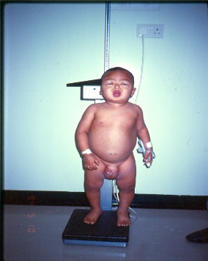
- Severe edema present as ascites, pleural effusions, scrotal or vulvar edema, skin breakdown.
this child would have nephrotic syndrome if he had:
normal BP, edema, no hematuria, proteinuria, normal renal function, and hypoalbuminemia.

[C] Infections
(caused by 2 mechanisms: 1- low protein> low immunoglobulins > immunocompromised child. 2- steroid)
1.Varicella
    - Varicella antibody should be obtained
    - Varicella – zoster immunoglobulin within 72 hours of exposure
    - Steroid should be tapered to 1 mg/kg/day
    - Acyclorir or valacylovir if varicella does develop & stop the steroid
2.Other infection
    - Cellulitis
    - 1° peritonitis
  - The organisms usually: Pneumococcus, E-coli

Immunization in N.S.:
- Live viral vaccines should not be given if patient on high dose of steroids
- Pneumococcal vaccine is recommended to all NS (off steroids)
- Varicella vaccine (varivax) in 2 doses regimen is safe and efficacious
- Antibodies to vaccines may fall during relapses (still contravesial)

[D] Hyperlipidemia (skipped)
- Transient and severe hypercholesterolemia during relapses
- Persist in treatment-resistent NS
- Atherosclerosis in young NS
- Dietary modification : limited benefit
- Cholestyramine is approved in NS

Approaches to treatment of NS
[A] Prednisone/prednisolone: Mainstay of treatment of NS
Typical protocol:
- 2 mg/kg/day (60mg/m2/day)
- (4+4 wks treatment)
- 4 wks daily steroid (induction)
- 4 wks every other day (maintenance)
- Recently: 6+6 weeks induce a higher rate of long remissions than the standard (4+4)
- Steroid resistance: no response to steroid for 1month

Treatment of Relapses of NS
- 60-80% of patients will relapse after stopping the steroid.
- Prednisolone 2mg/kg/day until the patient is free of proteinuria for 3 days then 4-6 wks of every other day treatment.
- Steroid dependent: relapse after stopping the steroid by 2 weeks.

Side effects of Glucocorticoids: (Must be discussed with the family)
- Cushingoid habitus (cushingoid appearance)
- Ravenous appetite
- Behavioral and psychological changes (mood liability)
- Gastric irritation (including ulcer)
- Fluid retention
- Hypertension
- Steroid-induced bone disease (like osteomalacia)
- (avascular necrosis, bone demineralization)
- Decreased immune function
- Growth retardation (short)
- Night sweats
- Cataracts
- Pseudotumor cerebri
- Steroid-related diabetes
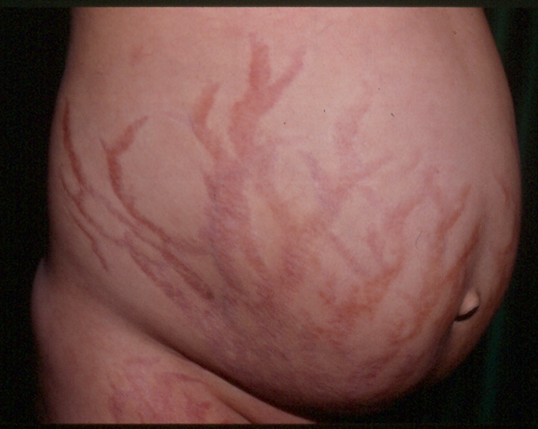
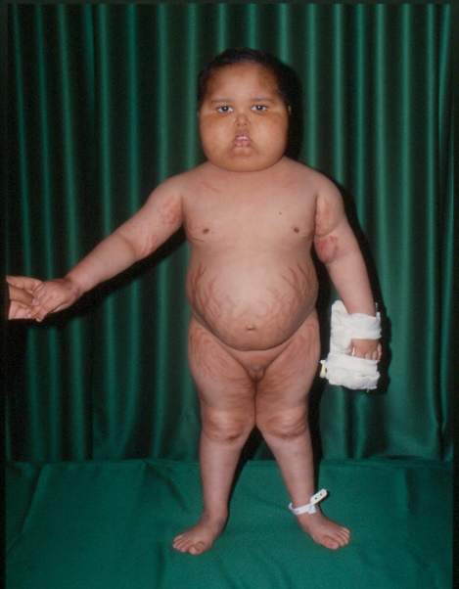

striae
(Habitus appearance)
Thick upper trunk
Thin lower trunk
Moon face

(doctor didn’t go in details about these other treatment options)
[B] IV Pulse Steroids
- May give success in steroid-resistant NS
- High dose IV methylprednisolone
30 mg/kg (max Igm)
- To be given every other day for 6 doses
- To continue in tapering regiment for period up to 18 months.
- Side Effects
    - Hypertension
    - Arrhythmias
[C] Cytotoxix Drugs
1. Cyclophosphamide:
- Over 12 weeks
- Total cumulative dose 170 mg/kg
- Side Effects
  - Bone marrow suppressions
  - Oligospermia, azoospermia and ovarium fibrosis (If given close to puberty)
  - Hemorrhagic cystitis
  - Risk of malignancy
2. Chlorambucil : May cause seizure
[D] Cyclosporin A
- Steroid dependent or resistant NS
- To be given after renal biopsy
- Relapses high after withdrawal
- Side Effects
    - Hypertension
    - Nephrotoxicity
    - Hyperkalemia
    - Hypomagnesemia
    - Hypertrichosis
    - Gingival hyperplasia
[E] Levamisole
- Weak steroid sparing drug
- Long term use
- Side Effects:
    - Neutropenia
    - Rash
    - Gastrointestinal disturbances
    - Seizures

Other Practical Aspects of the Management of NS (skipped)
- Fluid intake should be limited to double of insensible water loss in severely edematous NS
- Combined diuretics and IV albumin can be given in severe edema
- Diuretics should not be given in mild edema
- ACE: should not be given in the initial course of prednisolone because of the risk of hypotension and thrombosis in the diuretic phase
- ACE: can be given to steroid-resistant NS
- Schooling, activities, diet should be individualized

